Review of 2030 Proposed Revised Water Thresholds - Gnangara Groundwater System

Christopher Kavazos, Grant Buller, Pierre Horwitz, Ray Froend

19 February 2020

# 

# Executive Summary

This report presents a detailed analysis of the ecological effects of proposed revisions of water level criteria.

. Currently Ministerial Statement 819 minimum thresholds in water level criteria must be met by the Department of Water and Environmental Regulation (DWER) at wetlands covered by the Gnangara groundwater allocation plan. However, groundwater abstraction combined with declining rainfall in the region means that it is unlikely many sites will meet the criteria. A reduction of groundwater abstraction of up to 44 GL/yr by 2030 is being proposed by DWER. Hence, revised thresholds have been proposed. We describe the effect of these proposed thresholds on the values and managerial objectives of twelve wetland sites and five terrestrial sites on the Gnangara Groundwater System. Where water levels are likely to increase, proposed maximum thresholds are given. Finally, the management objectives for one additional wetland, Lake Gwelup, are reviewed with the aim of providing DWER with minimum and maximum thresholds that will maintain its ecological integrity.

In most cases the projected water levels are an improvement over the current (2019) situation, however wfor 2030 with existing criteria Accordingly, the Department has revised minimum thresholds to lower levels to ensure compliance at these sites based on what is achievable from these projected 2030 water levels.

Loch McNess and Lake Yonderup are currently experiencing dramatic shifts in ecological processes that are being driven by changes in hydrological regimes. The projected 2030 water levels are not going to return these lakes to their normal hydrological regime and nutrient enrichment will continue being a problem. At wetlands such as Lake Nowergup and Pipidinny Swamp, diminished habitat for water birds will persist. Other sites, such as Lexia 186 and Melaleuca Parks 173 and 78, are likely to contain increasingly stressed wetland vegetation as the ecological water requirements for some species are not met. These sites may experience terrestrialisation of vegetation at outer extremities. Similar shifts are described for the five terrestrial sites examined here, albeit the effects of terrestrialisation are almost certain and perhaps already well underway.

On the other hand, Lake Goollelal, Lake Joondalup, Lake Mariginiup and Lake Jandabup are projected to have water levels significantly greater than 2013 levels, hence it is proposed to increase minimum thresholds. For these wetlands, maximum thresholds (water levels should not exceed) are also proposed to ensure that fringing vegetation is maintained at these sites. The most dramatic changes are expected for Lake Mariginiup, which is proposed to reach surface water levels higher than what has (ever) been recorded at the lake. These higher water levels pose a risk for fringing vegetation as water levels are expected to surpass the hydrological ranges of the rush *Baumea articulata* and the riparian tree *Eucalyptus rudis*. We therefore also propose a revised minimum threshold that will enable the current fringing vegetation to persist.

Finally, minimum and maximum thresholds are proposed here that will achieve the proposed management objectives of Lake Gwelup (a minimum threshold of 5.4 mAHD and a maximum threshold of 7.6 mAHD at the staff gauge 6162504). These thresholds will ensure permanent water exists in the lake and thus protect the site as a drought refuge for water birds. These thresholds also ensure that the ecological water requirements for surrounding vegetation are met which will ensure the lake provides for a diverse range of aquatic macroinvertebrates that benefit from the habitats provided by fringing vegetation.

Contents

Executive Summary i

Introduction 1

Scope of report 2

Structure of report 3

Methodology 6

Vegetation monitoring 8

Aquatic invertebrate monitoring 9

Water quality monitoring 9

Statistical analyses 9

Tasks 1-3: Assessment of 2030 proposed minimum thresholds 11

Lake Goollelal 16

Current hydrological regime 16

Implications of revised threshold 17

Loch McNess 21

Hydrology 21

Implications of revised threshold 22

Lake Yonderup 27

Hydrology 27

Implications of revised threshold 28

Lake Joondalup 32

Hydrology 32

Implications of revised threshold 33

Lake Mariginiup 36

Hydrology 36

Implications of revised threshold 37

Lake Jandabup 41

Hydrology 41

Implications of revised threshold 42

Lake Nowergup 46

Hydrology 46

Implications of revised threshold 47

Lake Wilgarup 51

Hydrology 51

Implications of revised threshold 52

Pipidinny Swamp 55

Hydrology 55

Implications of revised threshold 56

Lexia 186 58

Hydrology 58

Implications of revised threshold 59

Melaleuca Park 173 62

Hydrology 62

Implications of revised threshold 63

Melaleuca Park 78 66

Hydrology 66

Implications of revised threshold 67

MM59B - Whiteman Park East 69

Hydrology 69

Implications of revised threshold 70

PM9 - Pinjar North 72

Hydrology 72

Implications of revised threshold 73

WM1 - Pinjar 74

Hydrology 74

Implications of revised threshold 75

WM2 - Melaleuca Park North 77

Hydrology 77

Implications of revised threshold 78

WM8 - Melaleuca Park 80

Hydrology 80

Implications of revised threshold 81

Task 4: East Wanneroo maximum threshold revisions 83

Task 5: Review of Lake Gwelup management 84

Hydrology 84

Proposed thresholds 85

References 88

Appendices 91

Appendix 1: Trends across wetlands on the Gnangara Groundwater System 91

Appendix 2: Data analysis for each wetland 94

Lake Goollelal 94

Loch McNess 100

Lake Yonderup 105

Lake Joondalup 112

Lake Mariginiup 117

Lake Jandabup 124

Lake Nowergup 129

Lake Wilgarup 136

Pipidinny Swamp 138

Lexia 186 140

Melaleuca Park 173 141

Melaleuca Park 78 147

# 

# Introduction

The Gnangara Groundwater System is located on the Swan Coastal Plain in south-western Australia. The system covers an area of 220,000 ha, extending from the Swan River in the south to the Moore River and Gingin Brook in the north and from the Darling Scarp in the east to the Indian Ocean in the west (Figure 1). The system consists of three major aquifers: The Superficial aquifer, Leederville aquifer and the Yarragadee aquifer. The Gnangara Groundwater System is an expression of the Superficial aquifer, an unconfined aquifer composed of Quaternary-Tertiary sediments of the Swan Coastal Plan that is in direct connection with the lower Leederville aquifer at locations where the Osborne Formation has eroded (Salama et al., 1991). This and the underlying aquifers supply Perth with up to 60 % of its drinking water supply.

The Gnangara Groundwater System supports a series of groundwater dependent ecosystems, including wetlands in the form of permanently inundated lakes and rivers, seasonally inundated sumplands and brooks and seasonally waterlogged damplands (Semeniuk 1987). These groundwater dependent ecosystems provide important habitat for an array of vegetation communities and aquatic fauna. Environmental gradients caused by variation in hydrological regimes provides a complex mosaic of vegetation across the Gnangara Groundwater System and within the wetlands themselves. The range of hydrological regimes that define these groundwater dependent ecosystems provides a mosaic of important habitat for aquatic fauna, including endemic fishes, turtles, mammals and waterbirds that reside throughout the Swan Coastal Plain. Groundwater dependent ecosystems are therefore an integral component of the ecological value of the Gnangara Groundwater System and have unquestionable value as remnants of a once more widespread coastal wetland system (Horwitz et al. 2009b).

The biophysical characteristics and the ecological health of groundwater dependent ecosystems overlying the Gnangara Groundwater System are directly related to the hydrological regime of the shallow superficial aquifers and, to a lesser extent, the deeper confined aquifers. The shallow superficial aquifers respond to the seasonal climatic patterns of the region, which experiences a Mediterranean-type climate with hot dry summers and cooler wet winters. June to August represent the wettest months of the year and December to March usually have little rainfall (Figure 2 Right), hence groundwaters in the system generally rise during winter to a spring peak and decline in summer to an autumn minimum. Vegetation and wetland associated fauna of these groundwater dependent ecosystems are largely determined by a given wetland’s hydrological regime, mostly influenced by these groundwater fluctuations.

Recharge of the Gnangara Groundwater System has been declining due to disruptions in the water balance caused by declining rainfall and abstraction. Major users of groundwater from the Gnangara groundwater resources include public water supply, private self-supply (such as for horticulture, irrigation of public open space and domestic gardens), native vegetation, pine forest plantations and wetlands (Salama et al., 1991). Clearing of native vegetation for pine plantations potentially reduces the recharge of groundwater as pines (planted at high densities) transpire more than the native plants they replace, and they are also able to directly access deeper levels of the water table. Groundwater recharge has been hampered by declining rainfall in the south west region of Australia; it is estimated that since the 1970s rainfall has been declining by approximately 12mm/year (England et al., 2006), with up to 64 % less runoff occurring in the region in 2003 compared to 1974 (Yesertener, 2007). Since the mid-1990s, rainfall has generally been below the long-term average (Figure 2 Left). The combined effects of groundwater abstraction, changes in vegetation and declining annual rainfall have contributed to long term declines in groundwater of the Gnangara Groundwater System (Yesertener, 2007) and associated declined health of many groundwater dependent ecosystems (Buller et al., 2019, Judd & Horwitz, 2019).

Drawdown of groundwater affects the mortality and health of plant communities that depend on groundwater access (Groom et al., 2000; Muler et al., 2018; Zencich et al., 2002) and the composition of aquatic invertebrate communities that inhabit the surface waters of wetlands of the Gnangara Groundwater System (Horwitz et al., 2008, 2009b). Changes in hydrological regimes directly affect the distribution, health and composition of fringing wetland vegetation by altering the depth to groundwater, depth of surface water and length of inundation periods (Froend, Loomes & Rogan, 2005). When water requirements are no longer being met for fringing vegetation species, the vigor of individuals within a population declines, eventually causing altered species distributions or complete loss of a population from a wetland. Often the loss of native species due to drying increases the likelihood of invasion by exotic species or in extreme cases, terrestrialisation through the establishment of xeric species.

Fauna associated with groundwater dependent systems tend to have specific life history stages that require surface water. Therefore, the spatial and temporal distributions of such fauna are determined primarily on where there is surface water and when it occurs (Horwitz et al. 2009b). Alteration of these regimes effects the persistence of these organisms and, in some cases, may enhance the survival and reproduction of others (Horwitz et al. 2009b). Organisms requiring permanent water, such as fish, are at most risk under a scenario of declining water levels as loss of permanent surface water in a lake will almost certainly cause the local extinction of those species. Most aquatic insects, on the other hand, can travel between wetlands as adults for reproduction and require surface water for only short periods.

Finally, the physicochemical integrity of groundwater dependent ecosystems can be compromised as groundwater and surface water levels decline. The seasonal exposure of sediments leads to drying and the beginning of acidification processes that effect the pH and water chemistry of surface waters (Horwitz et al. 2009b). The loss of mesic species can also add further organic matter to already organically rich peats which, when dry, are at risk of combustion. Generally, repeated fire disturbance to these sediments facilitates terrestrialisation of these wetlands through loss of peat sediments. Terrestrialisation ultimately leads to the permanent loss of the ecological values we associate with groundwater dependent ecosystems.

## Scope of report

Schedule 1 of Ministerial Statement 819 specifies minimum or minimum peak water level criteria that the Department of Water and Environmental Regulation (DWER) must meet at staff gauges and/or monitoring bores at 14 wetlands and 16 bushland sites in the area covered by the Gnangara groundwater allocation plan, north of Perth (Figure 1). Due to groundwater declines caused by groundwater abstraction and declining rainfall, DWER has been unable to meet the criteria levels at approximately half of the sites in recent years. DWER is currently in the process of preparing a draft Gnangara groundwater allocation plan for public comment. As part of the planning process, the department has modelled scenarios that reduce public and private groundwater abstraction in the plan area by a total of up to 44 GL/year by 2030. Even with these reductions in abstraction, modelling projects DWER will still not be able to achieve the current ‘absolute minimum’ levels at around half of the criteria sites and compliance rates will remain very similar to current rates because the expectations are for a continued drying climate regime into the future.

DWER is therefore proposing to alter the water level criteria at sites where the modelling projects absolute minimum levels cannot be met in the future despite reductions in abstraction. The department has developed a new set of water level criteria (or minimum ‘thresholds’, in line with the Environmental Protection Authority’s recommended terminology (Environmental Protection Authority, 2018). The proposed minimum thresholds have been based on what groundwater modelling has indicated can likely be met at the respective criteria sites following reductions in groundwater abstraction, and (in some areas) planned land use changes. Reductions to groundwater abstraction will come into effect before 2030, while land use changes have started to occur in some areas already and will happen progressively over the plan period.

There are five key tasks that are addressed in this report:

**Task 1:** Assess what effect altering absolute minimum threshold water levels may have on:

1. achieving the original stated site management objectives
2. the original stated site values
3. where these are different from b), the current values as described in recent monitoring reports.

These assessments are based on whether the proposed 2030 minimum threshold levels will meet the water requirements for these specific ecological values:

1. species composition
2. key, priority or threatened species
3. existing ecohydrological states

**Task 2:** For each site, an assessment of the significance of the impacts/changes found in Task 1 (taking into account guidance from the Environmental Protection Authority on the definition of “significant’ effects (EPA, 2018b)).

**Task 3:** For each site, an assessment of whether the proposed new minimum threshold water levels will meet proposed new management objectives. Where the proposed thresholds and proposed management objectives do not align, recommend amendments to the management objectives.

**Task 4:** For the wetlands likely to be affected by planned land use changes in East Wanneroo, an assessment of whether the original maximum water level criteria stated in WAWA (1995):

1. are appropriate to meet the proposed management objectives in Table 2, and protect site ecological and social values, or
2. require revision.
3. If b), recommend appropriate maximum thresholds with justification.

**Task 5:** Review the proposed management objectives for Lake Gwelup and consider the ecological, social and cultural values of the lake. Propose a minimum water level threshold, and if required, a maximum threshold, at bore GLP_EC to meet the management objectives.

## Structure of report

A detailed desktop review of all data collected during the *Gnangara Mound Environmental Monitoring Programme* and *Surveys of Gnangara Mound Wetland Vegetation Monitoring* will be presented in this report (see Appendix 1 & 2). An initial analysis of vegetation and aquatic assemblages is provided to understand the general trends of change for the Gnangara groundwater system in terms of changes in diversity, loss/gain of taxa, homogenisation of communities and the impact of invasive species. This general assessment provides a context of how historical shifts in diversity have shaped each wetland relative to other wetlands and illustrates the general changes being experienced by Gnangara groundwater-dependent ecosystems as a whole.

To understand the shifts that have occurred in aquatic and vegetation communities and the role groundwater levels have had in driving ecological changes at each of the monitored sites, a detailed examination of each wetland is provided. For each wetland, a summary of historical groundwater/surface water levels and current water quality information is presented. Each wetland vegetation community has been modelled to understand the role of groundwater level on the abundance of plant species and a discussion is provided on the causes of historical and contemporary shifts in vegetation composition and the likely trajectory of change should the proposed threshold levels be adopted. A similar interpretation is provided for the aquatic macroinvertebrate communities. Considering the role of groundwater on vegetation structure and the historical shifts in aquatic assemblages, an assessment of the ecological consequences of the revised 2030 thresholds on the stated site values and site management objectives is provided for each wetland.

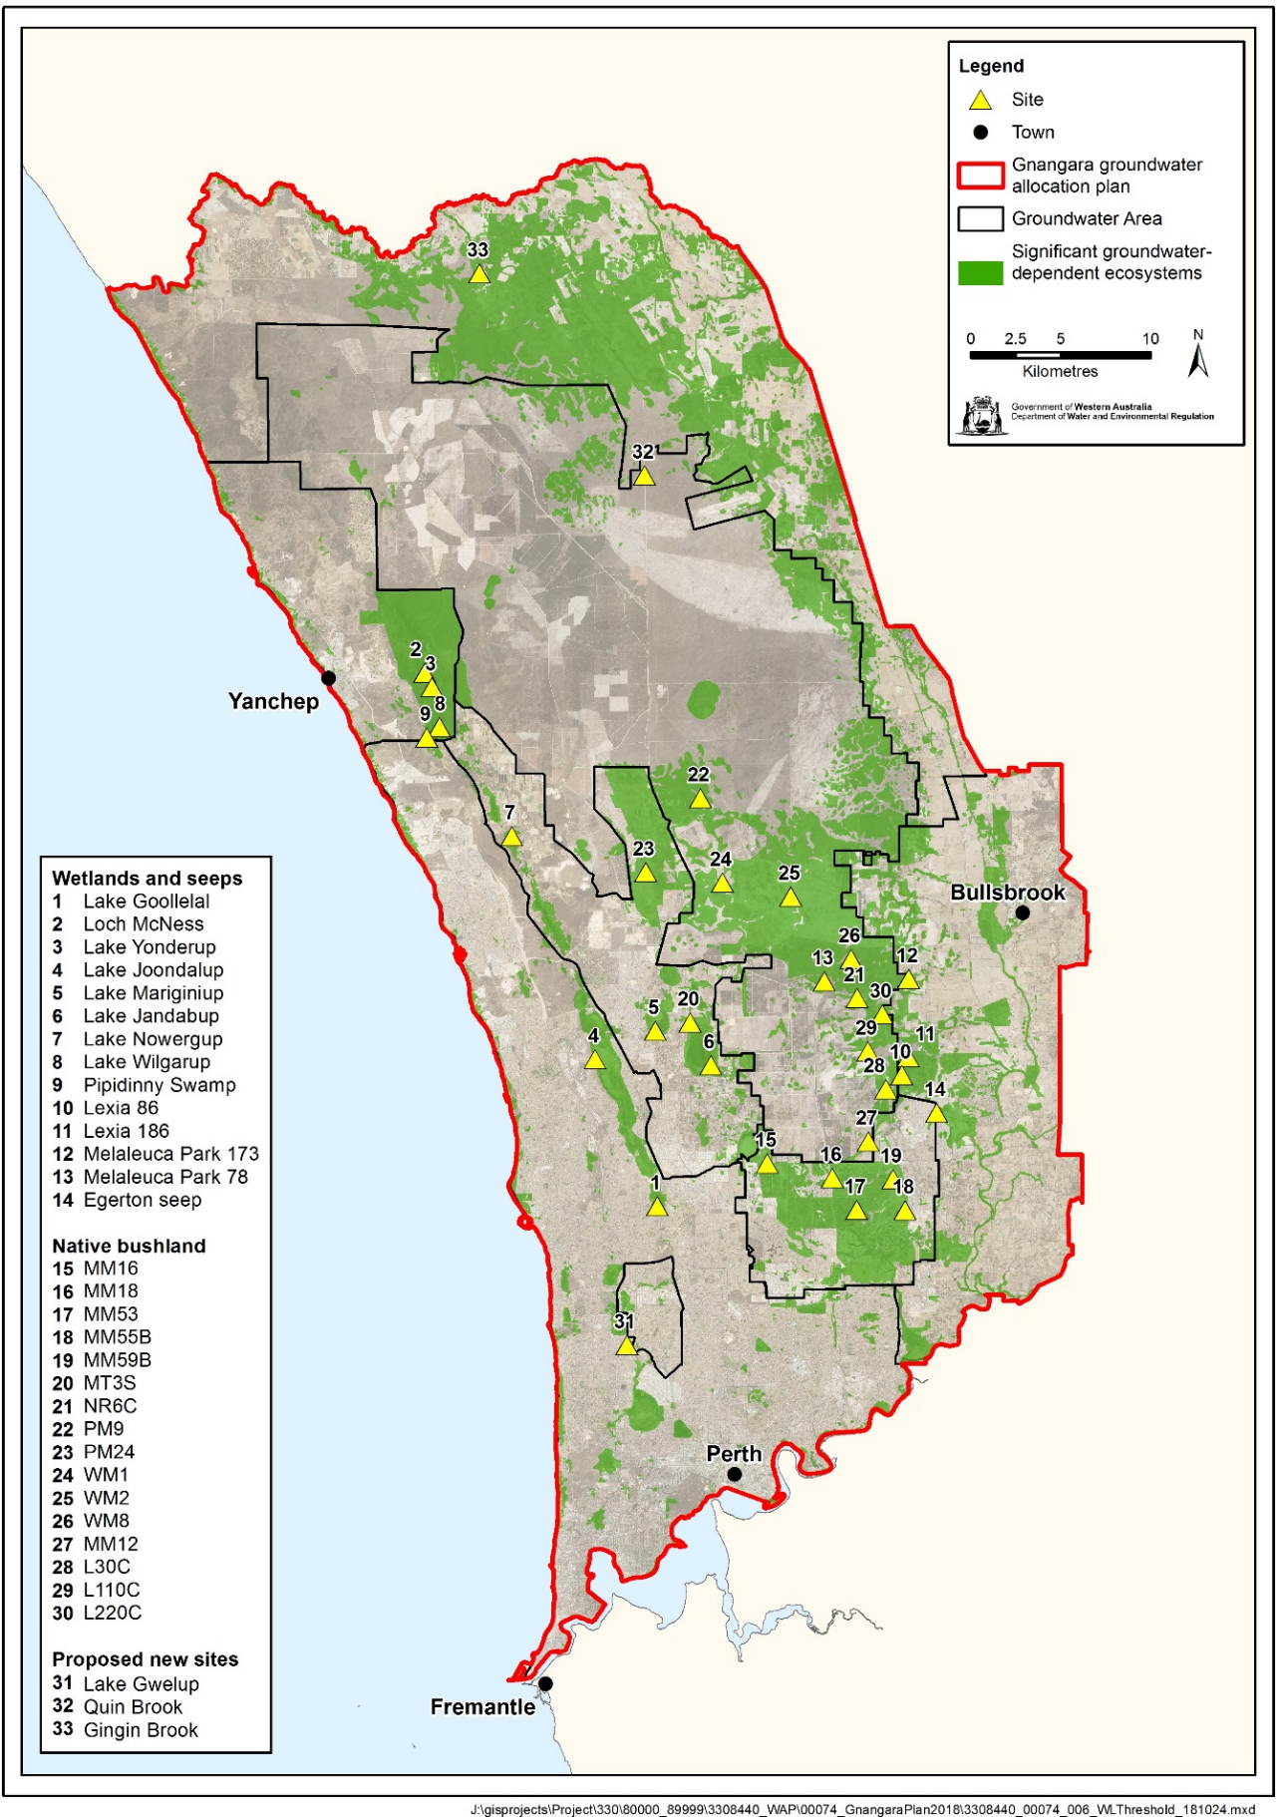

Figure 1 Gnangara groundwater allocation plan area and location of wetland and terrestrial sites investigated in this report.

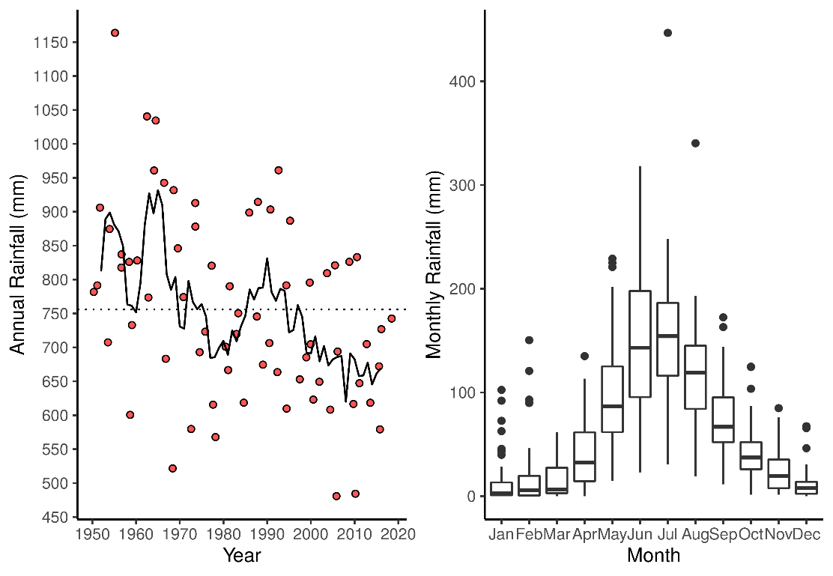

Figure 2 Left: Annual rainfall data reported for Perth Airport (BOM Site 9021) for 1950 - 2018. Red dots represent total rainfall for a given year and dotted line represents average annual rainfall for the entire period. Solid line represents a 5-year moving average of annual rainfall data. Right: Boxplots of monthly rainfall data reported for Perth Airport representing mean and range of monthly rainfall at BOM Site 9021 for 1950 - 2018.

# Methodology

Twelve wetlands and five terrestrial (bushland) environments from the Bassendean and Spearwood Dune systems are analysed in this report to assess the ecological and managerial impacts of revised groundwater thresholds (Figure 1 and Table 1). For each site, vegetation and aquatic macroinvertebrate communities, where applicable, are considered when determining the consequences of the proposed minimum thresholds on the site values and management objectives. The findings of these analyses are provided in summary tables for each site where the original site values and managerial objectives and the proposed management objectives are discussed in terms of the ecological consequences and likely future changes. An assessment of whether the site values and management objectives are achievable, given the proposed changes to the minimum threshold, are provided in terms of a likelihood scale (whether achievement is very unlikely, unlikely, possible, likely or very likely).

Table 1 Summary information for wetlands that have been systematically surveyed on an annual basis and those that have been sampled for the purposes of this report. For each wetland, information is provided on their morphological properties, the dunal system they are found on, whether systematic surveys of vegetation, aquatic macroinvertebrates and water quality have occurred and their location in the Swan Coastal Plain.

|  |  |  |  |  |  |  |
| --- | --- | --- | --- | --- | --- | --- |
| Wetland | Morphology | Dunal System | Vegetation | Macroinvertebrates | Water Quality | Coordinates |
| Lake Goollelal | Lake | Urban Spearwood Dunes | Annually | Annually | Annually | 31.817°S 115.815°E |
| Loch McNess | Lake | Peri-Urban Spearwood Dunes | Annually | Annually | Annually | 31.548°S 115.682°E |
| Lake Yonderup | Lake | Peri-Urban Spearwood Dunes | Annually | Annually | Annually | 31.555°S 115.686°E |
| Lake Joondalup | Lake | Urban Spearwood Dunes | Annually | Annually | Annually | 31.743°S 115.779°E |
| Lake Mariginiup | Lake | East Wanneroo Interdunal | Annually | Annually | Annually | 31.729°S 115.815°E |
| Lake Jandabup | Lake | East Wanneroo Interdunal | Annually | Annually | Annually | 31.746°S 115.847°E |
| Lake Nowergup | Lake | Peri-Urban Spearwood Dunes | Annually | Annually | Annually | 31.630°S 115.732°E |
| Lake Wilgarup | Dampland; was a lake | Spearwood Dunes | Annually | No | No | 31.574°S 115.692°E |
| Pipidinny Swamp | Dampland | Spearwood Dunes | 2019 survey | No | No | 31.580°S 115.683°E |
| Lexia 186 | Sumpland | Bassendean Dunes | Annually | No | No | 31.743°S 115.963°E |
| Melaleuca Park 173 | Lake | Bassendean Dunes | Annually | Annually | Annually | 31.704°S 115.963°E |
| Melaleuca Park 78 | Dampland | Bassendean Dunes | Annually | No | No | 31.704°S 115.915°E |
| MM59B - Whiteman Park East | Terrestrial | Bassendean Dunes | 2019 survey | No | No | 31.804°S 115.954°E |
| PM9 - Pinjar North | Terrestrial | Bassendean Dunes | 2019 survey | No | No | 31.612°S 115.843°E |
| WM1 - Pinjar | Terrestrial | Bassendean Dunes | 2019 survey | No | No | 31.655°S 115.855°E |
| WM2 - Melaleuca Park North | Terrestrial | Bassendean Dunes | 2019 survey | No | No | 31.662°S 115.895°E |
| WM8 - Melaleuca Park | Terrestrial | Bassendean Dunes | 2019 survey | No | No | 31.694°S 115.930°E |
| Lake Gwelup | Lake | East Wanneroo Interdunal | Annually | No | No | 31.878°S 115.791°E |
| Gingin Brook | Brook | Bassendean Dunes | No | No | No | 31.348°S 115.717°E |

## 

## Vegetation monitoring

The overall objectives of the wetland vegetation monitoring on the Gnangara Groundwater System are:

* to determine the impact of altered groundwater regimes on the ecological condition of wetland vegetation
* to monitor the condition and composition of fringing vegetation at selected Gnangara wetland sites, and to determine if observed changes to vegetation are associated with changes in groundwater and wetland water levels
* to identify vegetation monitoring parameters relevant to monitoring objectives.

Vegetation is monitored every spring at selected wetland sites. Spring provides the best opportunity to capture the greatest plant diversity as well as enhancing identification as most Swan Coastal Plain flora are in flower. Annual surveys permit direct comparisons of vegetation changes to be made, especially in response to rapidly declining groundwater levels.

Extensive methodological details can be found in the annual Wetland Vegetation Monitoring reports (see Buller et al., 2019). The data analysed here primarily deals with the longitudinal cover abundance data set that has been compiled between 1996 and 2018. This data set has been collected by surveying the species present at established transects at each wetland. The standard design of these transects is a series of 3 to 4 10x10 m plots extending from the wetland end (Plot A) to the terrestrial end (generally Plot D). In some instances, when surface water declines are significant, the transect has been extended to include new plots at the current water edge. It is important to note that not every wetland is sampled every year, and some wetlands have gone a number of years since last survey (Figure 3). The vegetation at the wetland Pipidinny Swamp and four terrestrial sites, WM1, WM2, WM8 and Whiteman Park East, were surveyed for the first time in spring (2019). Only a brief description of those sites is given in this report and a more detailed analysis will be given in the 2020 Wetland Vegetation Report.

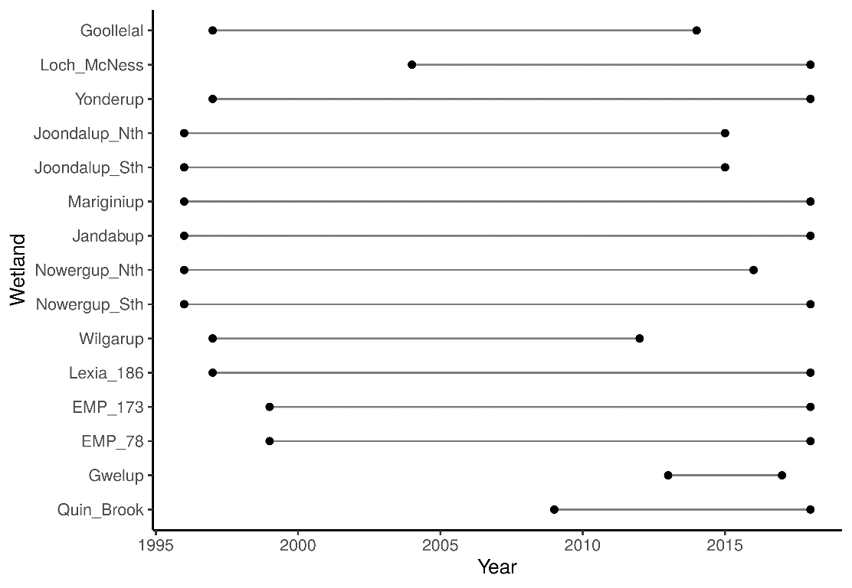

Figure 3 Period of vegetation monitoring for each wetland.

## Aquatic invertebrate monitoring

Data for aquatic macroinvertebrate communities have been compiled during the Gnangara Mound Environmental Monitoring Programme - Macroinvertebrate and Water Quality Wetland Monitoring since 1996 (see Judd and Horwitz (2019) for latest report and comprehensive methodology). The wetlands included in this report where macroinvertebrate data has been collected include Lake Jandabup, Lake Mariginiup, Loch McNess, Lake Nowergup, Lake Yonderup, Lake Goollelal, Lake Joondalup and Melaleuca Park 173. All these wetlands are either permanently or ephemerally inundated.

For each wetland, a series of habitat types are sampled using 250 $μ$ m mesh nets and identified under a microscope to family levels. An abundance score for each taxon is recorded (rare = 1-2 specimens, scarce = 3-10 specimens, common = 11-100 specimens, abundant = 100-1000 specimens and extremely abundant = > 1000 specimens). Sampled habitats are subject to availability, therefore not all habitats can be sampled each year for each wetland. Sampling occurs when spring high water levels are reached for each wetland each year to ensure maximum availability of habitats and potential diversity of macroinvertebrates. For the purposes of this report, sampled habitats for each wetland have been pooled for each year. Nonetheless, the disappearance of habitats when surface water levels are not high enough to make them available, or if habitats disappear due to loss of fringing vegetation, needs to be considered when considering the role of groundwater level on the aquatic ecology of these wetlands.

## Water quality monitoring

For selected wetlands, *in-situ* measurements of water chemistry at each site/location were undertaken for pH, conductivity (EC), temperature and dissolved oxygen concentration (DO). For each wetland, one sample for further analysis was usually pooled from the three most representative surface water habitats, for analysis of:

• Nitrates & Nitrites (NOx), Ammonia as N (NH4+) Total Kjeldahl Nitrogen (TKN),

• Orthophosphate (PO42-), Total Phosphorus (TP),

• Sulphate (SO42-), Chloride (Cl-)

• Iron (Fe), Aluminium (Al), Sulphur (S),

• Calcium (Ca2+), Potassium (K+), Magnesium (Mg2+), Sodium (Na+)

• Acidity, Alkalinity

• Chlorophyll-a, Turbidity

Patterns in these data were drawn from the most recent report and described qualitatively and extrapolated according to projected water regimes where applicable.

## Statistical analyses

Generalised additive models (GAMs) were used to model non-linear trends in water level time series data (Wood, 2011). Historical water level data for each of the wetlands in this report was accessed from the DWER website (<http://www.water.wa.gov.au/maps-and-data/monitoring/water-information-reporting>). To simplify modelling, mean monthly water levels were calculated and used for modelling. A cyclic cubic spline with 12 dimensions was used as a smooth term to ensure there was no discontinuity between January and December water levels. To account for correlated errors, an ARMA process, nested within each year, was fitted to the residuals using the R package *nlme* v 3.1-141 (Pinheiro et al., 2019). All GAMs were fitted using the R package *mgcv* v 1.8-30 (Wood, 2019). During periods when the staff gauge measuring surface water levels has been dry, the minimum reading of the staff gauge has been used in the modelling. These results need to be treated with caution as water level declines will be underestimated by our model.

A multivariate analysis was used to explore the effects of ground/surface water level on vegetation communities. This fits a multivariate generalised linear model to the data so that the effects of species covariates (including groundwater level) on each species can be modeled (Hui, 2016). Species abundances (vegetation and macroinvertebrates) were fitted to negative binomial distributions and the models fitted with two latent variables. The models were fitted and unconstrained model-based ordinations were carried out on the macroinvertebrate and vegetation data using the *boral* package v 1.7 (Hui, 2018). The resulting ordinations enable graphical representations of communities for each wetland to be made, with points closer to each other more similar in terms of taxonomic composition than those more distant. Wetland specific boral models were run using the mean fitted water level for each survey year as a covariate in order to understand species specific interactions with water levels. All analyses were conducted using R (version 3.6.1)

# Tasks 1-3: Assessment of 2030 proposed minimum thresholds

This section provides an assessment for each wetland on what effect the proposed 2030 absolute minimum threshold water levels will have on the original site management objectives and values as well as possible effects on species composition, key, priority or threatened species and existing ecohydrological states. A brief summary is provided in Table 2 that provides a summary of the findings for each wetland. For each wetland, a description of past hydrological patterns is provided with an emphasis on understanding periods of changing hydrological regimes. A summary table is provided for each wetland detailing the ecological consequences of the proposed changes on the site management objectives and values. These summaries are based on a thorough analysis of aquatic macroinvertebrate and wetland vegetation data from systematic annual surveys, when available. The results of these analyses are provided in Appendix 2, detailing specific patterns of change and predicted future effects for water quality, aquatic macroinvertebrates and vegetation.

Table 2 Summary of ecological consequences of revised thresholds in terms of compliance of stated site values and site management objectives at wetlands on Gnangara Groundwater System.

|  |  |  |  |
| --- | --- | --- | --- |
| Wetland | Current Threshold (mAHD) | Proposed Threshold (mAHD) | Ecological consequences |
| Lake Goollelal | 26.0 | 26.4 | The lake will remain permanently inundated at similar levels as present. As long as water quality does not deteriorate from other causes, fringing vegetation will persist and provide habitat for the current diversity of aquatic invertebrates, and the site will continue acting as a drought refuge for water birds and provide important habitat to important native fish species. |
| Loch McNess | 6.95 | 6.20 | Declines in groundwater have caused major shifts in vegetation and aquatic invertebrate communities. In particular, the unique assemblage of macroinvertebrates present within the lake has been partly replaced by more common taxa and nuisance species. Declining water levels have also caused the disappearance of *B. articulata*, an important fringing macrophyte. Declining water levels have also caused significant increases in nutrient levels and sustained low water levels are likely to have serious consequences for an important population of Rakali. Under the revised abstraction plans, threshold levels will rise beyond current water levels but not sufficiently to reverse these ecological shifts where characteristic features and ecological processes of the system are unlikely to return. |
| Lake Yonderup | 5.9 | 5.7 | The once stable hydrological regime is not likely to return to this wetland if the wetland remains non-compliant with the current ministerial threshold. Nonetheless, the aquatic macroinvertebrate community has remained relatively stable in composition, a feature likely to persist if further declines do not occur. Further declines in water level before 2030 may cause significant changes in water quality, especially nitrogen levels, which may impact aquatic invertebrate communities before the revised thresholds are applicable. Higher water levels than current (approximate minimum levels of 5.5 mAHD) may have beneficial effects for surrounding *Banksia* woodland and fringing vegetation. |
| Lake Joondalup | 15.8 | 16.2 | The proposed thresholds will see water levels maintained at levels higher than current levels. This will have a positive impact for fringing sedge vegetation and fish and bird habitat. There is the possibility that terrestrial vegetation occurring at higher elevations in the basin, may be squeezed as further migration up-slope become hampered by surrounding urbanisation. Nutrient enrichment remains an issue for the lake and further increases in nutrient levels may cause a shift in ecological processes and change the character of the lake. |
| Lake Mariginiup | 41.5 | 42.1 | The predicted increases in water levels may be sufficient to halt acidification of the lake. It is possible to restore the water quality of the lake, but this requires the sediments to have sufficient capacity to buffer the acidification once re-wetted. Nonetheless, if acidification cannot be reversed, the current assemblage of macro-invertebrates is likely to persist. The proposed changes to groundwater levels will enhance the extent of habitat available to wading birds and, over a period of decades, restore *E. rudis* woodland. Given the decline in water level and the acidification that has occurred, it is likely that the native fish *P. olorum* is locally extinct from the lake and it will not return unless water quality is restored and it is somehow able to migrate back to the lake. It is predicted that fringing vegetation will undergo distributional changes as surface water levels increase. Rate of inundation will need to be low enough to ensure fringing vegetation can migrate upslope. |
| Lake Jandabup | 44.3 | 44.3 | Acidification is currently causing a decrease in richness of the aquatic macroinvertebrate communities, and the proposed changes in water level are not likely to affect this process. Otherwise, the predicted increases in surface water levels will have a beneficial effect on native vegetation, sedges and wader bird habitat. Elevated nutrient levels may continue to remain a concern. |
| Lake Nowergup | 16.8 | 16.0 | Maintaining water levels above 16.0 mAHD represents a lowering of water level criterion, but an elevation above existing water levels. The latter will contribute to the on-going ecological decline of this wetland. Areas of wetland vegetation are likely to become terrestrialised, while the extent of existing sedge vegetation is going to be greatly reduced. It is possible that *B. juncea* will become the dominant sedge at this wetland. The capacity of this wetland to act as a drought refuge for birds will be diminished and habitat for native fish species will be at increased risk of disappearance. |
| Lake Wilgarup | 4.5 | 3.9 | Lake Wilgarup, as a wetland, has been severely compromised by a combination of declining groundwater levels and fire. The site no longer resembles a wetland and is dominated by terrestrial woodland vegetation. The proposed changes to groundwater level are unlikely to prevent further terrestrialisation of this site. |
| Pipidinny Swamp | 1.6 | 1.1 | Aquatic macroinvertebrate communities have been seriously compromised at Pipidinny Swamp due to falling water levels. Although the proposed changes to abstraction may cause water levels to be managed at levels higher than currently exists, this state will be much lower than pre-2000 levels. The proposed changes to abstraction are unlikely restore the aquatic macroinvertebrate communities to what was once typical of the swamp, and exotic plants will remain a feature of the vegetation community. Nonetheless, fringing vegetation is likely to persist and continue to provide habitat for aquatic fauna. It is unlikely that the site will provide habitat for the abundant bird populations that visited and resided at the swamp prior to 2000. |
| Lexia 186 | 47.2 | 46.5 | A significant shift in hydrological regime has occurred at Lexia 186. The site has been transformed from a seasonally waterlogged dampland to a system where saturation of surface sediments no longer occurs. The site has retained the high richness of native species and is still an important habitat for fauna. The proposed changes to the threshold are likely to maintain the system at a state that currently exists. |
| Melaleuca Park 173 | 50.2 | 48.5 | The proposed threshold will see the wetland managed in a state similar to what currently exists. The wetland has shifted from a permanently inundated wetland to a seasonally inundated dampland, hence there have been shifts in vegetation and aquatic fauna. The site no longer provides habitat to fish species, an important value of the wetland. Fringing vegetation is likely to continue shifting in composition as key wetland species are lost and more terrestrial species migrate down-slope. Aquatic fauna is likely to persist with much less diversity as available habitats are diminished and change. |
| Melaleuca Park 78 | 65.1 | 64.7 | Despite the dramatic declines in groundwater, the site still retains a high richness of native vegetation species. Some wetland species have disappeared, notably *B. articulata*, however, it is predicted that many key wetland species will remain at the site despite the predicted declines in groundwater levels under the planned abstraction changes. The proposed threshold will retain many of the values that currently exist at the site. |
| MM59B - Whiteman Park East | 36.3 | 36.2 | No long-term vegetation monitoring exists at this site. Current vegetation is impacted by predation from rabbits and despite the declining groundwater levels, the vegetation appears in good health. The proposed threshold will require water levels to be substantially higher than current levels, suggesting the health of the woodland will persist. Woodland health will be maintained by groundwater levels remaining above 5 m below the surface. |
| PM9 - Pinjar North | 56.3 |  | The declines projected to occur in groundwater at this site will make it impossible for wetland species to occur. The projected changes suggest water levels will decline to more than 10 m below the surface. The understory is likely to be dominated by dryland species (such as *Acacia*). *Banksia* woodlands may persist, but it is unlikely they will be dependent on groundwater and will need access to rainfall to meet their requirements. No vegetation data has been considered in this determination. |
| WM1 - Pinjar | 55.7 | 53.7 | Water levels will decline to more than 6 m below the surface, suggesting that this site will no longer be dependent on groundwater. It is likely that changes in vegetation have occurred as the site is currently dominated by a dryland understory. Remaining *Banksia* individuals appear in good health and may be meeting their water requirements from rainfall. |
| WM2 - Melaleuca Park North | 66.5 | 64.7 | Water levels will decline to more than 7 m below the surface, suggesting that this site will no longer be dependent on groundwater. It is likely that changes in vegetation have occurred as the site is currently dominated by a dryland understory. Remaining *Banksia* individuals appear in good health and may be meeting their water requirements from rainfall. |
| WM8 - Melaleuca Park | 64.8 | 63.7 | Water levels will decline to more than 7 m below the surface, suggesting that this site will no longer be dependent on groundwater. It is likely that changes in vegetation have occurred as the site is currently dominated by a dryland understory. Remaining *Banksia* individuals appear in good health and may be meeting their water requirements from rainfall. |

## 

## Lake Goollelal

Lake Goollelal, located within the Yellagonga Regional Park, is recognised as an important water bird habitat and drought refuge (Froend, et al., 2004a) as well as habitat for the Swan River Goby (*Pseudogobius olorum*) and the Western Pygmy Perch (*Edelia vittata*; Water Authority of Western Australia (1995)). The permanent deep waters found in the lake not only provide significant habitat for fauna and fringing vegetation, but also hold significant value as a place of public enjoyment. The lake is surrounded by a highly urbanised area, with much of the lake buffered by a belt of fringing vegetation, although some residences are near the lake’s margin.

### Current hydrological regime

Surface water levels recorded at Lake Goollelal reveal peak levels generally occur between September and November and lowest water levels between March and May (Table 3). Annually, water levels have consistently varied by about 0.7 m during this period. Since 1995, there has been a general trend of decreasing surface water levels, although recent increases since 2016 show surface water at a similar depth to 1990 levels (Figure 4). Surface water levels show similar trends to groundwater levels at a nearby bore (61611870) as the lake is largely fed by groundwater. Although the preferred minimum threshold of 26.0 mAHD has not been breached, it is likely the threshold is set too low as acidification of waters in the lake is a concern (Quintero Vasquez and Lund, 2018). Proposed changes to the Ministerial Criteria include adopting a higher threshold level of 26.4 mAHD. Based on the modelling, the proposed threshold can be met at 2030.

Table 3 Five year summaries of surface water level data at Lake Goollelal recorded at staff 6162517.

|  |  |  |  |  |
| --- | --- | --- | --- | --- |
| Period | Mean max seasonal  level (mAHD) | Mean min seasonal level (mAHD) | Mean seasonal change (m) | Mean max to min (days) |
| 08/1994 – 07/1999 | 27.5 (Oct) | 26.8 (May) | 0.78 | 207 |
| 08/1999 – 07/2004 | 27.5 (Sept) | 26.7 (Mar) | 0.80 | 206 |
| 08/2004 – 07/2009 | 27.4 (Sept) | 26.6 (Apr) | 0.75 | 137 |
| 08/2009 – 07/2014 | 27.2 (Oct) | 26.5 (Apr) | 0.73 | 190 |
| 08/2014 – 07/2019 | 27.4 (Nov) | 26.7 (Apr) | 0.68 | 139 |

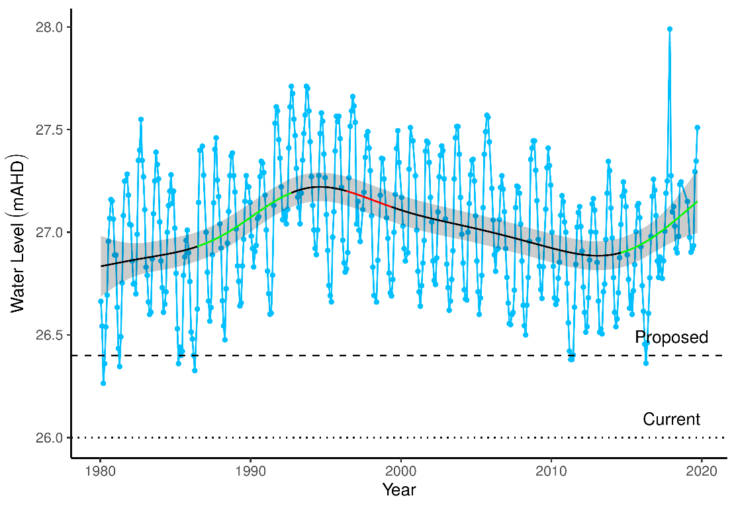

Figure 4 Surface water levels recorded at staff 6162517 for Lake Goollelal. Red segments on fitted line represent statistically significant periods of declining water levels and green segments represent statistically significant periods of increasing water levels. Dotted line is the current ministerial absolute minimum water levels. Dashed line is the proposed 2030 minimum threshold level. The shaded area around trend line represents the 95% confidence interval.

### Implications of revised threshold

Groundwater modelling of the proposed reductions in groundwater abstraction project that the current hydrological regime of Lake Goollelal can be maintained. Adopting a minimum threshold of 26.4 mAHD (0.4 m higher than current threshold) will minimise the risk of acidification at Lake Goollelal. Under the 2030 scenario, vegetation composition is likely to remain distinct across the elevations of the basin, with *B. articulata* and *Lepidosperma gladiatum* persisting along the lake margin. The richness of exotic plant species in the higher areas of the basin are likely to persist or decline if surface water levels remain at, or greater than, present levels. It is therefore likely that the predicted higher post-2030 water levels due to reduced abstraction will have a positive impact on the vegetation structure of the lake. Similarly, it is expected that the aquatic invertebrate community will remain stable as fringing vegetation preserves habitat availability and water quality. The continuation of higher than present water levels, combined with low nutrient concentrations, will facilitate the return of aquatic invertebrate assemblages to pre-2007 compositions. Unpublished research suggests that nuisance midges will not proliferate under conditions of higher water levels and decreased periods of exposure of nutrient rich sediments to shallow water.

Revised thresholds will likely maintain ecological conditions similar to the present (Table 4). The most important impact of the revised thresholds is that it will ensure water levels remain at, or higher than, present levels which has positive implications for habitat availability and risk of acidification. Maintaining permanent water will ensure that Lake Goollelal acts as a drought refuge for water birds, with seasonal fluctuations in water levels ensuring feeding habitats are available for waders during the summer months. The preservation of fringing vegetation, submerged macrophytes and deep water will also ensure the wetland continues to support important native fish species (*P. olorum* and *E. vittata*), a feature becoming rarer among wetlands in the Swan Coastal Plain. Conservation of these values will maintain the site as a place for public enjoyment and maintain the current landscape amenity values.

Table 4 Ecological consequences of proposed 2030 minimum threshold (26.4 mAHD) in terms of compliance of stated site values and site management objectives at Lake Goollelal set for the current absolute minimum Ministerial criteria (26.0 mAHD). Future compliance assessments are based on current understandings of the hydrological influences on flora and fauna. They do not include future exogenous factors (like pollution events, introduction of exotic plants or animals) that might or might not occur in the future and affect these compliance estimations.

|  |  |  |
| --- | --- | --- |
|  | Likely effect of 2030 proposed threshold (26.4 mAHD) | Values and objectives maintained in future |
| **Site values (WAWA, 1995)** |  |  |
| Water bird habitat and drought refuge | Permanent water will ensure site as drought refuge. Seasonal variation in water levels will preserve feeding habitats | Likely |
| Supports good populations of native fish species, Swan River goby (*Pseudogobius olorum*) and the western pygmy perch (*Edelia vittata*) | Maintenance of deep waters, fringing vegetation, submerged macrophytes and water quality will ensure the wetland remains an important habitat for these fish species | Likely |
| **Site management objectives (WAWA, 1995)** |  |  |
| Conservation and public enjoyment of natural and modified landscapes | Fringing vegetation and woodlands will remain healthy and the site will continue to provide habitat for fauna. The site will continue to remain a place of public enjoyment. | Likely |
| Protect and, if possible, enhance fringing wetland vegetation including woodland and sedge vegetation | Maintenance of surface water levels at, or slightly higher than, current levels will ensure that woodland and sedge vegetation remain healthy. The distribution of sedges may increase slightly. | Likely |
| Maintain permanent, deep water for water bird habitat and as a drought refuge | Current projections ensure that permanent and deep water will remain a feature of the wetland. The capacity of the wetland to act as a drought refuge will continue. | Likely |
| Maintain permanent water for fish and other dependent species | Current projections ensure that permanent and deep water will remain a feature of the wetland. Permanent water will preserve fish habitat and water quality. | Likely |
| Maintain the landscape amenity values of the wetland | Healthy vegetation and abundant bird life will remain a feature of the wetland if water levels are sustained at current levels, ensuring the amenity values of the wetland. | Likely |
| **Proposed site management objectives** |  |  |
| Maintain permanent surface water for fauna habitat and visual amenity | The proposed changes to abstraction will ensure permanent surface water at the site which will continue to provide faunal habitat and protect the visual amenity of the lake. | Likely |
| Maintain fringing vegetation | Permanent inundation of this site will ensure that fringing vegetation will continue to occupy available habitat at the site. | Likely |
| Minimise risk of acidification and nuisance midge proliferation | The projected changes to groundwater levels will reduce the risk of acidification by ensuring sediments remain wet. Unpublished research suggests that nuisance midges will not proliferate under conditions of higher water levels and decreased periods of shallow water over sediments. | Likely |

### 

## Loch McNess

Loch McNess, located in Yanchep National Park, is a relatively undisturbed wetland with large areas of intact Herdsman Complex vegetation. The lake was regarded as having relatively good water quality, having provided an important habitat for water birds and other aquatic fauna (Froend, et al., 2004a). Permanent water is required to support a local Rakali (*Hydromys chrysogaster*) population as well as both resident and visiting populations of waterbirds and waders. The southern lake at Loch McNess is one of the few wetlands known to contain the nightfish *Bostockia porosa*, and has one of the richest aquatic macroinvertebrate communities, of the Swan Coastal Plain (Horwitz et al. 2009). Loch McNess has previously been a wetland of high conservation value because of its intact vegetation, largely unaltered aquatic processes and important populations of fauna (Froend, et al., 2004a). Dramatic declines in surface water levels since 2007 have likely effected the conservation values of this wetland.

### Hydrology

Surface water levels were remarkably stable before 2003 at 7 mAHD and have declined at least 1.5 m to present levels. These declines have been mirrored in surrounding bores (Figure 5). Mean maximum and minimum seasonal water levels have declined by 0.9 m since 1994-2004 levels (Table 5). Changes in seasonal patterns are difficult to interpret due to staff gauge 6162564 being mostly dry since 2014, but during the period 2009-2014, minimum water levels were not being reached until May, compared to March in the decade 1994-2004. A recent increase in water level, as seen in surrounding wetlands during the last few seasons, has not been observed at Loch McNess. The dramatic decline in water levels is causing the terrestrialisation of the lake as much of the lakebed is now undergoing recruitment by fringing vegetation. Substantial parts of the lakebed are now covered by floating beds of rushes and sedges. Open water consists of a very shallow layer of clear water on top of very deep unconsolidated sediments.

The lake has been non-compliant with ministerial water levels since 2003 and water levels are now approximately 1.0 m below this threshold. Modelling of groundwater levels under proposed abstraction reductions projects that there will not be sufficient increases in groundwater level to make this wetland compliant with existing thresholds. Under the new plan, a proposed threshold of 8.0 mAHD at bore 61612104 will satisfy the proposed threshold of surface waters in the lake at 6.2 mAHD (0.75 m below existing threshold). This will result in water levels being similar to 2010 levels which are more than 0.3 m higher than current levels.

Prior to 2006, water flowed through the lake from springs and the lakebed and outflowed along the western margin. Evapotranspiration from the lake and its vegetation could be sufficient to account for minor seasonal fluctuations; the increased amplitude of seasonal variations experienced in recent years mirrors more closely the fluctuations of the groundwater. Kretschmer and Kelsey (2016) suggest that spillover along the lake’s western margin into caves and a karstic aquifer previously controlled maximum water levels in the past. However, due to declining inflows associated with a sustained decline in water table depth, inflow has been reduced sufficiently below outflow levels and hence lake surface water levels have declined (Kretschmer and Kelsey 2016). An alternative hypothesis suggests that the karst barrier on the western/southern side of the lake, which has maintained constant water levels, has been breached, probably due to an event-related erosion (Muirden pers comm.).

Table 5 Five year summaries of surface water level data at Loch McNess. No data is available for the 2014-2019 period due to the staff gauge being dry.

|  |  |  |  |  |
| --- | --- | --- | --- | --- |
| Period | Mean max seasonal  level (mAHD) | Mean min seasonal  level (mAHD) | Mean seasonal change (m) | Mean max to min (days) |
| 08/1994 – 07/1999 | 7.1 (Sep) | 7.0 (Mar) | 0.11 | 123 |
| 08/1999 – 07/2004 | 7.1 (Jul) | 6.9 (Mar) | 0.12 | 91 |
| 08/2004 – 07/2009 | 7.0 (Jun) | 6.8 (Feb) | 0.21 | 131 |
| 08/2009 – 07/2014 | 6.5 (Oct) | 6.2 (May) | 0.31 | 229 |
| 08/2014 – 07/2019 | NA | NA | NA | NA |

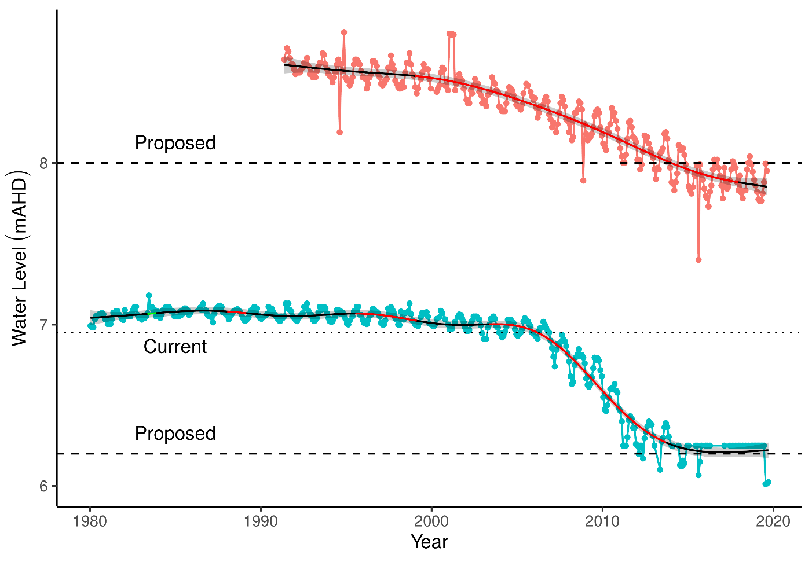

Figure 5 Ground and surface water levels recorded at bore 61612104 (red) and staff gauge 6162564 (blue) that represent changes in water levels at Loch McNess. Segments in red represent periods of significant decline in water level. Dotted line is the current ministerial threshold water level for surface waters at the staff gauge. Dashed lines are proposed ministerial thresholds for the staff gauge and bore. The shaded area around trend line represents the 95% confidence interval. Since 2015, water levels for the staff gauge have consistently been below the minimum reading of 6.25 mAHD. This model therefore underestimates the decline in surface water levels since 2015 which are likely to have continued to decline at a similar rate as before 2014. Accordingly the water levels in Loch McNess should actually be showing a continued decline in recent years, much like the bore.

### Implications of revised threshold

The unique hydrogeology of this system that once sustained stable water levels, high inflow and low nutrient levels has been compromised. Without the re-establishment of these hydrogeological drivers, the risk of eutrophication is likely to increase as the lake transitions away from a system that is well flushed from high inflow to one of shallower nutrient enriched waters. Despite representing an improvement on the current state (2018) state, managing the lake at the proposed threshold (0.75 m below the current threshold) will not reverse the deterioration of site values at Loch McNess (Table 6). The proposed threshold will ensure conditions similar to the 2011/season recorded by Kretschmer and Kelsey (2016) whereby less than one-third of the lake area was inundated with shallow, turbid water. Coverage of large areas of once inundated lakebed will continue, open water above metaphyton will become shallower, nutrient levels may stay elevated and important habitats for Rakali may be lost.

The characteristic stable water levels have been severely disrupted by a changing hydrological regime, and the proposed threshold will not manage surface water at a sufficient level to return to this state. Altered ecological processes have already caused shifts in nutrient levels and the composition of macroinvertebrate assemblages. Under the proposed changes to abstraction, it is unlikely that the macroinvertebrate community will return to compositions similar to pre-2008. Again, these features of Loch McNess are unlikely to return to normal given the proposed lowering of threshold levels.

Table 6 Ecological consequences of proposed 2030 minimum threshold (6.2 mAHD) in terms of compliance of stated site values and site management objectives at Loch McNess set for the current absolute minimum Ministerial criteria (6.95 mAHD). Future compliance assessments are based on current understandings of the hydrological influences on flora and fauna. They do not include future exogenous factors (like pollution events, introduction of exotic plants or animals) that might or might not occur in the future and affect these compliance estimations.

|  |  |  |
| --- | --- | --- |
|  | Likely effect of 2030 proposed threshold (6.2 mAHD) | Values and objectives maintained in future |
| **Site values (WAWA, 1995)** |  |  |
| Undisturbed wetland | Sustained low water levels will continue to cause a shift in vegetation composition as once inundated regions of the lake become terrestrialised or covered by floating mats. The disappearance of *B. articulata*, an important fringing sedge, marks a significant change in composition of the wetland vegetation. | Unlikely |
| Unusual hydrologic regime | Surface water levels appeared to reach a tipping point in 2003. There has been significant disruption of once stable water levels which are not projected to return to normal under reduced abstraction. | Unlikely |
| Rich aquatic fauna | Declining water levels have not changed the richness of the aquatic invertebrate assemblage. However, there has been a shift in the composition of the assemblage. Managing water levels above the minimum proposed threshold will prevent the assemblage returning to pre-2003 composition, and instead will maintain an assemblage composed of more common taxa and nuisance species. The fate of the nightfish population is currently unknown. | Disrupted |
| Vegetation largely intact, provides a range of habitat types | The health of fringing *M. rhaphiophylla* and *E. rudis* appears good, despite the lower water levels. Loss of *B. articulata* will alter fringing fauna habitat. Loss of islands in lake may affect the Rakali population. | Likely |
| Supports good populations of water birds and acts as a drought refuge | Revised threshold will sustain slightly deeper permanent water at the site compared to current levels. Permanent water is fundamental to the lake acting as a drought refuge for birds. | Likely |
| Excellent water quality | The altered hydrological regime of the lake will continue under the proposed changes to abstraction. This will prevent the lake returning to a state of high inflow that maintains low nutrient levels due to the low residence time of the water. Instead, higher than normal nutrient levels will persist, and the lake may be at risk of eutrophication. | Unlikely |
| **Site management objectives (WAWA, 1995)** |  |  |
| Maintain the environmental quality of the lake | The environmental qualities that characterized the lake will not be maintained; instead it is a reasonable supposition that they will change unless the hydrological regimes of the past are re-instated. | No |
| Maintain North Loch McNess’ pristine state | An erosion of the buffering capacity of the wetland system has been detected, probably due to drying and re-wetting regimes; even though levels maintained at above the current ones will reduce the frequency of these cycles, acidification of this wetland is possible under proposed revised thresholds. | Unlikely |
| Continue to use south Loch McNess for low key recreation | The deep unconsolidated sediments and floating mats make the wetland treacherous for any form of in-lake recreation. The use of the popular walking track around the lake will not change, however exposed sediments may make it less appealing. | Unlikely |
| Maintain east Loch McNess in a natural state, to restore, where possible, natural flow | No data. | Unknown |
| Maintain the existing hydrological regime | The loss of stable water levels (once a characteristic of the lake) has deteriorated to the point where water levels have declined more than 1.0 m and are susceptible to further declines under a drying climate despite the revised thresholds. In-lake evapotranspiration as the dominant contributor to seasonal fluctuations has been lost. | No |
| **Proposed site management objectives** |  |  |
| Increase surface area of permanent water for fauna habitat and visual amenity | Managing water levels above the proposed threshold will ensure at least 1/3 of the lake will remain inundated. These low water levels have already severely shifted ecological processes in the lake. Continuation of these low water levels will continue to impact faunal habitat, particularly for Rakali. It is possible visiting bird assemblages will shift from diving birds to waders. As permanent water will remain a feature of this wetland, fringing vegetation | Slight improvement on current conditions.  Very unlikely to return lake to previous extent/condition |
| Maintain healthy, intact fringing vegetation | There has been a marked decline in *B. articulata* at the site and it is possible that it is absent from the wetland all together now. Fringing vegetation is now dominated by *Lepidosperma gladiatum* and *E. rudis*. The projected changes in water levels will ensure permanent water at the site and maintain fringing vegetation stands, however it is unlikely *B. articulata* will reestablish. | Very likely  (continued absence of *B. articulata*) |
| Maintain diverse habitat types and excellent water quality | Maintaining water levels at 1/3 of the normal coverage will continue to negatively impact the diversity and availability of habitats. These effects have already been observed in the dramatic shift in the aquatic macroinvertebrate assemblages. It is unlikely that the previously rich consortium of habitats will return under the projected changes. Furthermore, the once excellent water quality of the site depended upon the low residence time of the water as inflow and outflow were sufficiently high to maintain high flushing rates and low nutrient levels. This process will continue to be disrupted under the projected changes and high nutrient levels will remain a concern. | Unlikely |

### 

## Lake Yonderup

Located to the south of Loch McNess and north of Lake Wilgarup in Yanchep National Park, Lake Yonderup has a high conservation value as it represents a largely undisturbed wetland with high macroinvertebrate richness and excellent water quality. The permanently filled lake is dependent on groundwater to maintain habitats and biophysical processes (Froend, et al., 2004a). Like other lakes in the region, Lake Yonderup has experienced a consistent decline in surface water levels that has affected the condition and health of fringing vegetation and aquatic processes. A fire also affected the fringing vegetation in 2004/2005 (Rogan et al., 2006). The hydrological processes sustaining water levels at Lake Yonderup have been compromised, probably from the same processes responsible for the decline in water levels at Loch McNess.

### Hydrology

There has been a continual decline in surface water levels at staff gauge 6162565 since 1994. Prior to 1994, water levels were relatively stable at 6 mAHD but have since declined to approximately 5.3 mAHD (Figure 6). Unlike many other wetlands in the Gnangara area, there has been no recent increase in surface water levels associated with the higher rainfall in 2017 and 2018. Mean maximum and minimum seasonal water levels have only declined 0.2 and 0.3 m, respectively from 1994-1999 levels (Table 7). There has been nearly a fourfold increase in seasonal water level variation and waters are generally now in decline for more than 200 days a year. The bore 61611840 is located near the vegetation transects and represents the groundwater levels in the superficial aquifer that the vegetation at the transect is utilising. There has been a similar decline in groundwater levels at this bore until 2017, although observations have only been recorded since 2008. Therefore surface water levels are used to assess changes in vegetation as surface water is likely an expression of the Superficial aquifer and will show similar trends (Froend, et al., 2004a). The current ministerial minimum threshold is 5.9 mAHD while the 2030 proposed threshold is 5.7 mAHD. The lake has been non-compliant with the current threshold since about 2004. The decline in surface waters mirrors what has been observed at Loch McNess suggesting that the same hydrological processes are occurring at Lake Yonderup and Loch McNess (see Loch McNess section for discussion). Slight increases in surface water levels are required to meet the proposed threshold.

Table 7 Five year summaries of surface water level data at Lake Yonderup

|  |  |  |  |  |
| --- | --- | --- | --- | --- |
| Period | Mean max seasonal  level (mAHD) | Mean min seasonal  level (mAHD) | Mean seasonal change (m) | Mean max to min (days) |
| 08/1994 – 07/1999 | 6.0 (Aug) | 5.9 (Sep) | 0.07 | 82 |
| 08/1999 – 07/2004 | 6.0 (Sep) | 5.9 (Feb) | 0.06 | 144 |
| 08/2004 – 07/2009 | 5.9 (Apr) | 5.9 (Apr) | 0.06 | 130 |
| 08/2009 – 07/2014 | 5.9 (Sep) | 5.7 (Apr) | 0.19 | 212 |
| 08/2014 – 07/2019 | 5.8 (Sep) | 5.6 (Mar) | 0.25 | 218 |

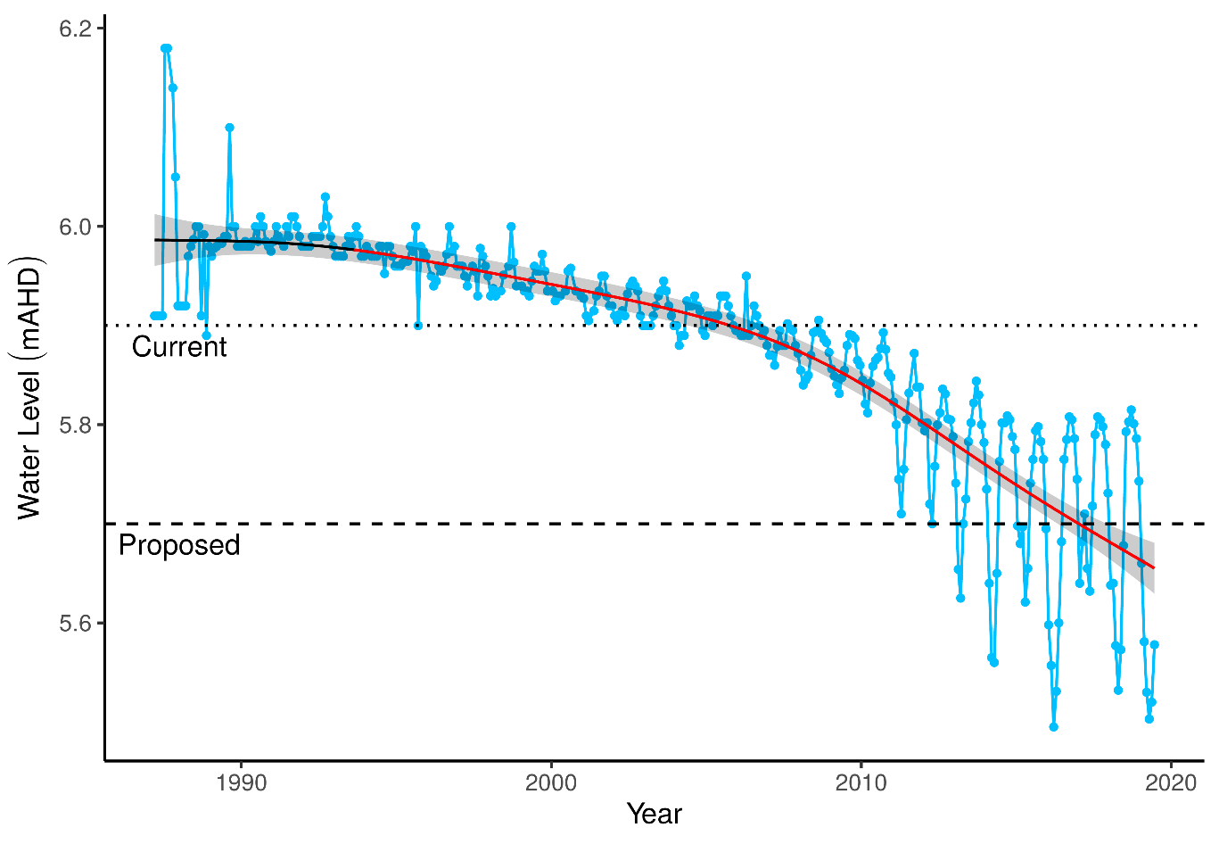

Figure 6 Surface water levels recorded at staff gauge 6162565 for Lake Yonderup. Red segments along trendline indicate periods of significant decline in groundwater levels and green segments represent significant increases in groundwater level. The shaded area around trend line represents the 95% confidence interval.

### Implications of revised threshold

Managing the lake at the proposed 2030 thresholds may alleviate some of the effects of declining surface waters at Lake Yonderup (Table 8). Like Loch McNess, the remarkably stable surface water levels were a feature of this wetland and have now been compromised by declining water levels and increased seasonal variation (Table 7). There are indications that water quality has begun to shift because of the declining water levels. Nonetheless, under the projected 2030 water levels, it is unlikely the lake will be at risk of acidification given that water levels are projected to be higher than current. The projected higher water levels may also have a positive impact on the nutrient status of the lake and may reverse the current trend of increasing nitrogen in the water.

The projected water levels may also improve the cover abundances of many native plant species; however, it is unknown whether the proposed increases in surface water are sufficient to achieve this. For instance, many natives, including *Banksia attenuatta* and *Melaleuca preissiana*, are predicted here to decline further in cover abundance. In fact, *B. attenuatta* and *M. preissiana* have already disappeared from the monitoring transect, while stands of *Melaleuca rhaphiophylla* are unhealthy. The proposed threshold will maintain these key species in a state of stress as they will have to continue surviving towards the maximum depth-to-water levels they can tolerate. As no vegetation transects exist at the lake’s margin, it can only be speculated that without any effort to reduce the seasonal variation in surface water levels to the small fluctuations characteristic of the lake before 2004, fringing vegetation will be dominated by sedges capable of surviving periods without surface water.

The projected 2030 water levels will ensure macroinvertebrate habitat persists and may halt the decline in family richness currently being observed. Although, the increased variability in water levels may change the nature of habitats available to aquatic macroinvertebrates and therefore a shift in assemblage composition may occur. On the other hand, habitat currently unavailable due to low water levels may become available again and restore some of the recently lost diversity.

Table 8 Ecological consequences of proposed 2030 minimum threshold (5.7 mAHD) in terms of compliance of stated site values and site management objectives at Lake Yonderup set for the current absolute minimum Ministerial criteria (5.9 mAHD). Future compliance assessments are based on current understandings of the hydrological influences on flora and fauna. They do not include future exogenous factors (like pollution events, introduction of exotic plants or animals) that might or might not occur in the future and affect these compliance estimations.

|  |  |  |
| --- | --- | --- |
|  | Likely effect of 2030 proposed minimum threshold (5.7 mAHD) | Values and objectives maintained in future |
| **Site values (WAWA, 1995)** |  |  |
| High ecological values due to undisturbed nature | Terrestrial regions of the site are currently dominated by exotic vegetation, with concerning declines in key native species. Further declines will exacerbate the decline of native vegetation. Native species may become more abundant post 2030 when higher water levels are achieved. Continuation of stable water quality and low nutrient state are likely to maintain the current composition of aquatic macroinvertebrates. The proposed thresholds increase the likelihood of maintaining this distinctive community. The stable hydrological regime is unlikely to return. | Likely |
| Rich invertebrate fauna | Higher than present surface waters, combined with maintenance of water quality conditions are likely to have a positive impact on aquatic macroinvertebrate assemblages. There has not been an observed dramatic shift in the assemblage structure in spring monitoring since 1996. | Likely |
| Excellent water quality | Sustaining surface waters greater than current levels will mean the risk of acidification will remain low. There are indications that nutrient levels may be on the rise and any further declines in water level before 2030 may cause shifts in the ecosystem functioning of the lake. | Likely - dependent on no further declines in water levels before 2030 |
| Undisturbed hydrologic regime and lack of seasonal variation | Seasonal variation has increased with declining water levels. This value can only be maintained if the hydrological controls in the wetland are re-instated as for Loch McNess. | Unlikely |
| *Banksia* woodland <8m depth to groundwater | There are currently few mature *B. littoralis* at the site and only a few, albeit healthy, seedlings in the transect. Mature woodland was destroyed by bushfire in 2004/05 and has not since recovered. Achieving water levels higher than current levels will facilitate recruitment and recovery. | Possible - dependent on future bushfire impacts |
| **Site management objectives (WAWA, 1995)** |  |  |
| Maintain the environmental quality of the lake | Many exotic vegetation species are likely to persist, particularly if water levels decline further before abstraction is reduced prior to 2030. If nutrient levels remain low, it is likely that the current aquatic invertebrate assemblage will persist. | Likely |
| Maintain the existing hydrological regime | The hydrological regime has been disrupted since the 2003 declines in surface water levels. In particular, the lack of seasonal variation was a key feature of this wetland that is unlikely to return. | Unlikely |
| **Proposed site management objectives** |  |  |
| Increase surface area of permanent water for fauna habitat | Although the projected changes are an improvement on the current hydrological state of the lake, they are not sufficient to return to the lake to pre-1990 levels before water levels declined markedly. Managing the lake at the proposed thresholds will ensure permanent water and habitat for aquatic fauna, albeit at a lesser extent to what was once characteristic of the wetland. | Likely |
| Maintain intact, undisturbed fringing vegetation | There has been a marked decline in *Baumea juncea* and *Lepidosperma gladiatum* which has altered the composition of fringing vegetation. The projected increases in water levels are unlikely to restore this aspect of the vegetation (at least at the monitoring transect). This is particularly true for *M. rhaphiophylla* which will continue to experience water levels approaching the maximum depths that are tolerable for that species. The northern region of the lake is still relatively undisturbed (Buller *et al.* 2019) and the projected changes of water levels may ensure that fringing vegetation remains intact. | Likely – at least for the northern region |
| Maintain diverse habitat types and excellent water quality | There is evidence that the lower than normal water levels, probably caused by reduced inflow, are causing nutrient levels in the wetland to increase. Under the projected changes to the water level of these ponds, it is unlikely that nutrient levels will return to normal. Elevated levels of nutrients will cause significant shifts in ecological processes and shift the composition of aquatic faunal communities. Aquatic macroinvertebrate richness is already declining due to low water levels. | Unlikely |

### 

## Lake Joondalup

At 611.5 ha, Lake Joondalup is the largest monitored wetland and is managed by the Department of Biodiversity, Conservation and Attractions. The lake is an important habitat and drought refuge for water birds, and in conjunction with Lake Goollelal, is managed to support the full range of avian habitats (Water Authority of Western Australia, 1995). Other management objectives include the conservation of diverse wetland vegetation communities, including sedge beds, fringing woodlands and aquatic macrophytes, and the maintenance or enhancement of aquatic fauna in the lake. Lake Joondalup supports an important population of Pygmy Perch (*Edelia vittata*) and Swan River Goby (*Pseudogobius olorum*) and the fringing woodlands and bushland support a variety of significant mammal species.

### Hydrology

Lake Joondalup has remained permanently inundated at the staff gauge since 1986 (Horwitz et al., 2009). However, vast regions of the basin dry most summers and provide habitat for visiting water birds. Recent monitoring of surface water levels at the staff gauge 6162572 remained relatively stable from 2002 but have been increasing from 16.4 mAHD to approximately 17.2 mAHD in 2019 (**Error! Reference source not found.**). Five-year summaries of hydrological regimes at Lake Joondalup also reveal the higher mean minimum and maximum surface water levels in the latest period compared to earlier periods, as well as an increase in the number of days to reach seasonal minimum water levels (**Error! Reference source not found.**). Historically, groundwater levels at monitoring bore 61610661 declined significantly by 1.2 m from 1970 to 2002. Currently, groundwater levels at this bore, as well as bore 61611423 (likely to better reflect lake surface water variation), have been increasing since 2015 to levels similar to the early 1990s.

Table 9 Five year summaries of surface water level data at Lake Joondalup

|  |  |  |  |  |
| --- | --- | --- | --- | --- |
| Period | Mean max seasonal  level (mAHD) | Mean min seasonal  level (mAHD) | Mean seasonal change (m) | Mean max to min (days) |
| 08/1994 – 07/1999 | 17.2 (Sep) | 16.2 (Apr) | 0.96 | 213 |
| 08/1999 – 07/2004 | 17.0 (Oct) | 16.1 (Apr) | 0.92 | 179 |
| 08/2004 – 07/2009 | 16.9 (Oct) | 16.1 (Apr) | 0.79 | 181 |
| 08/2009 – 07/2014 | 16.9 (Oct) | 16.1 (Mar) | 0.82 | 173 |
| 08/2014 – 07/2019 | 17.2 (Oct) | 16.5 (Apr) | 0.68 | 206 |

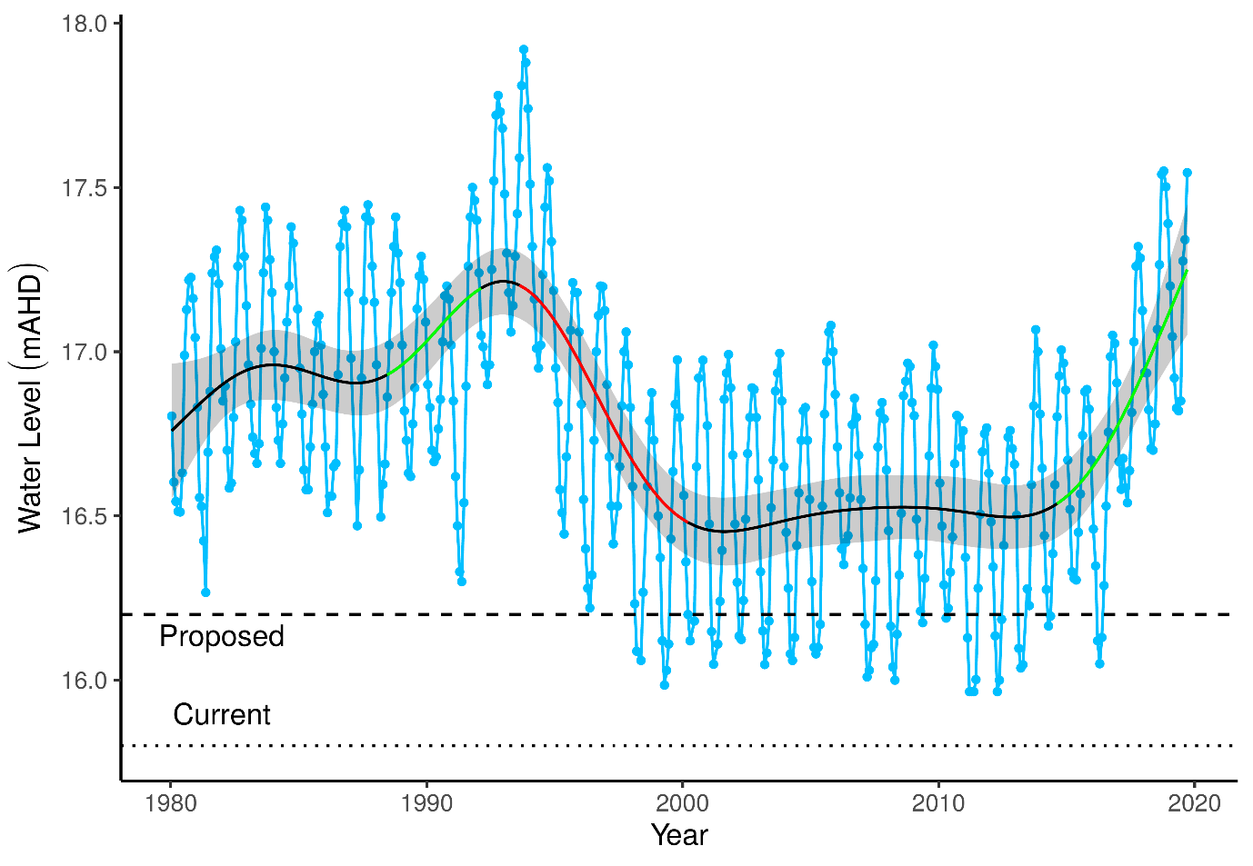

Figure 7 Surface water levels recorded at staff gauge 6162572 for Lake Joondalup. Red segments along trendline indicate periods of significant decline in groundwater levels and green segments represent significant increases in groundwater level. The shaded area around trend line represents the 95% confidence interval.

### Implications of revised threshold

The water levels in the vicinity of Lake Joondalup are expected to increase up to 2.1 m by 2030 from 2013 levels largely due to land use change and associated changes in groundwater use in East Wanneroo. This increase in water level will continue the rising trend being observed in the lake’s surface water levels since 2015. Maintaining surface water levels above 16.2 mAHD at staff 6162572 will ensure permanent water habitat for fauna and flora and the visual amenity of the area (Table 10). The diverse macrophytes inhabiting the lower elevations of the basin are likely to persist and continue to provide a rich habitat for aquatic invertebrates. Although important native macrophytes and wetland species are likely to continue at relatively high cover abundances under the future scenario, there are some native species that are likely to decrease in cover abundance or disappear. This group mainly includes *Acacia* and *Banksia* species which provide important habitat for fauna up-slope of the lake. Further vegetation monitoring is required at these transects to determine vegetation compositional changes since 2015 to understand if the trajectory in compositional change is continuing.

Table 10 Ecological consequences of proposed 2030 minimum threshold (16.2 mAHD) in terms of compliance of stated site values and site management objectives at Lake Joondalup set for the current absolute minimum Ministerial criteria (15.8 mAHD). Assessments of whether the values and objectives will be met under the revised thresholds are based on current understandings of the hydrological influences on flora and fauna. They do not include future exogenous factors (like pollution events, introduction of exotic plants or animals) that might or might not occur in the future and affect these compliance estimations.

|  |  |  |
| --- | --- | --- |
|  | Likely effect of 2030 proposed minimum threshold (16.2 mAHD) | Values and objectives maintained in future |
| **Site values (WAWA, 1995)** |  |  |
| Water bird habitat and drought refuge | The proposed increases in groundwater levels around the lake will ensure the site remains an important water bird habitat. The proposed increases will also ensure the lake is permanently inundated, which will ensure the lake is a drought refuge for water birds. Seasonal variation in surface water height will also ensure expansive mudflats, an important feeding habitat for many visiting birds, remain. | Very likely |
| Diverse range of macrophytes | The current diversity of macrophytes, including *B. articulata*, *B. juncea* and *L. longitudinale*, will continue. There is the possibility of these species extending into current terrestrial regions of the lake. | Very likely |
| **Site management objectives (WAWA, 1995)** |  |  |
| Conservation and public enjoyment of natural and modified landscapes | The wetland should retain the current natural and modified assets. | Very likely |
| Conserve existing wetland vegetation, including sedge beds, fringing woodland and aquatic macrophytes | The predicted increases in groundwater levels will ensure the current wetland at a state similar to 2015. It is possible that sustained increases in groundwater levels will extend the range of these species around the lake by ‘migrating’ up slope. | Very likely |
| Maintain and if possible, enhance the aquatic fauna of the lake | Aquatic vertebrates, including native fish, are likely to persist in the lake, given that permanent inundation will remain a feature of the lake. Although acidification is unlikely, there are issues around water quality and nutrient enrichment. If nutrients continue to rise, local extinctions of fish populations may occur. There are already unusual trends in macroinvertebrate diversity occurring which may be early warnings of significant ecological shifts that may occur due to nutrient enrichment |  |
| In conjunction with Lake Goollelal, to support the full range of habitats for avian fauna | The maintenance of permanent surface water and wetland vegetation will continue to provide a diverse habitat for different avian species. Extensive mudflats should continue to form during periods of low water level, which are also an important feeding habitat for birds. | Very likely |
| Ensure the landscape and amenity values of the lake are maintained, except under very low rainfall climatic conditions | The most significant threat to these values is likely to be changes to the water quality. High water levels combined with high temperatures could trigger algal blooms not yet seen at the wetland. Macroinvertebrate assemblages are also changing and a reduction of aquatic insect families in spring sampling suggests an as yet undiagnosed water quality problem. | Unsure |
| **Proposed site management objectives** |  |  |
| Maintain permanent water for fauna habitat and for visual amenity | The projected changes in water levels at Lake Joondalup will ensure permanent water in the basin, protect a diverse array of habitats for aquatic fauna and maintain the visual amenity of the site. | Likely |
| Maintain diverse aquatic plants and fringing vegetation | It is predicted that the high diversity of aquatic plants and fringing vegetation will persist at the site under the projected changes to water levels. It is likely that the cover abundance of *B. articulata* will remain at the current levels, or even increase, given the projected increases in surface water levels | Likely |
| Minimise risk of acidification | The projected higher water levels will further reduce the risk of acidification. | Likely |

### 

## Lake Mariginiup

Lake Mariginiup has a high conservation value as a groundwater dependent wetland (Froend, et al., 2004a). There are several wader birds present at the lake that require the shallow water during the summer for feeding, however, high water levels are required in winter to prevent vegetation encroachment into these habitats. The dramatic decline in surface and groundwater has likely diminished this important component of the system. Sediment processes have been altered as sediments dry and crack and water quality deteriorates due to acidification (Judd and Horwitz, 2019).

### Hydrology

Since 1997, Lake Mariginiup has frequently dried or been dry at the staff gauge 6162577 during the summer. Interpretations of seasonal patterns therefore need to be made with caution and perhaps it is more reliable to use groundwater levels at the nearby bore 616100685 as a proxy (Figure 8). Nonetheless, mean season maximum water levels have declined from 42.0 m to 41.4 m since the 1994-1999 period (Table 11). Maximum water levels usually occur in September/October. There has been a recent increase in groundwater level since 2015 which has caused maximum spring surface levels to increase. Proposed changes in 2030 abstraction are projected to increase surface water levels by 3.9 m and meet a threshold level of 42.1 mAHD. This will increase surface waters to levels higher than has been recorded during the monitoring program.

Table 11 Five year summaries of surface water level data at Lake Mariginiup. Minimum water levels should be treated with caution as the staff gauge 6162577 has frequently been dry since 2000.

|  |  |  |  |  |
| --- | --- | --- | --- | --- |
| Period | Mean max seasonal  level (mAHD) | Mean min seasonal  level (mAHD) | Mean seasonal change (m) | Mean max to min (days) |
| 08/1994 – 07/1999 | 42.0 (Sep) | 41.2 (Sep) | 0.81 | 176 |
| 08/1999 – 07/2004 | 41.8 (Oct) | NA | NA | NA |
| 08/2004 – 07/2009 | 42.5 (Sep) | NA | NA | NA |
| 08/2009 – 07/2014 | 41.3 (Oct) | NA | NA | NA |
| 08/2014 – 07/2019 | 41.4 (Sep) | NA | NA | NA |

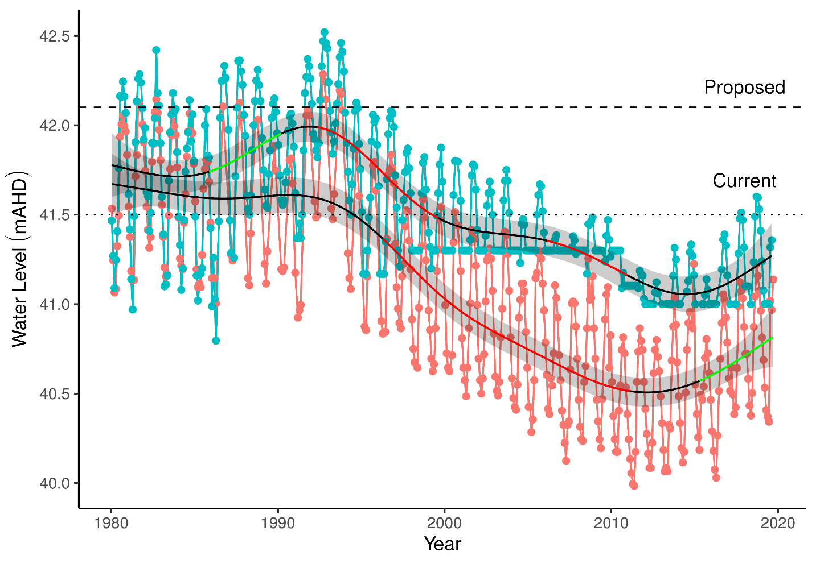

Figure 8 Ground and surface water levels recorded at bore 61610685 (red) and staff gauge 6162577 (blue) that represent changes in water levels at Lake Mariginiup. The shaded area around trend line represents the 95% confidence interval.

### Implications of revised threshold

As a result of land use change and reductions in local abstraction, water levels are expected to rise beyond 2030. Adopting a preferred minimum peak threshold of 42.1 mAHD will require water levels to rise considerably higher than what has been recorded since 1980 in order to be compliant. Thus, it is difficult to predict the ecological consequences as the lake has never been monitored at those levels (Table 12). It is unlikely that large areas of the wetland will continue to dry during summer under the proposed 2030 scenario. The greater inundation of Lake Mariginiup will likely alleviate acidification issues as sediments are re-wetted and sediment processes return to normal. Artificial augmentation of surface waters at Lake Jandabup has shown that returning a wetland to a ‘more’ normal hydrological regime can reverse the effects of acidification, although this process is dependent on a number of factors, including whether the sufficient buffering capacity of the sediments remain (Sommer and Horwitz, 2009). It is also possible projected water levels for 2030 to have a positive impact on the nutrient status of the lake as nutrient concentrations have risen dramatically with declining surface waters. However, nutrient loading may remain high from other anthropogenic sources.

The projected changes in groundwater levels are likely to have a dramatic positive impact on the cover abundances of native species although these projections are beyond the range considered in the modelling. Species likely to increase in cover abundance include *Angianthus* sp., *Epilobium billardierianum*, *Isolepis cernua*, *Juncus* sp., *Lepyrodia muirii*, *Lobelia alata* and *Villarsia capitata*. Other natives, including *Acacia cyclops*, *Acacia saligna* and *E. sparteus*, are likely to decrease in cover abundance as water levels increase. Along with the projected higher water levels, the decline in macroinvertebrate family richness is likely to be reversed as available habitats increase. It is possible that the projected increases in water level may return the macroinvertebrate assemblage composition like those observed before 2002. This will require the re-establishment of Amphisopidae, Ceinidae, Chydoridae and Cyprididae in the lake.

However, there are potential adverse effects of the proposed minimum threshold. The significant increase in surface water levels that are projected are going to completely inundate fringing vegetation and exceed the maximum water levels that many species can tolerate. This is especially true for *B. articulata* and *E. rudis*. The projected changes in water level will require significant migration of these plants upslope if they are going to persist at the wetland. It is therefore recommended that a lower minimum threshold be set that will preserve the current fringing vegetation health. The current minimum threshold is sufficient to achieve the ecological water requirement to maintain the health of fringing vegetation of *B. articulata* and *E. rudis*.

Table 12 Ecological consequences of proposed 2030 minimum threshold (42.1 mAHD) in terms of compliance of stated site values and site management objectives at Lake Mariginiup set for the current absolute minimum Ministerial criteria (41.5 mAHD). Future compliance assessments are based on current understandings of the hydrological influences on flora and fauna. They do not include future exogenous factors (like pollution events, introduction of exotic plants or animals) that might or might not occur in the future and affect these compliance estimations.

|  |  |  |
| --- | --- | --- |
|  | Likely effect of 2030 proposed minimum threshold (42.1 mAHD) | Values and objectives maintained in future |
| **Site values (WAWA, 1995)** |  |  |
| Rich aquatic fauna (Swan River Goby, *Pseudogobius olorum*) | Given the declines in water quality and the seasonal drying of the wetland, it is unlikely the lake still provides habitat for *P. olorum*. It is probable the Lake Mariginiup population is now extinct. The lack of compliance is a problem of past management, not revised thresholds. | Very unlikely |
| Wading bird habitat | Rising water levels may be high enough to reverse the terrestrialisation currently occurring at the wetland. Seasonal maximum water levels need to be sufficient to prevent macrophytes growing while seasonal minimums need to be low enough to provide shallow wading habitat. It is likely that these requirements will be met at locations throughout the basin | Likely |
| Good water quality | Water quality is currently compromised as sediments become dry and are oxidised, causing significant acidification issues. The return of good water quality relies on having the sediments with sufficient buffering capacity remaining to reverse the decline of pH as they are re-wetted. | Possible |
| **Site management objectives (WAWA, 1995)** | | |
| Conservation of flora and fauna | The lake has undergone significant shifts in wetland vegetation and aquatic fauna composition. Many native flora species are predicted to increase in cover abundance throughout the wetland under a scenario of rising surface water levels. The significant decline of *E. rudis* is likely to continue and will take decades to return if re-establishment occurs post 2030. The decline of *E. rudis* woodlands would have had a significant impact for the many fauna that rely on the trees for habitat. The wetland will remain an important site for water birds post if the proposed thresholds are achieved. Given the likely extinction of the Lake Mariginiup population of *P. olorum*, it is unlikely this fish will return unless water quality is restored, and the fish is able to immigrate. | Unlikely |
| Maintenance of the existing areas of fringing sedge vegetation | Fringing sedge vegetation, including *B. articulata*, is like to increase in cover abundance as water levels rise. It is likely this habitat will occur at higher elevations than present and will continue to provide important habitat for macroinvertebrates. However, these projections assume that the rate of inundation will be sufficient to allow fringing vegetation to migrate upslope. An alternative is to consider a lower minimum threshold (such as the current minimum threshold). | Likely – depends on rate of inundation |
| Maintain invertebrate diversity through some lake bed drying in summer | This management objective is deemed to be inappropriate. Exposing once permanently saturated sediments to drying and rewetting is now regarded to be damaging to the sediments, and a progenitor to acidification. | Not desirable |
| Maintain and if possible, enhance fringing woodland vegetation | There has been a significant decline in *E. rudis* woodland surrounding Lake Mariginiup. Although elevated water levels will be beneficial to *E. rudis*, the trees are slow growing and will require decades to return. *Acacia* woodland is predicted here to decrease in cover abundance along the transect if water levels increase. Survival of fringing vegetation depends on the rate of inundation being sufficiently low enough to allow important fringing species to migrate upslope | Possible - depends on rate of inundation |
| **Proposed site management objectives** |  |  |
| Increase wading bird habitat | See above site value (WAWA, 1995). It is likely that the projected increases in water level will reverse the terrestrialisation of some mud flats and ensure that these areas remain viable feeding habitat for wading birds. | Likely |
| Maintain rich aquatic macroinvertebrate community | The projected increases in water level may be sufficient to restore the aquatic macroinvertebrate community to pre-2000 composition as habitats become increasingly available. | Likely |
| Reduce lake acidity to beneficial levels for fauna | Acidification events will be at a much lower risk given the projected increases in water levels. Higher waters are also likely to facilitate a return to higher pH levels given that the lake has reasonable alkalinity. | Likely |

### 

## Lake Jandabup

Lake Jandabup is a wetland that is supplemented with groundwater pumped into it from the Superficial aquifer. The lake supports the most diverse sedge and macrophyte vegetation communities in the Bassendean Dune wetlands (Judd and Horwitz, 2019). Lake Jandabup has a high conservation value as it is one of the few ‘eastern circular wetlands’ to not be permanently acidic. Low rainfall and groundwater abstraction impacts are thought to have caused an acidification event in 1998 and 1999; restoration of water levels by supplementation has returned the pH to normal levels (Sommer and Horwitz 2009; Judd and Horwitz, 2019). The lake usually has low levels of nutrients and clear stained waters that support a diverse aquatic invertebrate community. The current trajectory of the macroinvertebrate community suggests the assemblage is transitioning towards a state that will be like the communities of Lake Mariginiup and Melaleuca Park 173, although both wetlands are acidic (the latter has an acidity driven by dissolved organics which is different to the mineral processes at Mariginiup). The abundance of invertebrates and fringing vegetation habitats also allow the wetland to support high numbers of resident and visiting water birds (Bamford and Bamford, 2003).

### Hydrology

Surface water levels of Lake Jandabup have only declined slightly since 1980 (Figure 9). Mean maximum seasonal water levels are now 0.2 m lower than in 1994-1999 but mean minimum seasonal water levels are 0.1 m higher than 1994-1999 levels and since 2009, the period of annual maximum to minimum water levels has increased (Table 13). Projected groundwater levels in the vicinity of this wetland are predicted to increase by 3.4 m in 2030 due to proposed changes in abstraction and proposed changes to the ministerial criteria suggest adopting the current absolute minimum peak of 44.3 mAHD. It is unlikely surface waters will need to be sustained artificially and that an increased threshold level can be proposed.

Table 13 Five year summaries of surface water level data at Lake Jandabup

|  |  |  |  |  |
| --- | --- | --- | --- | --- |
| Period | Mean max seasonal  level (mAHD) | Mean min seasonal  level (mAHD) | Mean seasonal change (m) | Mean max to min (days) |
| 08/1994 – 07/1999 | 44.9 (Oct) | 44.1 (Feb) | 0.81 | 156 |
| 08/1999 – 07/2004 | 44.9 (Sep) | 44.2 (Mar) | 0.64 | 151 |
| 08/2004 – 07/2009 | 44.8 (Jul) | 44.2 (Mar) | 0.59 | 108 |
| 08/2009 – 07/2014 | 44.7 (Oct) | 44.2 (Jan) | 0.52 | 164 |
| 08/2014 – 07/2019 | 44.7 (Sep) | 44.2 (Mar) | 0.51 | 182 |

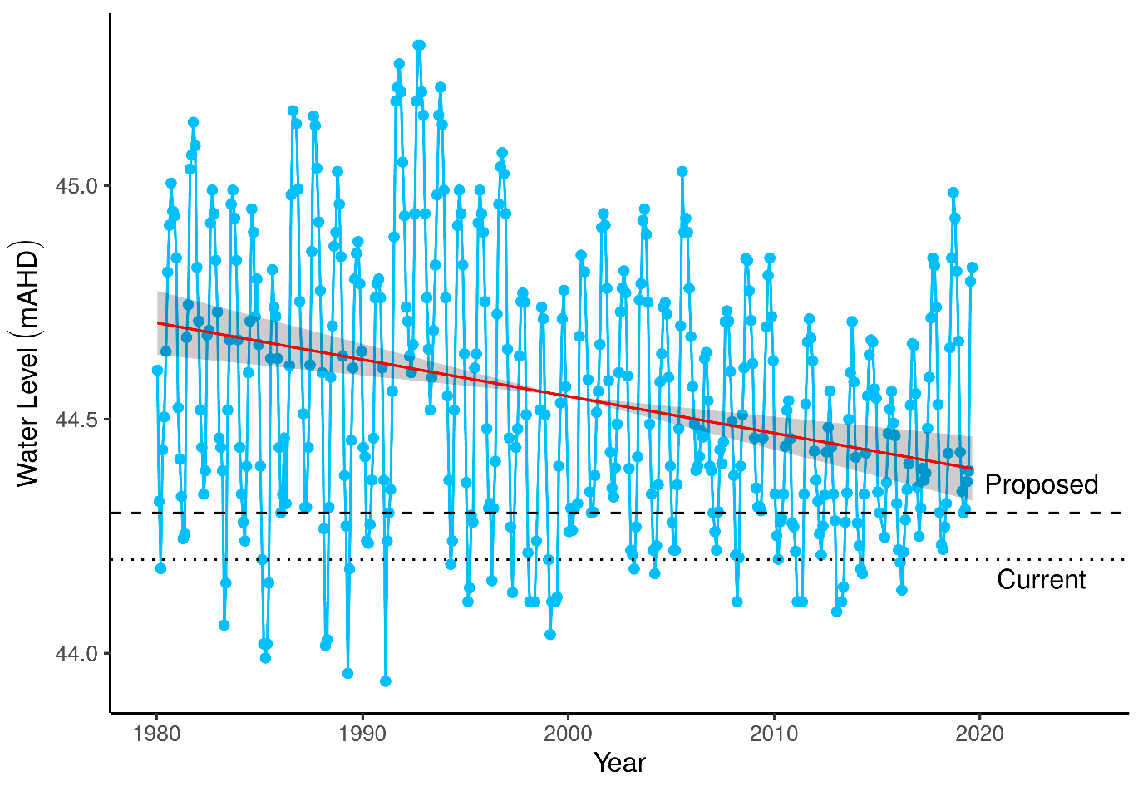

Figure 9 Surface water levels for Lake Jandabup recorded at staff 6162578. Red segments on fitted line represent statistically significant periods of declining water levels and green segments represent periods of increasing water levels. The shaded area around trend line represents the 95% confidence interval. Dotted line represent current ministerial threshold and dashed line represents the proposed threshold for 2030.

### Implications of revised threshold

Many of the site values of Lake Jandabup are likely to be maintained if water levels are managed above the proposed 2030 threshold level (Table 14). The lake is currently susceptible to acidification due to the deterioration of the chloride:sulphate ratio and very low alkalinity. Maintaining surface water levels at the proposed threshold will minimise the risk of further acidification by ensuring sediments remain wet, although acidification events have previously occurred in this wetland at water levels not much lower than the proposed 2030 threshold. Higher water levels in 2030 should also alleviate concern of increased nutrient concentrations although it difficult to predict whether the wetland will return to a more typical low nutrient state.

It is predicted here that many species of native vegetation are likely to increase in cover abundance given higher water levels. If water levels rise to the point where artificial augmentation is no longer required, restoration of the hydrological regime may facilitate the expansion of wader habitat as seasonal variation in surface water levels increases towards 0.8 m. Under the projected 2030 scenario, the diverse *Banksia* and *Eucalyptus rudis* overstorey is likely to be maintained at a healthier state than current. The dense and diverse native understory typical of this wetland is also likely to be maintained, and possibly increase in extent, under the projected changes in water levels.

The current low pH of the wetland is driving the aquatic macroinvertebrate community away from pre-2000 compositions and towards one composed of a less diverse, acidophilic community that is likely to also occur at Lake Mariginiup and Melaleuca Park 173. Careful monitoring of nutrient levels is required also as increased nitrogen levels may also be driving the shift in this aquatic community. The projected changes in water level by 2030 are likely to affect the richness and diversity of this assemblage, although these changes will be difficult to predict. The future composition of aquatic macroinvertebrates will be largely determined by the changes in habitat availability driven by sustained higher water levels, whether nutrient levels decrease and if acidification events occur again.

Table 14 Ecological consequences of proposed 2030 minimum threshold (44.3 mAHD) in terms of compliance of stated site values and site management objectives at Lake Jandabup. Future compliance assessments are based on current understandings of the hydrological influences on flora and fauna. They do not include future exogenous factors (like pollution events, introduction of exotic plants or animals) that might or might not occur in the future and affect these compliance estimations.

|  |  |  |
| --- | --- | --- |
|  | Likely effect of 2030 minimum threshold (44.3 mAHD) | Values and objectives maintained in future |
| **Site values (WAWA, 1995)** |  |  |
| * Most diverse sedge and macrophyte vegetation of all Bassendean dune wetlands, including unusual species | The diverse sedge communities are likely to persist as higher water levels provide additional habitat. | Likely |
| * Supports wide range of waterbirds, especially waders | Provided that seasonal variation in water levels is restored, extensive habitat for waders will continue being a feature of this wetland as seasonal high waters prevent macrophyte encroachment of wader habitat during periods of minimum water levels. Seasonal variation in water levels has decreased from about 0.8 m to 0.5 m. Restoration of hydrological regime is likely to restore seasonal variation to pre-2000 levels and extend feeding habitat for waders. | Likely |
| * Extremely good water quality with low nutrients | Water quality has been compromised by reduced buffering capacity that makes the wetland susceptible to acidification. Sediments need to be prevented from drying to prevent further acidification. Nutrient levels are also rising and may be causing shifts in the aquatic invertebrate assemblages. The projected increases of water levels will minimise the risk of further acidification but elevated nutrient levels will remain a concern. | Possible |
| **Site management objectives (WAWA, 1995)** |  |  |
| * Conservation of flora and fauna | Native plant species are predicted to increase in abundance if water levels continue to increase. This will have a beneficial effect for other terrestrial fauna that inhabit the wetland. Wader bird habitat is also likely to remain a feature of this wetland. Elevated nutrient levels and low pH are a concern as the aquatic macroinvertebrate community transitions towards a less diverse, acidophilic composition. | Likely for waders and vegetation. Unlikely for aquatic invertebrates unless pH is restored. |
| * Maintenance of the current extent of wading bird habitat | Greater seasonal variation and higher surface water levels are likely to maintain or expand current feeding habitat for waders. | Very likely |
| * No expansion in the areas of sedge vegetation, but maintenance of existing areas | Modeling does not suggest sedge vegetation is likely to increase although higher water levels are likely to provide additional habitat for fringing vegetation. | Likely |
| * Removal of mosquito fish from the lake | This management objective needs to be reworded. *Gambusia holbrooki* should not be referred to in this way because it does not control mosquitoes. The drying that occurred in the wetland in the late 1990s eradicated this species of non-native fish and to our knowledge it has not returned. Vigilance is required to ensure that it does not become established again. | No change |
| * Maintenance of high species richness of aquatic macroinvertebrates, macrophytes and sedge vegetation | The proposed changes will maintain the rich macrophytic and sedge vegetation. The richness of the aquatic macroinvertebrate community has changed, at least partly due to acidification but other factors may be involved. | Likely for macrophytes and sedges. Unlikely for aquatic macroinvertebrates |
| **Proposed site management objectives** |  |  |
| Increase wading bird habitat | Wading bird habitat is likely to be maintained under the projected increases to lake water levels. Probably unlikely to increase from current extent. | Unlikely |
| Maintain rich aquatic macroinvertebrate community | There have been marked shifts in the composition of aquatic macroinvertebrates since an acidification event. The projected water levels are unlikely to restore the community to pre-acidification composition. Nonetheless, maintain water levels similar to those currently found at the lake will ensure that further risk of acidification is minimised. | Unlikely |
| Minimise risk of acidification | The projected increases in water level will minimise the risk of further acidification. However, the lake may have reduced buffering capacity due to previous low water levels and acidification events. Low alkalinity levels mean that the lake will remain at risk of future acidification events despite higher water levels. | Possible |

### 

## Lake Nowergup

Lake Nowergup was one of the deepest permanent lakes on the Swan Coastal Plain and has provided a permanent habitat for aquatic invertebrates and fish, as well as an important drought refuge for water birds (Froend, et al., 2004a). Despite the wetland being artificially maintained since 1989, water levels have continued to decline. This decline has altered the fringing vegetation of the lake and reduced the area of permanent water.

### Hydrology

Since 2010, surface water levels in the lake have declined significantly to levels that are currently below the minimum reading on the staff gauge 6162567 (Figure 10). Groundwater levels at the nearby bore 61611247 have shown similar trends as surface water levels. Between 2008 and 2014, groundwater levels at the bore have declined by more than 1.0 m. A similar decline in surface waters is likely and measurements from this bore have been used in the vegetation analysis. Currently, groundwater levels have increased to above 15 mAHD due to recent rainfall and nearby supplementation influencing local superficial levels. Mean seasonal maximum groundwater levels from the 1994-1999 period to the 2014-2019 period declined by 1.7 m, while for the mean minimum water levels the decline was 1.5 m (Table 15). Maximum and minimum water levels now tend to occur earlier in the year than previously. Proposed threshold levels will apply to bore 61610601, where under proposed reduction in abstraction a threshold at 18.0 mAHD should be achievable. This is likely to correspond to threshold level of 16.0 mAHD at the staff gauge, 0.8 m lower than the current threshold but an increase from current minimum levels by about 1 m.

Table 15 Five year summaries of surface water level data at Lake Nowergup.

|  |  |  |  |  |
| --- | --- | --- | --- | --- |
| Period | Mean max seasonal  level (mAHD) | Mean min seasonal  level (mAHD) | Mean seasonal change (m) | Mean max to min (days) |
| 08/1994 – 07/1999 | 17.0 (Oct) | 16.2 (May) | 0.84 | 115 |
| 08/1999 – 07/2004 | 16.7 (Oct) | 16.0 (May) | 0.72 | 20.4 |
| 08/2004 – 07/2009 | 16.8 (Oct) | 16.2 (Sep) | 0.56 | 0 |
| 08/2009 – 07/2014 | NA | NA | NA | NA |
| 08/2014 – 07/2019 | NA | NA | NA | NA |

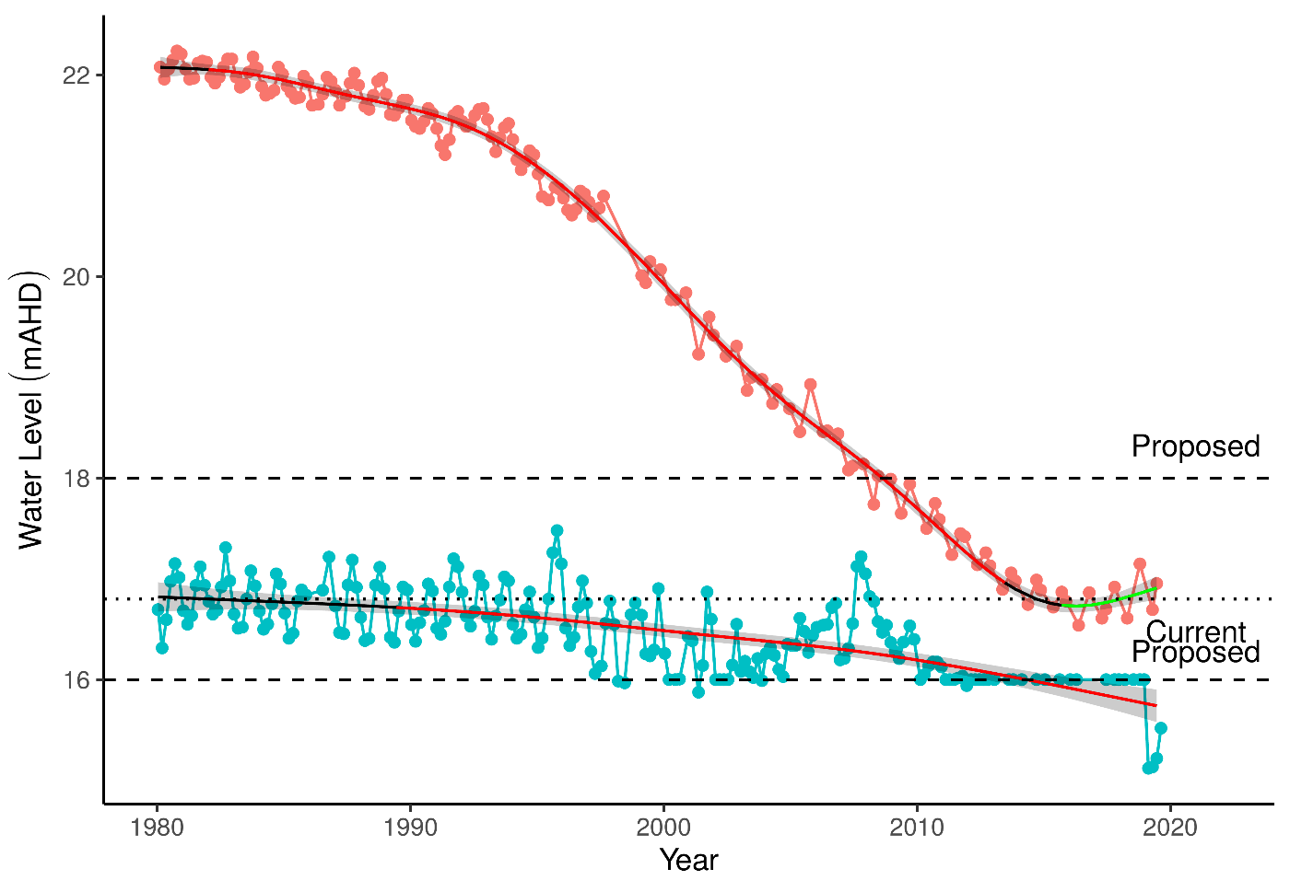

Figure 10 Ground and surface water levels for Lake Nowergup recorded at bore 61610601 (red) and staff gauge 6162567 (blue). The minimum recordable water level for the staff gauge is 16.0 mAHD. Measurements at 16.0 mAHD represent water levels below the minimum level measurable at the staff gauge which has recently been shifted to a lower elevation. Red segments on fitted line represent statistically significant periods of declining water levels and green segments represent periods of increasing water levels.

### Implications of revised threshold

The projected changes in ground water levels by 2030 mean water levels will be higher than current and similar to 2010 levels. Many of the site values of Lake Nowergup are unlikely to be maintained under the proposed changes to groundwater abstraction and a lowering of the minimum threshold to 16.0 mAHD (Table 16). The low water levels have caused a significant decline in macroinvertebrate richness and a shift in assemblage composition away from what was once typical of this wetland. This deterioration of the macroinvertebrate community coincides with increased drying of the wetland and supplementation of surface waters by artificial watering, probably consistent with a decline in the diversity of habitats available. The changes in assemblages are probably driven by a decline in habitat availability for these organisms, although increased nutrient levels may also be facilitating this process. The projected changes in groundwater level for 2030 will return the lake to a similar condition observed in 2010 which may reverse the trend of declining macroinvertebrate family richness. It is unlikely some species will return, such as the Sphaeridae bivalve will not re-establish unless the natural hydrological regime and water quality are restored and only if a remnant population exists in the lake.

Although many native vegetation species are predicted to increase in cover abundance with declining water levels, there is a substantial decline in fringing wetland vegetation and sedges. The projected water levels for 2030 are likely to facilitate the continued terrestrialisation of the vegetation community, which in turn, will further impact the macroinvertebrate communities as many of these plant species (e.g. *Baumea articulata*) provide important habitat for many macroinvertebrate species and reduce the effect of nutrient enrichment. At some regions of the lake, it is possible that *Baumea juncea* will become the dominant sedge species and perhaps prevent further nutrient enrichment of the waters, while *Eucalyptus rudis* will dominate the overstorey. Nonetheless, under the projected water levels, the ecological water requirements for key wetland species will continue to be met.

Table 16 Ecological consequences of proposed 2030 minimum threshold (16.0 mAHD) in terms of compliance of stated site values and site management objectives at Lake Nowergup set for the current absolute minimum Ministerial criteria (16.8 mAHD). Future compliance assessments are based on current understandings of the hydrological influences on flora and fauna. They do not include future exogenous factors (like pollution events, introduction of exotic plants or animals) that might or might not occur in the future and affect these compliance estimations.

|  |  |  |
| --- | --- | --- |
|  | Likely effect of 2030 revised minimum threshold (16.0 mAHD) | Values and objectives maintained in future |
| **Site values (WAWA, 1995)** |  |  |
| As a permanent deep-water wetland acts as a major drought refuge for waterbirds | Loss of 0.8m water depth is significant on the Swan Coastal Plain – no longer retain the title of ‘deep-water’. Some water birds may benefit from shallower waters, diving water birds need deeper waters. | Unlikely |
| Supports dependent invertebrates and fish species (one native, Swan River Goby (*Pseudogobius olorum*); and one exotic, Mosquito fish (*Gambusia holbrooki*) | Habitat dependent. Invertebrate species have been apparently lost from this wetland, and new thresholds are unlikely to bring them back. *Gambusia* should not be regarded as a value and the question is how to remove them, not how to keep them. *Pseudogobius olorum* will benefit from the proposed higher water levels that will ensure habitat availability. However reestablishment is unlikely if the species is already locally extinct or goes extinct before 2030.  Acidification of the wetland is highly likely if organic sediments dry, crack and periodically rewet, which will likely result in further losses of fauna. Maintaining water levels above the proposed threshold should reduce the risk of drying and minimise the risk of further acidification. | Likely (dependent upon *P. olorum* persisting) |
| Large areas of sedges minimize impact of nutrient enrichment on aquatic fauna | Likely to be jeopardised with declining water levels. Modelling predicts a decline in *B. articulata* and *T. orientalis* as water levels recede further. *B. juncea* may establish in some regions of the lake and minimise the impact of nutrient enrichment. | Very unlikely |
| **Site management objectives (WAWA, 1995)** |  |  |
| Wildlife and conservation, scientific study and preservation of features of archaeological, historic or scientific interest | No data to reach conclusion | Unknown |
| Maintain the existing areas of fringing sedge vegetation | Existing areas of sedge vegetation are likely to become terrestrialised. Sedges will be required to migrate down-slope with receding surface water levels and are likely to be reduced in extent. | Very unlikely |
| Maintain deep, permanent water as a bird habitat and drought refuge and to protect aquatic invertebrates and fish dependent on permanent water | The decline of surface water levels will reduce the areas of deep water and jeopardise the habitat available to birds and fish. The function of the lake as a drought refuge for particular birds (diving birds) will diminish. | At a reduced capacity |
| Maintain the existing extent of *Baumea* fringe between *Typha* stands and the fringing woodland | Modelling predicts *B. articulata* and *T. orientalis* to decline further. Existing stands are likely to disappear and will need to establish down-slope. The extent of these stands will decrease. | Very unlikely |
| Provide some area of wading bird habitat at the end of summer, although it is recognized that this is limited by the shape of the wetland. | Depends on seasonal variation allowing areas of mudflats suitable for waders to establish. Some shallow areas will be affected by drying at the end of summer, particularly areas of cracked organic sediments, which are unlikely to be quality feeding habitat for wading birds. | Unlikely |
| **Proposed site management objectives** |  |  |
| Increase area of permanent deep-water habitat for fauna | Even though the projected changes do represent an increase in the extent of permanent water (deeper than 1.5 m) throughout the basin, these levels are insufficient to return to the normal permanent deep-water habitat that the lake once provided. Nonetheless, managing water levels above the proposed 2030 minimum threshold will ensure permanent deep water remains a feature of this wetland and could have beneficial consequences like helping to reverse the declining trend in aquatic macroinvertebrate richness and reducing phosphate levels. Much of the lake margin will remain dominated by *T. orientalis* sedge. | Likely |
| Maintain fringing vegetation to support macroinvertebrate diversity and nutrient retention | The projected changes in water levels will maintain fringing vegetation habitats. However, it is likely to remain dominated by *T. orientalis*. A remnant patch of *B. articulata* is also found along the margin of the lake but may disappear despite the higher projected water levels. Loss of *B. articulata* will reduce habitat diversity and further contribute towards declining macroinvertebrate richness. | Possible |

### 

## Lake Wilgarup

Lake Wilgarup is a high conservation, once seasonally inundated Dampland located in the southern area of Yanchep National Park. The basin covers an area of 16 ha in a limestone depression that used to experience discharge from groundwater. There are extensive peat deposits in the lakebed that suggest the sediments saturated for a long period. Surface waters have not been recorded in the basin since 1998 and peats have been burnt significantly in the 2004/5 fire, and remaining peats are dry and vulnerable to combustion.

### Hydrology

Groundwater levels have been recorded at the nearby bore 61618500 since 1997 (Figure 11). There has been a significant decline in groundwater levels throughout this monitoring period from 4.75 to 3.25 mAHD despite recent increased annual rainfall. Maximum and minimum seasonal groundwater levels have decreased by 1.6 and 1.2 m, respectively (Table 17). Maximum water levels have consistently occurred during September-October, but minimum water levels are now occurring later in the year with the site experiencing a longer period of drying. The wetland has been non-compliant with ministerial thresholds for most of the monitoring period. A proposed threshold at 0.5 m lower than the current threshold is likely to be achievable under proposed reductions in abstraction by 2030. These changes in abstraction are projected to cause an increase in groundwater levels, but it is unlikely to be sufficient to restore the natural.

Table 17 Five year summaries of ground water level data at Lake Wilgarup

|  |  |  |  |  |
| --- | --- | --- | --- | --- |
| Period | Mean max seasonal  level (mAHD) | Mean min seasonal  level (mAHD) | Mean seasonal change (m) | Mean max to min (days) |
| 08/1994 – 07/1999 | 5.2 (Oct) | 4.3 (Sep) | 0.91 | 184 |
| 08/1999 – 07/2004 | 4.7 (Oct) | 4.0 (Feb) | 0.73 | 193 |
| 08/2004 – 07/2009 | 4.3 (Sep) | 3.7 (Apr) | 0.62 | 150 |
| 08/2009 – 07/2014 | 3.8 (Oct) | 3.2 (Apr) | 0.59 | 190 |
| 08/2014 – 07/2019 | 3.6 (Oct) | 3.1 (Mar) | 0.55 | 212 |

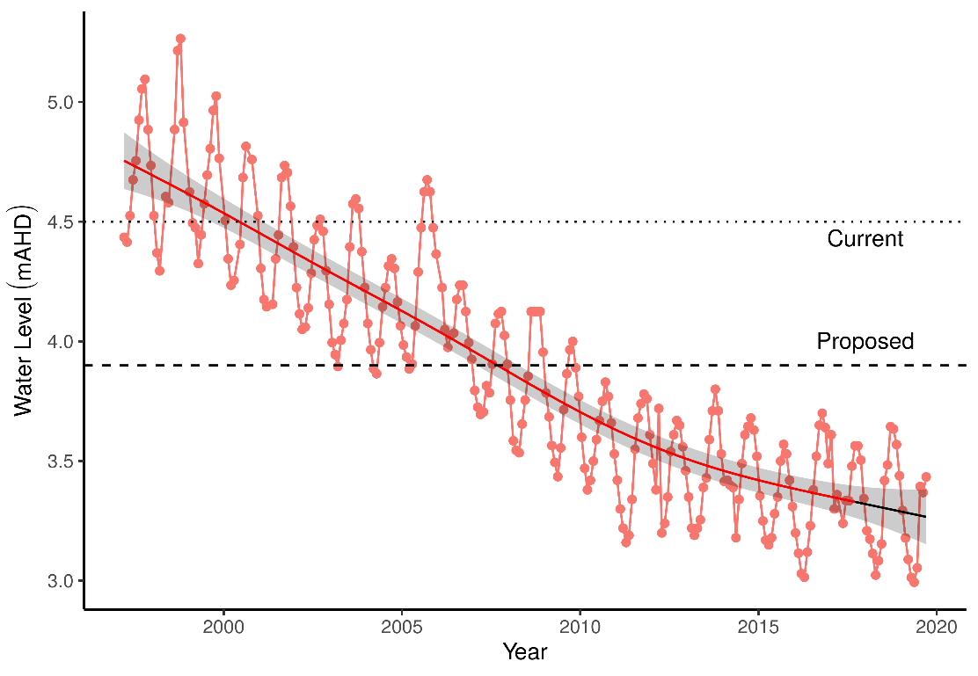

Figure 11 Groundwater levels recorded at bore 61618500 in the vicinity of Lake Wilgarup. Red segments along trendline indicate periods of significant decline in groundwater levels.

### Implications of revised threshold

The site values of Lake Wilgarup are unlikely to be maintained if levels are managed to meet the proposed threshold level (Table 18) despite water levels returning to pre-2005 levels. Vegetation composition has shifted from one dominated by wetland species, such as *B. articulata*, to a terrestrial community dominated by *Eucalyptus gomphocephala*. Increases in groundwater are unlikely to have an impact on the vegetation unless seasonal inundation of the basin can be restored. For instance, the ecological water requirements for *M. rhaphiophylla* are unlikely to be met given the proposed minimum threshold. Even if the hydrological regime begins to resemble that of a dampland, the significant losses of peat sediments due to bushfire events mean that any re-establishment of wetland vegetation, particularly *Baumea* species, is unlikely to resemble the site’s natural state. Furthermore, the re-establishment of wetland vegetation will need to compete with the woodland vegetation that now inhabits the basin.

Table 18 Ecological consequences of proposed 2030 minimum threshold (3.9 mAHD) in terms of compliance of stated site values and site management objectives at Lake Wilgarup set for the current absolute minimum Ministerial criteria (4.5 mAHD). Future compliance assessments are based on current understandings of the hydrological influences on flora and fauna. They do not include future exogenous factors (like pollution events, introduction of exotic plants or animals) that might or might not occur in the future and affect these compliance estimations.

|  |  |  |
| --- | --- | --- |
|  | Likely effect of 2030 revised minimum threshold (3.9 mAHD) | Values and objectives maintained in future |
| **Site values (WAWA, 1995)** |  |  |
| One of few remaining undisturbed wetlands within the region | Declining groundwater and fire render this wetland highly disturbed. The vegetation composition no longer reflects that of a wetland as the site has become highly terrestrialised. | Extremely unlikely |
| Rich and unusual vegetation (dense monospecific stands of sedges) | These sedges are locally extinct. | Extremely unlikely |
| Likely to support diverse fauna | A rich woodland fauna likely exists at the site; however, this assemblage would not reflect the rich wetland fauna that would have once occupied the site. | Extremely unlikely |
| **Site management objectives (WAWA, 1995)** |  |  |
| Maintain the environmental quality of Lake Wilgarup | The quality of Lake Wilgarup as a Swan Coastal Plain wetland has been permanently compromised. As it is extremely unlikely that permanent water will become a feature of Lake Wilgarup in the future, the site will not retain its environmental quality. | Extremely unlikely |
| Maintain the existing extent and variety of wetland vegetation | Wetland vegetation has probably been permanently destroyed by declining water levels and fire. The terrestrial woodlands that now inhabit the site are unlikely to facilitate the return of wetland vegetation unless permanent water is restored to the site. | Extremely unlikely |
| **Proposed site management objectives** |  |  |
| Maintain soil moisture and minimise risk of acidification | The projected changes in groundwater levels will not restore inundation of the site. However, the soils will increase in moisture and be at a reduced likelihood of acidification. Peats have probably been destroyed by fire events, so even under the proposed scenario which resemble conditions prior to 2005, it is unlikely the diverse *Baumea* stands will return. Without further raises in groundwater, the basin is likely to remain dominated by *E. gomphocephala*. | Likely |

### 

## Pipidinny Swamp

Vegetation at Pipidinny Swamp was damaged by a fire in 2005. Macroinvertebrate and water quality monitoring occurred in the 2000s but ceased in 2011 as the wetland was atypical and had little water. A single vegetation survey has been conducted in September 2019 and the results are presented here.

### Hydrology

There has been at least a 2 m decline in surface water levels at Pipidinny Swamp since the mid-1990s, although measurements at the staff gauge were frequently below the minimum recordable level in the mid-late 2000s to 2019 despite the gauge being moved in 2010 (Figure 12). Mean maximum seasonal surface waters are at least 1.2 m lower now than in the 1994-1999 seasons. Records of minimum levels are difficult to interpret due to the water levels frequently being below the staff gauge. Groundwater levels at the nearby bore 61611872 suggest that water levels at the swamp are no longer in decline, however this conclusion assumes groundwater levels at the bore and surface water levels at the staff gauge are related. It is not possible to verify this assumption as groundwater measurements have only been made while the surface water levels have been below detection limits for the staff gauge.

It is likely that water levels in Yanchep National Park will increase under the proposed 2030 changes in groundwater abstraction. The proposed threshold level of 1.1 m at bore 61611872 is likely to slightly increase or stabilise surface water levels in Pipidinny Swamp.

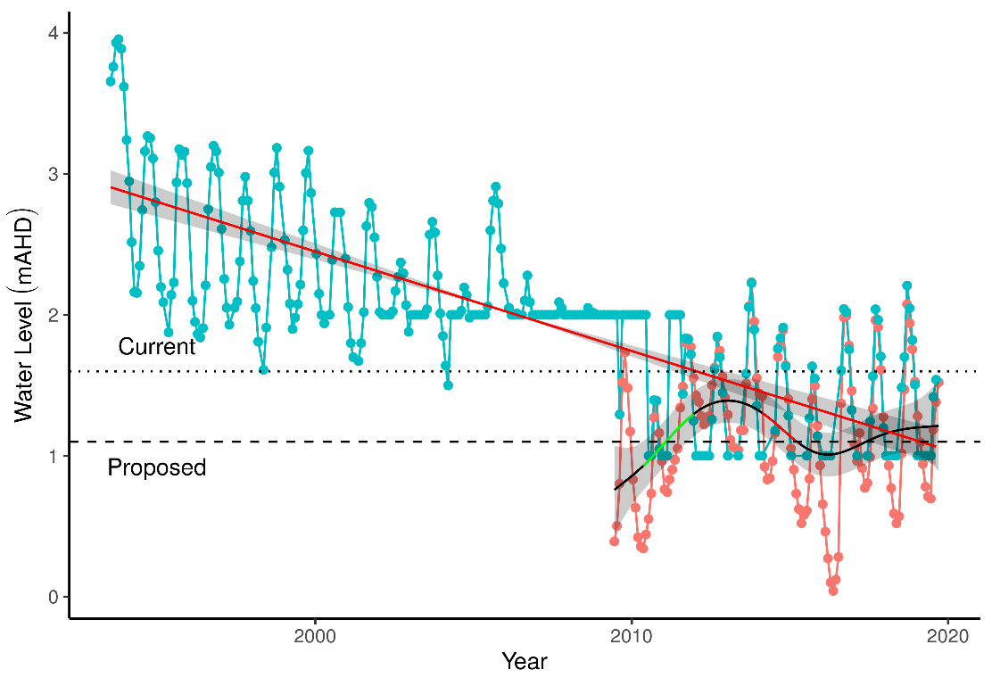

Figure 12 Ground and surface water levels recorded at bore 61611872 (red) and staff gauge 6162624 (blue) that represent fluctuations in water levels at Pipidinny Swamp. Surface water levels were initially only recordable above 2 mAHD and later above 1 mAHD. Red segments of trend line represent periods of significant decline in water levels while green segments represent periods of significant increases in water levels.

### Implications of revised threshold

The proposed reductions to abstraction are not likely to restore surface water levels to pre-2000 levels at Pipidinny Swamp which will affect the capacity to maintain the site values (Table 19). Features that characterised this wetland before the significant decline in water levels are unlikely to return given the predicted outcomes of reduced abstraction as water levels will be maintained at levels much lower than was once typical of the wetland. However, the water levels are predicted to be slightly higher than current levels, which will have a beneficial effect on fringing vegetation health. Given the location of this swamp in an increasingly urbanised region and the altered hydrological regime, it is likely that exotic vegetation species will remain a feature of this swamp. Exotic species that are likely to remain abundant at the site include *Bromus diandrus* and *Ehrharta longiflora*.

The swamp was once an important habitat for a variety of resident and non-resident waterbirds such as White-faced Heron, Pacific Black Duck, Dusky Moorhen, Purple Swamphen, Australian Reed Warbler, Maned Duck, Grey Teal and the Little Pied Cormorant (Boucher 2000). Water bird richness was consistently between 16 and 29 species between 1984 and 1993 but very dramatically reduced to less than 5 by 2000 (Boucher 2000). Similar declines of water bird abundance have been recorded and are likely caused by the declines in water levels that occurred during that period. Given the further declines in water levels since 2000, the value of the site for water bird habitat has been seriously degraded.

Table 19 Ecological consequences of proposed 2030 minimum threshold (1.1 mAHD) in terms of compliance of stated site values and site management objectives at Pipidinny Swamp set for the current absolute minimum Ministerial criteria (1.6 mAHD). Future compliance assessments are based on current understandings of the hydrological influences on flora and fauna. They do not include future exogenous factors (like pollution events, introduction of exotic plants or animals) that might or might not occur in the future and affect these compliance estimations.

|  |  |  |
| --- | --- | --- |
|  | Likely effect of 2030 revised minimum threshold (1.1 mAHD) | Values and objectives maintained in future |
| **Site management objectives (WAWA, 1995)** |  |  |
| Maintain and enhance wetland vegetation | Water levels are currently more than 1 m lower than pre-2000 levels. Proposed changes to abstraction are unlikely to restore the swamp to pre-2000 levels but are likely to maintain slightly higher levels than currently exist. The slightly deeper waters will provide additional habitat for aquatic fauna than currently exists. Fringing vegetation is likely to persist with higher surface water levels, although this prediction is not based on empirical data. If fringing *B. articulata* and *T. orientalis* continue to occur, additional habitat for aquatic macroinvertebrates may become available. | Possible |
| Protect and enhance waterbird habitats | The value of the wetland to waterbirds has been seriously compromised by low water levels. The richness and abundance of waterbirds found at the swamp in the 1980’s has been reduced because of declining water levels. Under the proposed changes, it is unlikely that this aspect of the wetland will return. | Very unlikely |
| **Proposed site management objectives** |  |  |
| Increase area of permanent deep-water habitat for fauna | It is probable that the extent of permanent water will increase given the projected increases in water levels. These levels will not be sufficient to reach pre-2000 coverage. | Likely |
| Maintain fringing vegetation to support a range of habitat types for macroinvertebrates | Any increase in water levels will support fringing vegetation. It is unlikely that the proposed changes will drastically alter the extent nor the diversity of fringing vegetation. Currently the only data for macroinvertebrates does not come from the swamp itself only from the constructed wetlands. Here fringing vegetation will remain an important habitat for macroinvertebrates. | Likely |

### 

## Lexia 186

The Lexia 186 wetland has a high conservation value because it consists of a largely undisturbed Sumpland habitat with a diverse vegetation community that provides significant habitat for fauna (Froend, et al., 2004a). The Lexia system of wetlands is composed of a series of separate wetlands including Lexia 86, Lexia 94 and Lexia 186. These three wetlands were chosen as representative and were given Ministerial water level criteria report for the East Gnangara (Lexia) borefield (EPA 1998). Lexia 186 was normally a seasonally waterlogged basin (Dampland), however, prolonged decline of groundwater levels mean water levels are now below the level of the basin all year. There have been dramatic shifts in fringing vegetation health and composition as the basin sediments dry and oxidise.

### Hydrology

There has almost been a significant decline in groundwater levels at Lexia 186 from 1996 to 2015 by approximately 1 m and a significant increases in water levels since 2015 by 0.5 m (Figure 13). Nonetheless, current mean maximum and minimum water levels are 1.1 and 0.6 m below 1994-1999 levels and seasonally minimums are occurring earlier in the year (Table 20). Groundwater levels at Lexia 186 have been non-compliant since 2000. Proposed reductions in groundwater abstraction are not projected to increase water levels in the Dampland, therefore a threshold 0.7 m below the current threshold has been proposed for 2030. This projection will maintain groundwater at similar levels to the period between 2010-2015.

Table 20 Five year summaries of surface water level data at Lexia 186

|  |  |  |  |  |
| --- | --- | --- | --- | --- |
| Period | Mean max seasonal  level (mAHD) | Mean min seasonal  level (mAHD) | Mean seasonal change (m) | Mean max to min (days) |
| 08/1994 – 07/1999 | 48.2 (Sep) | 47.2 (May) | 1.02 | 233 |
| 08/1999 – 07/2004 | 47.9 (Oct) | 47.1 (Apr) | 0.86 | 212 |
| 08/2004 – 07/2009 | 47.7 (Sep) | 46.9 (Jun) | 0.77 | 241 |
| 08/2009 – 07/2014 | 47.2 (Oct) | 46.6 (May) | 056 | 219 |
| 08/2014 – 07/2019 | 47.1 (Oct) | 46.6 (Apr) | 0.54 | 224 |

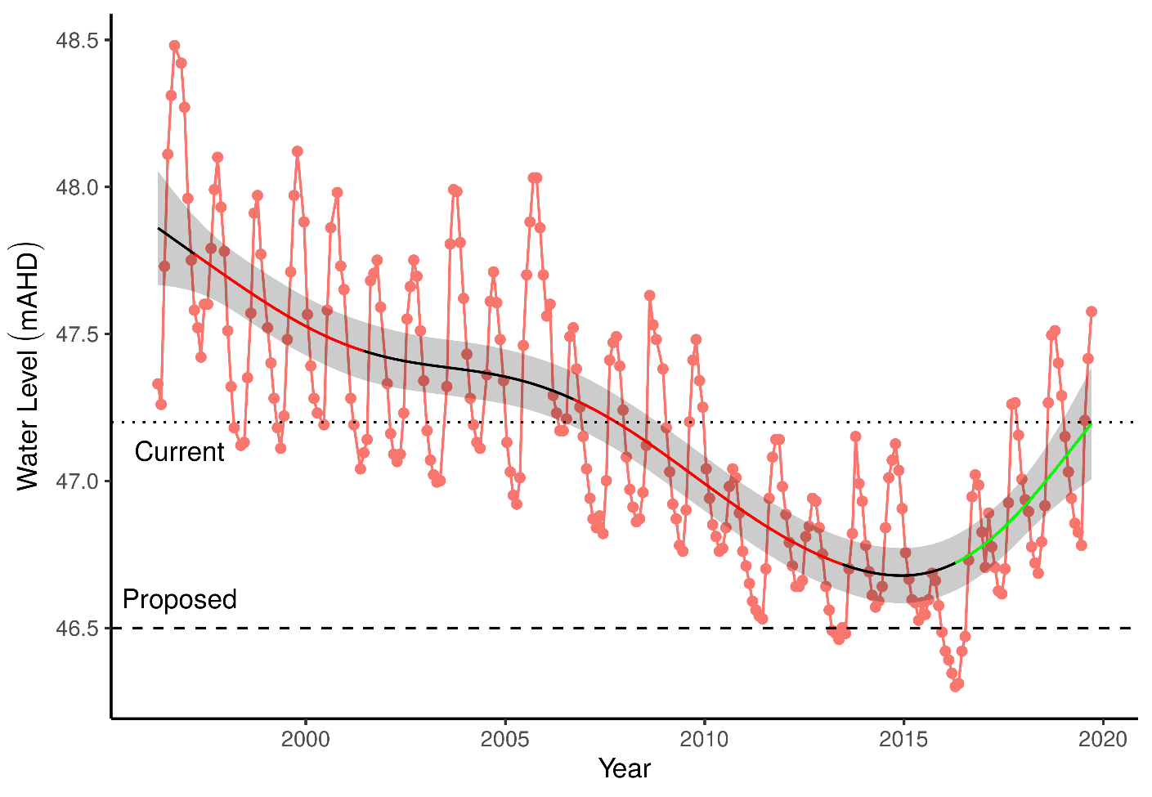

Figure 13 Groundwater levels recorded at bore 61613214 that represent water level fluctuations at Lexia 186. Red segments represent periods of significant decline in water levels while green segments represent periods of significant increase in water levels.

### Implications of revised threshold

The site values of the Lexia 186 wetland are unlikely to be maintained under the proposed changes to groundwater abstraction (Table 21). There has been a significant shift from a seasonally waterlogged basin to a system that is now permanently dry. The proposed reductions in abstraction are not going to restore this important characteristic of the wetland. Instead, predicted changes in water level suggest maintenance of conditions similar to what the site has experienced since 2011. It is likely that vegetation will undergo further shifts in composition as their ecological water requirements are not met. Nonetheless, further monitoring will provide additional information as to whether the vegetation is likely to continue to change further.

Table 21 Ecological consequences of proposed 2030 minimum threshold (46.5 mAHD) in terms of compliance of stated site values and site management objectives at Lexia 186 set for the current absolute minimum Ministerial criteria (47.2 mAHD). Future compliance assessments are based on current understandings of the hydrological influences on flora and fauna. They do not include future exogenous factors (like pollution events, introduction of exotic plants or animals) that might or might not occur in the future and affect these compliance estimations.

|  |  |  |
| --- | --- | --- |
|  | Likely effect of 2030 revised minimum threshold (46.5 mAHD) | Values and objectives maintained in future |
| **Site values (WRC, 1997)** |  |  |
| * Undisturbed by typical impacts | Extensive native vegetation remains a feature of this site despite the significant shifts in composition during the monitoring period. Modelling suggests these shifts are not attributed to changes in groundwater levels. | Likely |
| * Supports diverse vegetation | The proposed thresholds are likely to maintain the high richness of native vegetation of the site, although it is markedly different to 1997 baseline conditions. | Very likely |
| * Significant fauna habitat | The continued diverse native vegetation will continue to provide a rich habitat for (terrestrial) fauna. | Very likely |
| **Site management objectives (1997)** |  |  |
| * Conserve ecological values | Despite the altered hydrological regime, the site has maintained may of the ecological values that make this site important. These values are likely to persist given the proposed changes to the threshold levels. Nonetheless, the site has been fundamentally altered as it is no longer a seasonally waterlogged Dampland and altered sediment processes are likely contributing to the shift in vegetation community being observed. | Possible |
| * Protect vegetation assemblages in and fringing the wetland | Fringing vegetation has been lost at the wetland as the site is no longer inundated. The proposed changes to abstraction are not going to cause inundation and therefore fringing vegetation will continue to remain absent from the site. | Extremely unlikely |
| * Protect invertebrate communities dependent on the wetland | Given the likely persistence of native vegetation at the site, terrestrial invertebrates will continue to inhabit the site, although this prediction is not based on any empirical evidence. Invertebrates typical of Damplands are likely to have been affected by the declining ground water levels. Aquatic macroinvertebrates have been lost since inundation no longer occurs. This situation will persist given the proposed changes to abstraction. | Extremely unlikely |
| **Proposed site management objectives** |  |  |
| Maintain fringing and wetland vegetation to support a range of habitat types | The projected water levels are not going to support fringing vegetation. Some wetland vegetation, such as *Melaleuca preissiana* and *Banksia ilicifolia* will be sustained. This vegetation supports a variety of habitat for terrestrial fauna. | Unlikely |

### 

## Melaleuca Park 173

Melaleuca Park 173 (EPP 173) is located within the Bassendean North Vegetation Complex and represents a regionally significant wetland (Hill et al., 1996). Normally, the site represents a permanently filled lake that is fed from a series of springs along the western margin of the basin (Froend, et al., 2004a; Judd and Horwitz, 2019). The waters supported a rich macroinvertebrate community and an endemic (and most northern) population of the black-striped minnow (*Galaxiella nigrostriata*). There have been dramatic decreases in surface and groundwater levels in recent decades, to the point where the lake is almost dry during the summer months. Declining water levels are thought to have caused the local extinction of the black-striped minnow and degradation of fringing vegetation.

### Hydrology

There has been a prolonged decline in surface water levels since 1990 that show similar trends with fluctuations in groundwater levels (bore 61613213; Figure 14). Surface water level measurements are now unreliable at staff 6162628 due to water levels usually being below the minimum level of the staff. Since 2011, groundwater levels have been stable. Mean maximum and minimum water levels have decreased by 0.8 m and 0.5 m, respectively, since 1994 (Table 22). The latest 5-year period (2014-2019) suggests that groundwater is reaching an annual minimum earlier in the year than in previous seasons. Groundwater levels have been non-compliant during the monitoring period. The proposed threshold level of 48.5 mAHD is 1.7 m lower than the current threshold. Managing the wetland to these levels may result in further declines in water levels.

Table 22 Five year summaries of surface water level data at Melaleuca Park 173. Data is based on data from bore 61613213 as many readings for the surface water staff 6162628 are below the minimum reading of 50.4 mAHD.

|  |  |  |  |  |
| --- | --- | --- | --- | --- |
| Period | Mean max seasonal  level (mAHD) | Mean min seasonal  level (mAHD) | Mean seasonal change (m) | Mean max to min (days) |
| 08/1994 – 07/1999 | 50.9 (Sep) | 49.2 (May) | 1.73 | 242 |
| 08/1999 – 07/2004 | 50.8 (Sep) | 49.1 (May) | 1.66 | 220 |
| 08/2004 – 07/2009 | 50.6 (Sep) | 49.0 (May) | 1.59 | 168 |
| 08/2009 – 07/2014 | 50.0 (Oct) | 48.7 (Jun) | 1.27 | 224 |
| 08/2014 – 07/2019 | 50.1 (Sep) | 48.7 (Apr) | 1.38 | 225 |

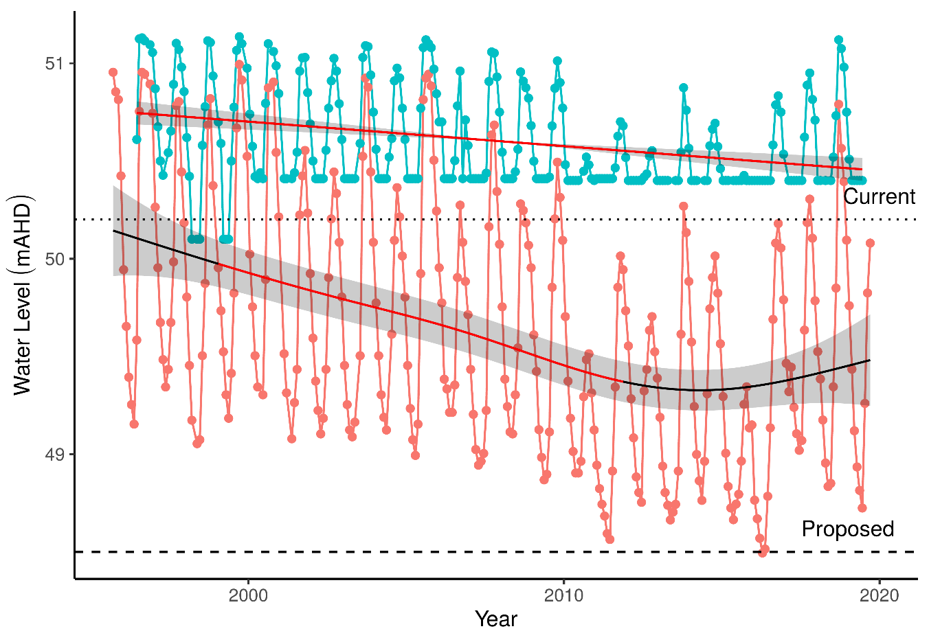

Figure 14 Ground and surface water levels for Melaleuca Park 173 recorded at bore 61613213 (red) and staff 6162628 (blue). The minimum recordable water level for the staff gauge is 50.4 mAHD. Records at 50.4 mAHD represent water levels below the minimum level measurable by the staff. Red segments on fitted line represent statistically significant periods of declining water levels. Current and proposed threshold levels for bore 61613213 are represented by dotted and dashed lines, respectively.

### Implications of revised threshold

It is unlikely that management many of the site values of the Melaleuca Park 173 wetland will be achievable given that the low groundwater levels and loss of permanent water are projected to continue (Table 23). The vegetation modelling presented here suggests that vegetation from higher elevations of the basin are likely to migrate down-slope as water levels remain at the current low levels. The health of the important overstorey species, *Melaleuca preissiana*, is likely to continue to decline whilst terrestrial species, such as *Xanthorrhoea preissii* and *Dielsia stenostachya*, are likely to increase in abundance. It is unlikely that the ecological water requirments for important wetland species found at Melaleuca Park 173 will be met when maintaining water levels at the proposed thresholds.

The macroinvertebrate assemblage at Melaleuca Park 173 is displaying similar shifts as the other wetlands that have low pH, such as Lake Jandabup and Lake Mariginiup, which are experiencing declining richness. The projected water levels for 2030 are not likely to restore the high richness recorded at the site prior to 2008 as habitat availability continues to be diminished by low water levels and the low pH excludes non-acidiphilic species.

Table 23 Ecological consequences of proposed 2030 minimum threshold (48.5 mAHD) in terms of compliance of stated site values and site management objectives at Melaleuca Park 173 set for the current absolute minimum Ministerial criteria (50.2 mAHD). Future compliance assessments are based on current understandings of the hydrological influences on flora and fauna. They do not include future exogenous factors (like pollution events, introduction of exotic plants or animals) that might or might not occur in the future and affect these compliance estimations.

|  |  |  |
| --- | --- | --- |
|  | Likely effect of 2030 revised minimum threshold (48.5 mAHD) | Values and objectives maintained in future |
| **Site values (WRC, 1997)** |  |  |
| Unique hydrology | Permanent water is no longer a feature of this wetland. The proposed threshold of 48.5 m will allow the ongoing transformation of the site into a seasonally inundated wetland | Very unlikely |
| High vertebrate and macro invertebrate species richness | Aquatic vertebrate and invertebrate richness have declined significantly. Native fish species are probably no longer at the wetland and macroinvertebrate surveys show a clear decline in richness of taxa. Proposed water level changes are not sufficient to reverse this trend. | Very unlikely |
| Contains most northern population of black stripe minnow (*Galaxiella nigrostriata*) | Probably locally extinct from the wetland due to loss of permanent water. | Very unlikely |
| **Site management objectives (WRC, 1997)** |  |  |
| Maintain wildlife and landscape values of the wetlands | The functioning of this wetland has changed markedly from a permanently inundated wetland to a seasonally inundated Dampland. This has had a significant effect on the flora and fauna of the site. Nonetheless, the high native vegetation richness of the site is likely to persist and provide habitat for wildlife. | Likely |
| Maintain the existing areas of wetland and stream vegetation they support | Permanent water is unlikely to be a feature of this wetland under the revised abstraction plan. Seasonal inundation is likely to continue and will maintain many of the components of existing wetland vegetation. | Likely |
| To protect invertebrate communities dependent on the wetland and stream | Declining waters are attributed to the marked decline in aquatic macroinvertebrate richness. The proposed changes to abstraction are unlikely to reverse this trend. | Unlikely |
| To protect the fish species, *Galaxiella nigrostriata* | The proposed abstraction plan suggests the wetland will not become permanently inundated, a necessity for fish. Because surface waters will continue to disappear seasonally, the wetland will not provide the habitat required for any fish species. *G. nigrostriata* is likely to be(come) locally extinct from this wetland. | Extremely unlikely |
| **Proposed site management objectives** |  |  |
| Limit declines in health of fringing and wetland vegetation to support a range of habitat types | The proposed changes to abstraction are likely to maintain water levels similar to the current conditions. The loss of permanent water is significant, however the wetland should remain as seasonally inundated Sumpland. Managing the water levels above the proposed minimum threshold is likely to maintain fringing and wetland vegetation at a similar state to present and continue to support the current consortium of habitats. | Likely |

### 

## Melaleuca Park 78

Melaleuca Park 78 (also referred to as Dampland 78) is located north-west of the Lexia wetlands in the southern area of Melaleuca Park. The site is approximately 6.7 ha in area and represents a regionally significant wetland (Hill et al., 1996). Melaleuca Park 78 is classified as a Dampland habitat, meaning the basin has seasonally waterlogged soils that are not often inundated with surface waters (Semeniuk and Semeniuk, 1996). The site is an important habitat for a unique assemblage of phreatophytic vegetation which provides important habitat for native populations of fauna.

### Hydrology

Water levels at the site have been declining since the beginning of monitoring in 1999 up until 2014, although absolute minimum levels were recorded in 2016. Bore 61613231 indicates that groundwater in the Dampland may have declined by about 1.3 m since 1999, although there has been a recent increase in groundwater levels since 2016 due to increased rainfall (Figure 15). Current 5 year mean maximum and minimum groundwater levels in the bore are about 1 m lower than when monitoring began in 1999, with peak levels occurring in October/November and minimums occurring between April-May (Table 24).

Groundwater levels have mostly been non-compliant since 2012 after a significant decline from 2009 levels. The effects of reduced abstraction are unlikely to arrest the decline in groundwater levels at this wetland. The proposed threshold is 0.4 m lower than the current threshold. Further declines in groundwater levels are expected by 2030 under a drying climate scenario.

Table 24 Five year summaries of ground water level data Melaleuca Park 78 recorded at bore 61613231.

|  |  |  |  |  |
| --- | --- | --- | --- | --- |
| Period | Mean max seasonal  level (mAHD) | Mean min seasonal  level (mAHD) | Mean seasonal change (m) | Mean max to min (days) |
| 08/1999 – 07/2004 | 66.2 (Oct) | 65.8 (May) | 0.40 | 235 |
| 08/2004 – 07/2009 | 66.0 (Nov) | 65.6 (Apr) | 0.36 | 228 |
| 08/2009 – 07/2014 | 65.4 (Oct) | 65.1 (July) | 0.31 | 213 |
| 08/2014 – 07/2019 | 65.2 (Nov) | 64.9 (May) | 0.29 | 170 |

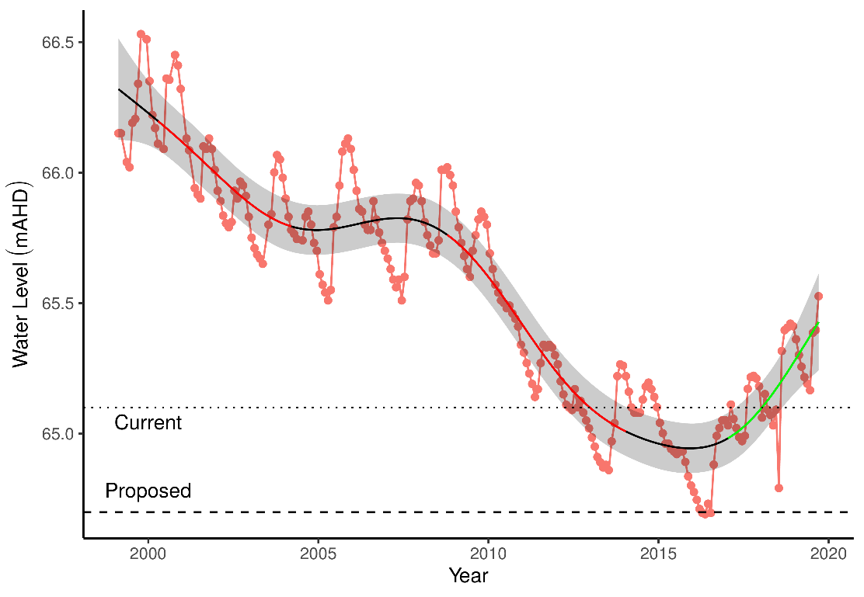

Figure 15 Groundwater levels recorded at bore 61613231 in the vicinity of the Melaleuca Park 78 wetland. Red segments on fitted line represent statistically significant periods of decline and blue represent statistically significant periods of increasing water levels.

### Implications of revised threshold

The current site values are likely to be maintained despite the projected decreases in groundwater levels at Melaleuca Park 78 by 2030 (Table 25). The site will continue to contain a rich native consortium of vegetation that will provide habitat for fauna and important wetland species, such as *Banksia attenuatta* and *Melaleuca preissiana*. There is evidence that the site has recovered substantially from past bushfire events and the ecological water requirements of *M. preissiana* will be met under the proposed changes.

Table 25 Ecological consequences of proposed 2030 minimum threshold (64.7 mAHD) in terms of compliance of stated site values and site management objectives at Melaleuca Park 78 set for the current absolute minimum Ministerial criteria (65.1 mAHD). Future compliance assessments are based on current understandings of the hydrological influences on flora and fauna. They do not include future exogenous factors (like pollution events, introduction of exotic plants or animals) that might or might not occur in the future and affect these compliance estimations.

|  |  |  |
| --- | --- | --- |
|  | Likely effect of 2030 revised minimum threshold (64.7 mAHD) | Values and objectives maintained in future |
| **Site values (WRC, 1997)** |  |  |
| * Supports wetland vegetation | The site is composed of *Banksia* woodland and many groundwater dependent plant species typical of Dampland habitats. Monitoring suggests that the community is relatively stable and has recovered from past fire events. There is evidence of declining *M. preissiana* health in the upper elevations of the wetland. Given the proposed changes in abstraction, it is likely that these species will continue to persist, and the rich native consortium of vegetation will also persist. | Very likely |
| **Site management objectives (WRC, 1997)** |  |  |
| * Maintain wildlife and landscape values of the wetlands | The site will retain the *Banksia* woodlands as a feature and continue to provide habitat to wildlife. It is possible that sustained low water will ultimately kill *M. preissiana* individuals located at higher elevations of the basin. | Very likely |
| * Maintain the existing areas of wetlands and wetland vegetation | Some deep-rooted wetland species, such as *Adenanthos cygnorum,* which are susceptible to groundwater declines, are predicted to increase in cover abundance given a scenario of low ground water levels. It is likely that the site will retain many of key wetland species, but it is unlikely *B. articulata* will return. There is a risk that some wetland vegetation will disappear in the higher elevations of the basin, including *M. preissiana*. | Likely although *M. preissiana* distribution may decrease |
| **Proposed site management objectives** |  |  |
| Limit declines in health of wetland vegetation | There is evidence that the proposed low water levels are sufficient to maintain the health of *Banksia* vegetation, however, *M. preissiana* health has been declining in the upper elevations of the site. The site has experienced very dry conditions similar to the projected water levels since 2010 and the continued decline in health of *M. preissiana* is likely. | Possible. Unlikely for *M. preissiana* |

### 

## MM59B - Whiteman Park East

### Hydrology

Groundwater levels at Whiteman Park East have been declining since 1980, although this decline seems to have stabilised since 2010 (Figure 16). Current 5-year mean maximum and minimum water levels are 0.9 and 0.6 m lower than 1994-1999 levels, respectively (Table 26). Minimum water levels occur in June, while maximums are usually reached in October.

Table 26 Five year summaries of surface water level data at Whiteman Park East.

|  |  |  |  |  |
| --- | --- | --- | --- | --- |
| Period | Mean max seasonal  level (mAHD) | Mean min seasonal  level (mAHD) | Mean seasonal change (m) | Mean max to min (days) |
| 08/1994 – 07/1999 | 37.2 (Oct) | 36.2 (Jun) | 1.08 | 229 |
| 08/1999 – 07/2004 | 37.2 (Oct) | 36.1 (Jun) | 1.11 | 244 |
| 08/2004 – 07/2009 | 36.6 (Sep) | 35.8 (Jun) | 0.86 | 244 |
| 08/2009 – 07/2014 | 36.2 (Oct) | 35.5 (Jun) | 0.72 | 249 |
| 08/2014 – 07/2019 | 36.3 (Oct) | 35.6 (Jun) | 0.69 | 249 |

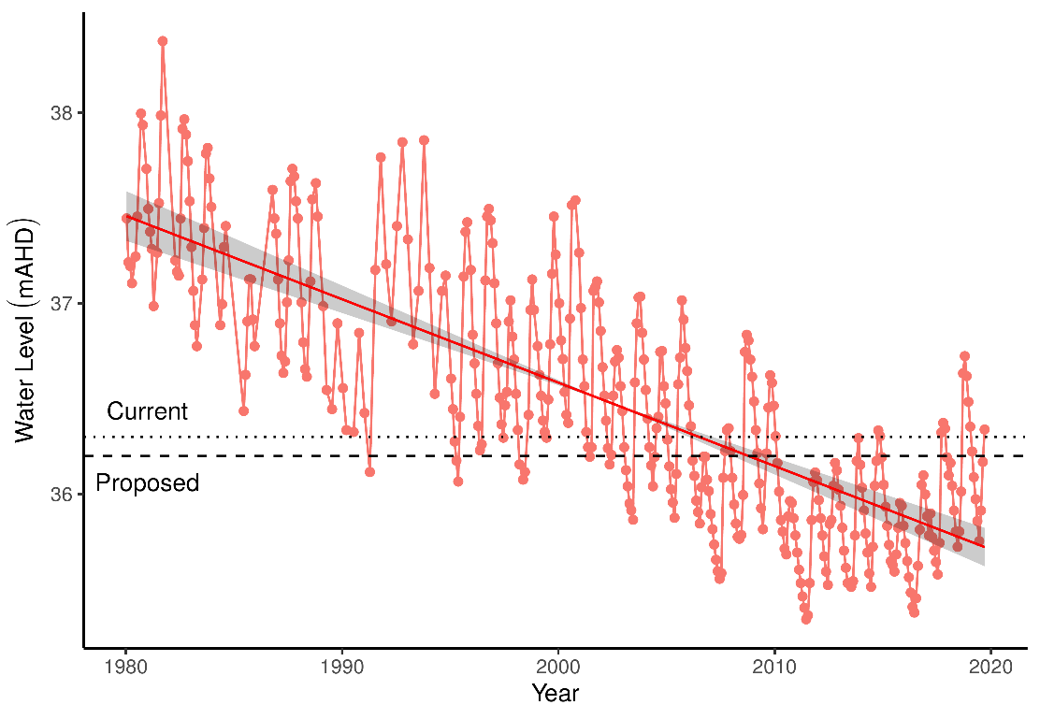

Figure 16 Groundwater levels recorded at bore 61610661 in the vicinity of MM59B. Red segments represent periods of significant decline in groundwater level while green segments represent periods of significant increase in groundwater level.

### Implications of revised threshold

The site contains a fairly sparse understory and open mixed woodland canopy consisting of *Banksia* spp., *Allocasuarina fraseriana*, *Nuytsia floribunda* and *Eucalyptus todtiana*. *Banksia* species found at the site include *B. attenuata*, *B. ilicifolia* and *B. menziesii*. Vegetation is slightly degraded with signs of rabbits evident. Species richness and diversity are notably less than some of the other Pinjar sites and more exotic species, such as *Ursinia anthemoides*, are present at high cover abundances. Predominant native understory species include *Scholtzia involucrata*, *Calytrix* spp. and *Patersonia occidentalis*. *Banksia* spp. health was mostly good, although some *B. attenuata* appeared to be approaching senescence, and a number of dead *Banksia* are also present. Recruitment was present but low.

The projected increases in groundwater level are likely to have a positive impact on the health of the *Banksia* stands as groundwater becomes more readily available. However, such predictions are speculative as there has been no monitoring programme at this site and the shifts associated with groundwater decline are unknown. Nonetheless, the projected increases in groundwater levels at this site will ensure the *Banksia* woodland remains within 5 m of groundwater throughout the year (assuming a ground elevation of 41.2 mAHD). This will allow the woodland to be somewhat dependent upon groundwater and enhance the health of *Banksia* individuals.

Table 27 Ecological consequences of proposed 2030 minimum threshold (36.2 mAHD) in terms of compliance of stated site values and site management objectives at MM59B (Whiteman Park East) set for the current absolute minimum Ministerial criteria (36.3 mAHD). Future compliance assessments are based on current understandings of the hydrological influences on flora and fauna. They do not include future exogenous factors (like pollution events, introduction of exotic plants or animals) that might or might not occur in the future and affect these compliance estimations.

|  |  |  |
| --- | --- | --- |
|  | Likely effect of 2030 revised minimum threshold (36.2 mAHD) | Values and objectives maintained in future |
| **Site values (WAWA, 1995)** |  |  |
| * Selected to represent water levels over area of undisturbed phreatophytic vegetation | The site contains some important wetland species, including *Banksia* species, *E. todtiana*, *N. floribunda*, *S. involucrate* and *Calytrix* sp. However, the site is compromised by predation from rabbits and high abundance of exotic species. | Unlikely |
| * Banksia woodland <8m depth to groundwater | *Banksia* woodland appears in good health current low groundwater levels are not causing water stress. Given the proposed threshold will require groundwater levels to be higher than current levels, it is likely that *Banksia* woodland will remain healthy. | Likely |
| **Site management objectives (WAWA, 1995)** |  |  |
| * To protect terrestrial vegetation | The high predation from rabbits probably pose the greatest threat to the vegetation currently found at the site. | Possible |
| **Proposed site management objectives** |  |  |
| Improve groundwater levels to improve the condition of dependent vegetation and potential *Banksia* woodland threatened community | Low groundwater levels and predation by rabbits appears the be affecting the health of the *Banksia* woodland at this site. Managing water levels above the proposed minimum threshold are likely to be sufficient to improve the health of the *Banksia* stands as the projected increases represent maintenance of groundwater levels within 5 m of the surface. | Likely |

### 

## PM9 - Pinjar North

### Hydrology

Groundwater at PM9 have almost continually been in decline since 1980 from approximately 59 mAHD to 2016 levels around 53 mAHD (Figure 17). The most significant rate of decline has been occurring since 1995 to 2016. Maximum and minimal seasonal water levels are 4 and 5 m lower now than in the 1994-1999 period, respectively (Table 28). Since 2016, no measurements at bore 61610804 have been made due to the operation of a nearby rifle range. It is unknown if groundwater levels have continued to decline since 2016 because no measurements have been recorded due to safety concerns regarding access to the bore. If the observed decline has continued, groundwater levels at the site may currently be below 52 mAHD, representing more than a 7 m decline since 1980.

Table 28 Five year summaries of surface water level data at Pinjar North. The final period is based on data up to 2016 only.

|  |  |  |  |  |
| --- | --- | --- | --- | --- |
| Period | Mean max seasonal  level (mAHD) | Mean min seasonal  level (mAHD) | Mean seasonal change (m) | Mean max to min (days) |
| 08/1994 – 07/1999 | 58.4 (Nov) | 57.7 (Jun) | 0.73 | 252 |
| 08/1999 – 07/2004 | 57.5 (Sep) | 56.8 (Jul) | 0.68 | 201 |
| 08/2004 – 07/2009 | 56.5 (Oct) | 56.0 (Jul) | 0.49 | 257 |
| 08/2009 – 07/2014 | 55.2 (Nov) | 54.7 (Sep) | 0.44 | 207 |
| 08/2014 – 07/2016 | 54.4 (Dec) | 52.8 (May) | 1.55 | 242 |

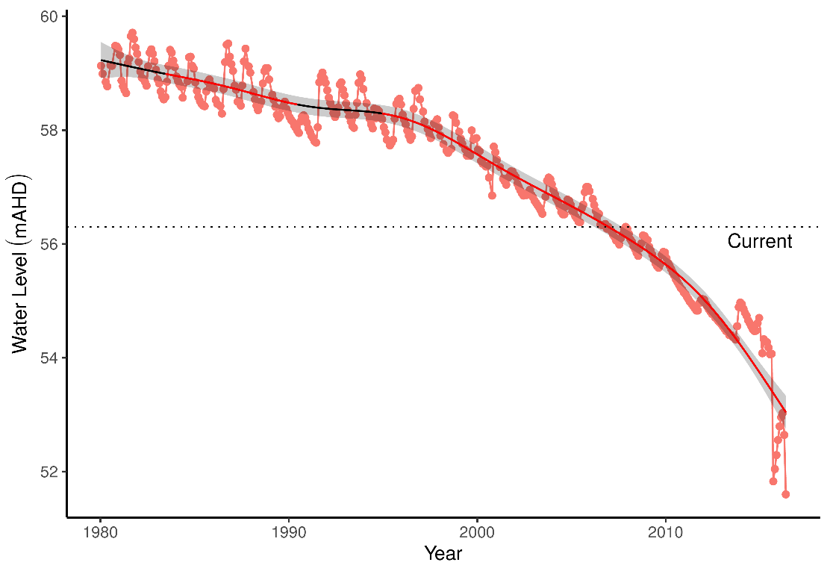

Figure 17 Groundwater levels recorded at bore 61610804 in the vicinity of PM9. Red segments along trendline indicate periods of significant decline in groundwater levels.

### Implications of revised threshold

The significant declines in groundwater levels at this site currently mean the water table is 12 m below the surface. Vegetation at this site is therefore no longer groundwater dependent. It is likely vegetation at this site has experienced significant shifts since 2008 as water levels declined to more than 8 m below the surface. Projected changes to groundwater suggest that further declines are likely. Therefor the site will continue to lose any value as a groundwater dependent system.

## WM1 - Pinjar

WM1 is located east of Lake Pinjar in the Chitty Road Bushland within the Bassendean north vegetation complex. Water levels at WM1 have been non-compliant since 2001.

### Hydrology

Groundwater levels at WM1 have declined up to 4.0 m since 1980, although recent rainfall has increased levels from 54.4 to 55.5 mAHD since 2015 (Figure 18). Current mean maximum and minimum water levels are 2.0 and 1.7 m lower than 1994-1999 levels (Table 29). Maximum water levels generally occur in October and minimum water levels are now occurring later in the year than previously.

Table 29 Five year summaries of surface water level data at Pinjar (WM1).

|  |  |  |  |  |
| --- | --- | --- | --- | --- |
| Period | Mean max seasonal  level (mAHD) | Mean min seasonal  level (mAHD) | Mean seasonal change (m) | Mean max to min (days) |
| 08/1994 – 07/1999 | 57.1 (Nov) | 56.2 (Apr) | 0.95 | 217 |
| 08/1999 – 07/2004 | 56.5 (Oct) | 55.6 (Jun) | 0.86 | 246 |
| 08/2004 – 07/2009 | 55.9 (Oct) | 55.1 (Jul) | 0.81 | 200 |
| 08/2009 – 07/2014 | 54.9 (Oct) | 54.3 (Aug) | 0.54 | 204 |
| 08/2014 – 07/2019 | 55.1 (Oct) | 54.5 (Aug) | 0.57 | 110 |

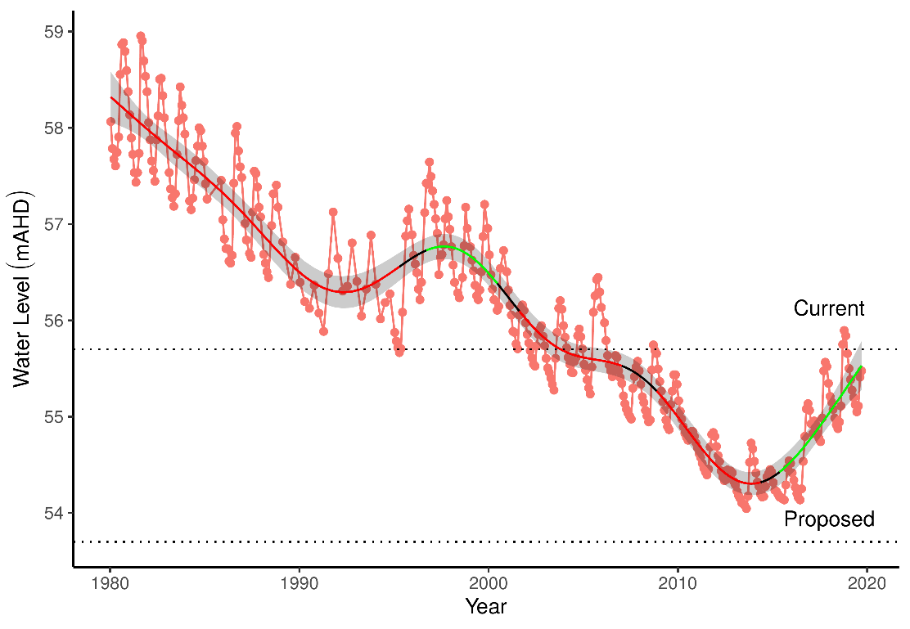

Figure 18 Groundwater levels recorded at bore 61610833 in the vicinity of WM1. Red segments along trendline indicate periods of significant decline in groundwater levels and green segments represent significant increases in groundwater level.

### Implications of revised threshold

The area has been affected by fire in the past (sometime between early Jan 2015 and late February 2015) and some of the older *Banksias* on the transect have old fire scars. Vegetation structure and community composition of the site is typical *Banksia* woodland, consisting of overstorey species *B. attenuata*, *B. menziesii* and *B. ilicifolia* and a typically diverse dry land understory of *Acacia pulchella*, *Adenanthos cygnorum*, *Jacksonia* spp and *Xanthorrhoea preissii*. Although not recorded in the transect, *Melaleuca preissiana* has been noted nearby. In general, *Banksia* health appears good despite several individuals having significant insect damage and yellow leaves. Previous reports have document the decline of vegetation at this site due to declining groundwater levels (Department of Water, 2008; Water and Rivers Commission, 2004). The trends included a general thinning of the understory, *B. attenuata* deaths, declining condition of *B. ilicifolia* and *B. menziessi*. *Eucalyptus todtiana* and *Corymbia calophylla* have also been reported to be declining in health in 2008 (Department of Water, 2008).

The projected decline of groundwater in 2030 is to levels lower than what has previously observed at this site. This decline will hasten the decline of canopy health of species dependent on groundwater, including *B. attenuata*. Terrestrial species, such as *Acacia* species and *Xanthorrhoea preissii* are likely to become more abundant at the site, although these predictions are speculative because no long-term monitoring has occurred at the site. Despite these predicted low groundwater levels, the decline should arrest and be maintained to minimum levels that are less than 6.9 m below the surface levels (assuming ground level at 60.6 mAHD). Individuals that are located more than 6 m above the groundwater are unlikely to be groundwater dependent and instead rely on rainfall. It is likely that this wood land will not be dependent on groundwater given the projected groundwater levels.

Table 30 Ecological consequences of proposed 2030 minimum threshold (53.7 mAHD) in terms of compliance of stated site values and site management objectives at WM1 set for the current absolute minimum Ministerial criteria (55.7 mAHD). Future compliance assessments are based on current understandings of the hydrological influences on flora and fauna. They do not include future exogenous factors (like pollution events, introduction of exotic plants or animals) that might or might not occur in the future and affect these compliance estimations.

|  |  |  |
| --- | --- | --- |
|  | Likely effect of 2030 revised minimum threshold (53.7 mAHD) | Values and objectives maintained in future |
| **Site values (WAWA, 1995)** |  |  |
| * Selected to represent water levels over area of undisturbed phreatophytic vegetation | Phreatophytic vegetation at this site has already undergone changes associated with the declining groundwater level. This site still represents typical *Banksia* woodland although the understory has likely shifted to one dominated by dryland species. Given the low groundwater levels, it is possible that fire disturbance could shift the composition of the woodland dramatically. Water levels are likely to be below 6 m, and up to 7 m below the surface. Therefore, the vegetation is unlikely to be dependent on groundwater. | Unlikely given continued low groundwater levels |
| * *Banksia* woodland <8m depth to groundwater | The projected changes in water level should maintain the groundwaters within 6.9 m of the surface level (assuming ground elevation of (60.6 mAHD) | Likely |
| **Site management objectives (WAWA, 1995)** |  |  |
| * To protect terrestrial vegetation | Terrestrial vegetation will persist at the site but may not be dependent on groundwater. | Likely |
| * Maintain the existing extent and variety of wetland vegetation | It is unlikely that the vegetation will be groundwater dependent as groundwater levels will frequently be below 6 m from the surface. Groundwater dependent vegetation unlikely to meet their water requirements from rainfall may continue to be loss. | Unlikely |
| **Proposed site management objectives** |  |  |
| To avoid significant impacts to the habitat values of the *Banksia* woodland community as it transitions from groundwater-dependent to non-groundwater dependent vegetation | Much of the groundwater dependent vegetation has already been lost from the site. Further losses are likely although it is possible that remaining *Banksia* individuals can rely solely on rainfall and persist into the future. | Likely as changes may have already occurred |

## WM2 - Melaleuca Park North

Located in Melaleuca Park in the Bassendean north vegetation complex, the area represents an area of undisturbed phreatophytic vegetation, including *Banksia* woodlands.

### Hydrology

There have been periods of significant decline in groundwater levels from 68.8 mAHD in 1980 to 66.4 mAHD in 2014 (Figure 19). The projected declines in groundwater levels at this site are significant and represent changes up to 1 m below levels ever recorded for the site. Since 2015, there has been an increase in groundwater to slightly above 67 mAHD. Mean maximum and minimum seasonal water levels are now 1.5 and 0.9 m lower than the period 1994-1999. Maximum levels have consistently been reached in October, on average (Table 31).

Table 31 Five year summaries of surface water level data at Melaleuca Park North (WM2).

|  |  |  |  |  |
| --- | --- | --- | --- | --- |
| Period | Mean max seasonal  level (mAHD) | Mean min seasonal  level (mAHD) | Mean seasonal change (m) | Mean max to min (days) |
| 08/1994 – 07/1999 | 68.5 (Nov) | 67.6 (Sep) | 0.94 | 216 |
| 08/1999 – 07/2004 | 68.1 (Oct) | 67.4 (Feb) | 0.68 | 246 |
| 08/2004 – 07/2009 | 67.7 (Oct) | 67.1 (Apr) | 0.62 | 205 |
| 08/2009 – 07/2014 | 66.8 (Oct) | 66.4 (Apr) | 0.46 | 210 |
| 08/2014 – 07/2019 | 67.0 (Oct) | 66.5 (Mar) | 0.52 | 79 |

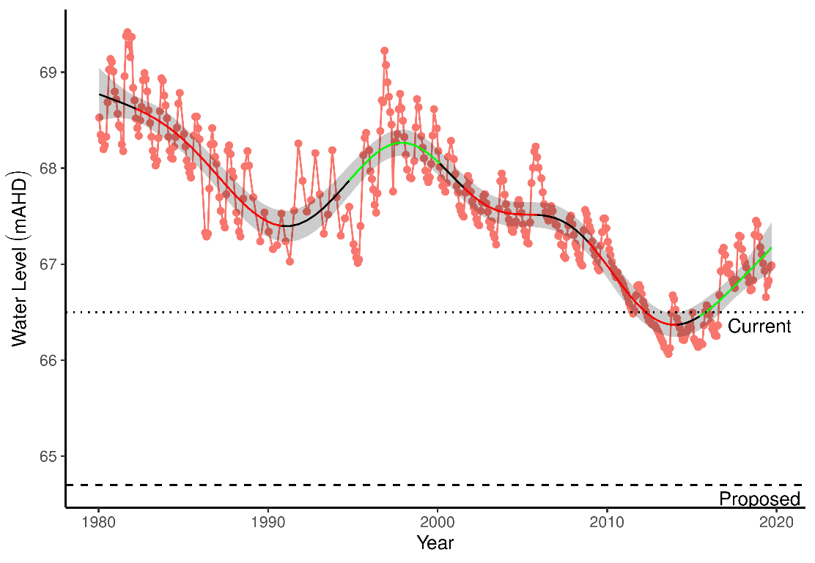

Figure 19 Groundwater levels recorded at bore 61610908 in the vicinity of WM2. Red segments along trendline indicate periods of significant decline in groundwater levels and green segments represent significant increases in groundwater level.

### Implications of revised threshold

The vegetation around monitoring bore WM2 has similar vegetation composition as WM1. The vegetation also appears to have been affected by fire in the summer of 2014/2015. The understory is highly diverse, with *Acacia pulchella*, *Adenanthos cygnorum* and *Xanthorrhoea preissii* common. Canopy cover is quite open, with several mature *Banksias* present. Most *Banksias* were resprouts and/or young trees between 1 and 3 m tall. Several mature trees bore significant epicormic growth. New *Banksia* recruitment (mainly very small seedlings) for *Banksia attenuata* and *Banksia menziessi* have been observed.

The projected declines in groundwater at this site are likely to have a serious impact on groundwater dependent trees such as *Banksia attenuata* and *Banksia menziessi*. The health of these trees is likely to decline as groundwaters approach 65 mAHD as the groundwater is expected to reach more than 7 m below the surface. The diverse understory is likely to continue to be composed of terrestrial species such as *Acacia pulchella* and *Xanthorrhoea preissii*. Long term monitoring at this site is likely to capture significant shifts in vegetation composition if groundwater declines to the project levels by 2030.

Table 32 Ecological consequences of proposed 2030 minimum threshold (64.7 mAHD) in terms of compliance of stated site values and site management objectives at WM2 set for the current absolute minimum Ministerial criteria (66.5 mAHD). Future compliance assessments are based on current understandings of the hydrological influences on flora and fauna. They do not include future exogenous factors (like pollution events, introduction of exotic plants or animals) that might or might not occur in the future and affect these compliance estimations.

|  |  |  |
| --- | --- | --- |
|  | Likely effect of 2030 revised minimum threshold (64.7 mAHD) | Values and objectives maintained in future |
| **Site values (WAWA, 1995)** |  |  |
| * Selected to represent water levels over area of undisturbed phreatophytic vegetation | Declining groundwaters have deteriorated the site as an example of undisturbed phreatophytic vegetation. The site is unlikely to be dependent on groundwater as groundwater levels are predicted to be more than 7 m below the surface. | Unlikely |
| * *Banksia* woodland <8m depth to groundwater | Water levels should not decline past 7.2 m below the surface. | Likely |
| **Site management objectives (WAWA, 1995)** |  |  |
| * To protect terrestrial vegetation | Vegetation is likely to shift to one dominated by dryland species. Some wetland species, such as *Banksia* may persist and intermittently access groundwaters when levels are high. | Likely |
| * Maintain the existing extent and variety of wetland vegetation | As above. Vegetation is unlikely to be groundwater dependent given the projected declines. | Unlikely |
| **Proposed site management objectives** |  |  |
| To avoid significant impacts to the habitat values of the *Banksia* woodland community as it transitions from groundwater-dependent to non-groundwater dependent vegetation | Much of the groundwater dependent vegetation has already been lost from the site. Further losses are likely although it is possible that remaining *Banksia* individuals can rely solely on rainfall and persist into the future. | Likely as changes may have already occured |

### 

## WM8 - Melaleuca Park

The WM8 monitoring bore is in Melaleuca Park within the Bassendean north vegetation complex and represents native vegetation that may be affected by abstraction from the Lexia groundwater scheme. There has been no reported change in vegetation at the site, although no monitoring or transects have been established here.

### Hydrology

Groundwater levels began to decline in 2000 at WM8 from approximately 66.0 mAHD to 64.6 mAHD in 2015 (Figure 20). Since 2015, there has been an increase in groundwater levels to approximately 65.5 mAHD. Mean maximum and minimum seasonal water levels have declined by 1.3 and 1.0 m, respectively (Table 33). Maximum levels are generally reached in December while minimum levels are reached in July.

Table 33 Five year summaries of surface water level data at Melaleuca Park (WM8).

|  |  |  |  |  |
| --- | --- | --- | --- | --- |
| Period | Mean max seasonal  level (mAHD) | Mean min seasonal  level (mAHD) | Mean seasonal change (m) | Mean max to min (days) |
| 08/1994 – 07/1999 | 66.3 (Oct) | 65.7 (Jul) | 0.65 | 230 |
| 08/1999 – 07/2004 | 66.0 (Dec) | 65.5 (Jun) | 0.53 | 180 |
| 08/2004 – 07/2009 | 65.6 (Nov) | 65.2 (Jul) | 0.40 | 256 |
| 08/2009 – 07/2014 | 65.0 (Nov) | 64.7 (Aug) | 0.36 | 200 |
| 08/2014 – 07/2019 | 65.0 (Dec) | 64.7 (Jul) | 0.33 | 30 |

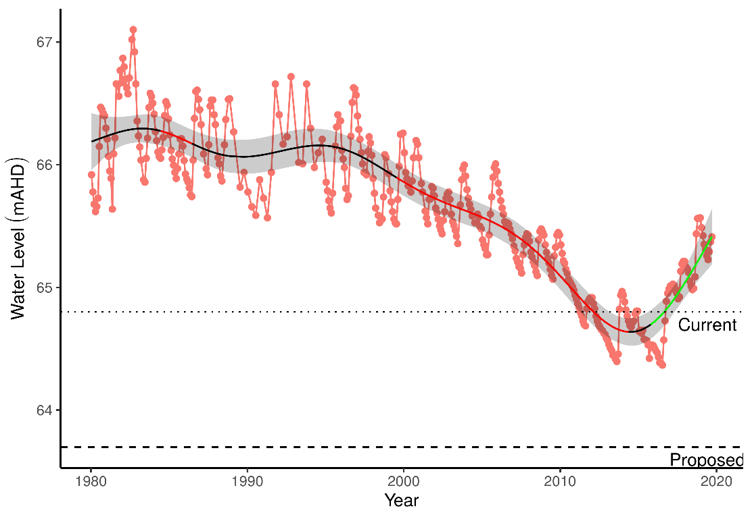

Figure 20 Groundwater levels recorded at bore 61610983 in the vicinity of WM8. Red segments along trendline indicate periods of significant decline in groundwater levels and green segments represent significant increases in groundwater level.

### Implications of revised threshold

The vegetation community at WM8 is typical of *Banksia* woodland. There is a sparse understory composed predominately of *Lyginia barbata*, *Scholtzia involucrata* and *Eremaea pauciflora*. The canopy is open and consists predominately of *Banksia attenuata* and *B. menziesii*. Tree health at the site was good although several dead mature *Banksias* were present. There is evidence of recent *Banksia attenuata* recruitment, mainly in the form of small seedlings. *Jacksonia floribunda* in notably poorer health than at the other Pinjar sites (WM1 and WM2).

Similar to the other Pinjar sites, the projected decline in groundwaters by 2030 are very likely to have a detrimental effect on species accesses the groundwater. Groundwaters are projected to decline to 7.2 m below the surface. The site will therefore transition away from groundwater dependence. The understory is likely to remain dominated by dryland species. Some wetland species may persist. These species include the important canopy forming *Banksia attenuata*. Long term monitoring the site is likely to detect the shift of the *Banksia* woodland to a community dominated by terrestrial species by 2030 if groundwaters decline as predicted.

Table 34 Ecological consequences of proposed 2030 minimum threshold (63.7 mAHD) in terms of compliance of stated site values and site management objectives at WM8 set for the current absolute minimum Ministerial criteria (64.8 mAHD). Future compliance assessments are based on current understandings of the hydrological influences on flora and fauna. They do not include future exogenous factors (like pollution events, introduction of exotic plants or animals) that might or might not occur in the future and affect these compliance estimations.

|  |  |  |
| --- | --- | --- |
|  | Likely effect of 2030 revised minimum threshold (63.7 mAHD) | Values and objectives maintained in future |
| **Site values (WAWA, 1995)** |  |  |
| * Selected to represent water levels over area of undisturbed phreatophytic vegetation | Declining groundwaters have deteriorated the site as an example of undisturbed phreatophytic vegetation. The site is unlikely to be dependent on groundwater as groundwater levels are predicted to be more than 7 m below the surface. | Unlikely |
| * *Banksia* woodland <8m depth to groundwater | Water levels should not decline past 7.2 m below the surface. | Likely |
| **Site management objectives (WAWA, 1995)** |  |  |
| * To protect terrestrial vegetation | Vegetation is likely to shift to one dominated by dryland species. Some wetland species, such as *Banksia* may persist and intermittently access groundwaters when levels are high. | Likely |
| * Maintain the existing extent and variety of wetland vegetation | As above. Vegetation is unlikely to be groundwater dependent given the projected declines. | Unlikely |
| **Proposed site management objectives** |  |  |
| To avoid significant impacts to the habitat values of the *Banksia* woodland community as it transitions from groundwater-dependent to non-groundwater dependent vegetation | Much of the groundwater dependent vegetation has already been lost from the site. Further losses are likely although it is possible that remaining *Banksia* individuals can rely solely on rainfall and persist into the future. | Likely as changes may have already occurred |

### 

# Task 4: East Wanneroo maximum threshold revisions

It is projected that a number of Spearwood/East Wanneroo lakes could experience a substantial increase in water levels due to increased recharge from urban development and decreased abstraction. Surrounding groundwater levels at Lake Goollelal are projected to increase by 0.4 m while groundwater levels surrounding Lake Mariginiup may increase by up to 3.9 m from 2013 levels.

Revised maximum thresholds are proposed here that increase proportionally with the proposed minimum thresholds (Table 35). For example, at Lake Goollelal the minimum threshold is proposed to increase by 0.4 m (from 26.0 to 26.4 mAHD), therefore a similar 0.4 m increase in the maximum threshold is recommended. However, care has been taken to ensure that maximum water levels are not greater than 1.5 m above fringing vegetation elevations, hence only a 0.5 m maximum threshold is proposed for Lake Mariginiup where a 0.6 m rise in minimum threshold is proposed. The proposed maximum thresholds should maintain the current hydrological regimes of each lake and preserve the current hydrological gradients and fringing vegetation communities that currently exist.

Careful attention should be paid to the scenario proposed for Lake Mariginiup. The projected changes to surface water levels are significant and will cause a significant shift in the distribution of fringing vegetation. The survival of these populations will depend upon the rate of inundation being low enough that the species are able to migrate upslope. An alternative is to propose a minimum threshold that will maintain vegetation distributions like those currently observed. A minimum threshold of 41.5 mAHD (the current minimum threshold) will satisfy this requirement, while a maximum threshold of 42.6 mAHD will satisfy the maximum water depths of fringing vegetation and provide the range in water depths required to provide water bird habitat.

Table Summary of proposed water level changed projected for four lakes likely to experience increased water levels (compared to 2013 levels) under the proposed changes to groundwater abstraction. Maximum thresholds are proposed here (Proposed maximum threshold) to ensure current hydrological regimes are maintained. Range of plot elevations refer to the elevation gradient captured by the vegetation monitoring transects where the minimum values represent elevation of fringing vegetation.

|  |  |  |  |  |  |  |
| --- | --- | --- | --- | --- | --- | --- |
| Wetland | Current minimum threshold (mAHD) | Proposed minimum threshold (mAHD) | Projected increase of surrounding groundwater (m) | Current maximum threshold (mAHD) | Proposed maximum threshold (mAHD) | Range of plot elevations (mAHD) |
| Lake Goollelal | 26.0 | 26.4 | 0.4 | 27.5 | 27.9 | 26.7-27.0 |
| Lake Joondalup | 15.8 | 16.2 | 2.1 | 17.6 | 18.0 | 16.9-20.3 |
| Lake Mariginiup | 41.5 | 42.1 | 3.9 | 42.6 | 43.1 | 41.6-41.9 |
| Lake Jandabup | 44.2 | 44.3 | 3.4 | 46.1 | 46.2 | 45.0-48.3 |

# Task 5: Review of Lake Gwelup management

Lake Gwelup is a shallow groundwater system located in the highly urbanised area of Gwelup/Karrinyup. The lake was once permanently inundated with surface waters dependent on groundwater. These hydrological conditions made the lake an important habitat to a variety of fauna and fringing vegetation. However, between 2001 and 2016, the lake has been dry during the summer Recent years have seen the lake contain surface water year round.

The wetland does not currently have Ministerial water level criteria. Proposed minimum and maximum thresholds are provided here to facilitate the development of management objectives. It is projected that groundwater levels in the surrounding area will rise by about 0.6 m from 2013 levels, probably resembling current conditions somewhat.

## Hydrology

Lake water levels were first monitored in 1960, but regular monitoring has occurred between 1967 and 1988, and from 1999 until the present. Lake levels in the 1970s and 1980s were 1m to 2m higher than in the 2000s (Figure 21). They have risen again since 2013 following a reduction in nearby public water supply abstraction, and levels are currently similar to levels in the 1980s and 1990’s (Table 36). The nearby bore 61610032 has been monitored since 1972. Water levels at the bore have declined by around 4 meters since the start of monitoring. Levels have been reasonably stable since the early 2000s and have trended slightly upwards since 2011.

Table 36 Five year summaries of surface water level data at Lake Gwelup.

|  |  |  |  |  |
| --- | --- | --- | --- | --- |
| Period | Mean max seasonal  level (mAHD) | Mean min seasonal  level (mAHD) | Mean seasonal change (m) | Mean max to min (days) |
| 08/1994 – 07/1999 | 7.5 (Sep) | 5.7 (Apr) | 1.85 | 239 |
| 08/1999 – 07/2004 | 6.7 (Oct) | 5.1 (Apr) | 1.52 | 172 |
| 08/2004 – 07/2009 | 6.3 (Sep) | 5.0 (Dec) | 1.32 | 14 |
| 08/2009 – 07/2014 | 6.1 (Oct) | 5.0 (Jan) | 1.17 | 138 |
| 08/2014 – 07/2019 | 7.3 (Oct) | 5.6 (Apr) | 1.66 | 222 |

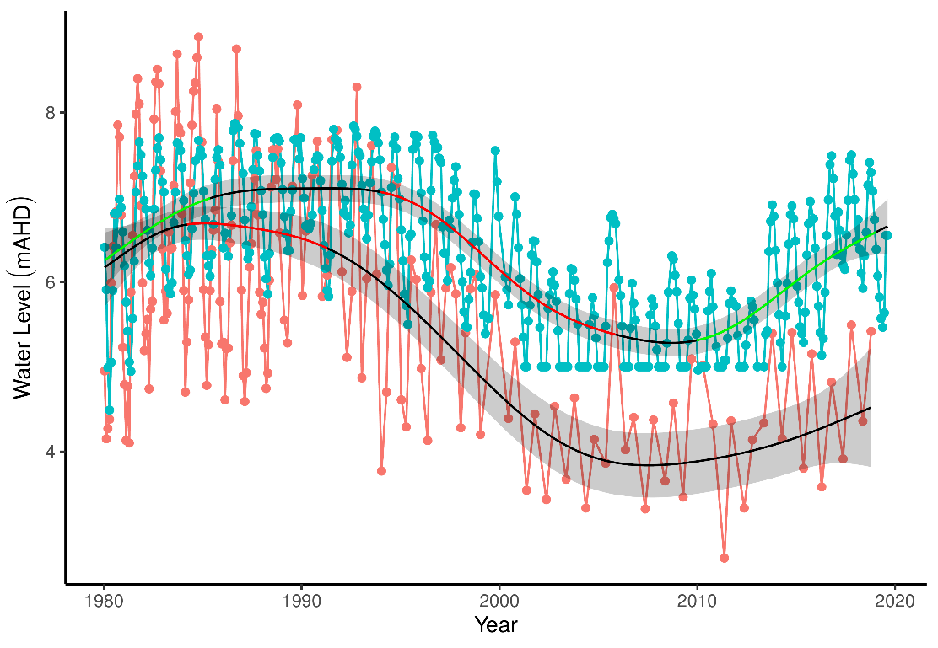

Figure 21 Ground and surface water levels for Lake Gwelup recorded at bore 61610032 (red) and staff 6162504 (blue). The minimum recordable water level for the staff gauge is 5.0 mAHD. Blue dots at 5.0 mAHD represent water levels below the minimum level measurable by the staff. Red segments on fitted line represent statistically significant periods of decline and blue represent statistically significant periods of increasing water levels.

## Proposed thresholds

The key wetland vegetation species at Lake Gwelup include *Melaleuca rhaphiophylla* and *Eucalyptus rudis* (Buller et al., 2018). The important bullrush species, *Typha orientalis*, has also been recorded at the lake but is absent from monitoring transects (Buller et al., 2018; Froend et al., 2009b). There is no information regarding aquatic macroinvertebrate trends at Lake Gwelup, but due to the importance of fringing and emergent vegetation providing habitat, proposed thresholds that aim to protect the surrounding vegetation can be considered a surrogate for the ecological water requirements for aquatic macroinvertebrates. However, increased inflow from stormwater needs to be monitored as pollution, primarily nutrient enrichment, may have a detrimental effect on macroinvertebrate assemblages. Because of the permanent surface water that typically occurs, the site is an important habitat for waterbirds. Shallow water is required by wader species in summer to facilitate feeding and high waters in winter to prevent the spread of vegetation throughout the basin.

Froend et al., (2004b) suggest that absolute minimum ecological water requirements for *M. rhaphiophylla*, *E. rudis* and *T. orientalis* are 2.14, 3.26 and 0.95 m below surface levels, respectively. Clohessy (2012) determined, that based on the lowest elevation occurrence of individuals at Lake Gwelup, the ecological water requirements at this site may be 4.24 and 3.86 mAHD for *M. rhaphiophylla* and *E. rudis*, respectively.

However, as the proposed management objectives for Lake Gwelup include the maintenance of permanent surface water, a minimum threshold needs to ensure that minimum water levels do not fall below the surface of the lake (approximately 5.0 mAHD). Considering the projected local rises in groundwater levels of 0.6 m from 2013 levels, maintaining surface water levels at the staff gauge that resemble the 1990-2000 hydrological regime could be met. The following thresholds are suggested for the staff gauge 6162504:

* Minimum threshold: 5.4 mAHD
* Maximum threshold: 7.6 mAHD

These thresholds will ensure permanent water exists in the lake, enough variation in water levels for water bird feeding habitat, absolute minimum ecological water requirements for fringing vegetation are met and that maximum water levels prevent loss of important fringing vegetation (*M. rhaphiophylla* and *E. rudis*). An assessment of the proposed management objectives for the proposed thresholds is provided in Table 35.

Table 37 Ecological consequences of proposed minimum threshold of 5.4 mAHD and maximum threshold of 7.6 mAHD at staff gauge 6162504 in terms of compliance of proposed site management objectives at Lake Gwelup. Future compliance assessments are based on current understandings of the hydrological influences on flora and fauna. They do not include future exogenous factors (like pollution events, introduction of exotic plants or animals) that might or might not occur in the future and affect these compliance estimations.

|  |  |  |
| --- | --- | --- |
|  | Likely effect of proposed minimum and maximum thresholds (5.4 – 7.6 mAHD) | Future Compliance |
| To maintain permanent water for fauna habitat and for visual amenity | Managing surface water levels above 5.4 mAHD will ensure permanent water remains a feature of Lake Gwelup. Seasonal minimum surface water levels greater than 5.4 mAHD will ensure habitat for aquatic fauna and flora. Permanent surface water will also enhance the visual amenity of the lake. Seasonal variation in surface water levels should be sufficient to provided feeding habitat for visiting and resident water birds. | Very likely |
| To maintain permanent water for fringing vegetation | The minimum and maximum thresholds provided here will ensure that fringing vegetation of *E. rudis*, *M. rhaphiophylla* and *T. orientalis* are maintained. The occurrence of surface water will ensure the ecological water requirements for these key species, while the maximum threshold will prevent the death of fringing vegetation when maximum water levels occur. | Very likely |

# References

Bamford, M.J., Bamford, A.R., 2003. Vertebrate Fauna: Values and Groundwater Dependence in the Gnangara Study Area. Water; Rivers Commission, Perth, Western Australia.

Boucher, B., 2000. Biogeography of a changing landscape: Pipidinny Swamp, Yanchep National Park Western Australia. Faculty of Community Services, Education and Social Sciences, Edith Cowan University, Joondalup.

Buller, G., Kavazos, C.R.J., Froend, R., 2019. Wetland Vegetation Monitoring 2018 Survey of Gnangara Wetlands. Edith Cowan University, Joondalup.

Buller, G., Kavazos, C.R.J., Froend, R., 2018. Wetland Vegetation Monitoring 2017 Survey of Gnangara Wetlands. Edith Cowan University, Joondalup.

Clohessy, S. G., 2012, Perth Shallow Groundwater Systems Investigation: Lake Gwelup, Hydrogeological record series, report no. HG56, Department of Water, Perth, Western Australia.

Department of Water, 2011. Groundwater-surface water interaction along Gingin Brook Western Australia (No. January). Government of Western Australia.

Department of Water, 2008. Review of ministerial conditions on the groundwater resources of the Gnangara Mound (No. January). Department of Water, Perth, Western Australia.

England, M.H., Ummenhofer, C.C., Santoso, A., 2006. Interannual rainfall extremes over southwest Western Australia linked to Indian Ocean climate variability. Journal of Climate 19, 1948–1969. <https://doi.org/10.1175/JCLI3700.1>

Environmental Protection Authority, 1998. Groundwater resource allocation, East Gnangara. Bulletin 904. Environmental Protection Authority, Perth, Western Australia.

Environmental Protection Authority, 2018. Instructions on how to prepare Environmental Protection Act 1986 Part IV Environmental Management Plans. Government of Western Australia.

Froend, R., Loomes, R., Horwitz, P., Rogan, R., Lavery, P., How, J., Storey, A.W., Bamford, M., Metcalf, B., 2004a. Study of Ecological Water Requirements on the Gnangara and Jandakot Mounds under Section 46 of the EP Act. Task 1: Identification and Re-valuation of Ecological Values. Centre for Ecosystem Management, Edith Cowan University, Joondalup, Western Australia.

Froend, R., Loomes, R., Horwitz, P., Bertuch, M., Storey, A., Bamford, M., 2004b. Study of Ecological Water Requirements on the Gnangara and Jandakot Mounds under Section 46 of the EP Act. Task 2: Determination of Ecological Water Requirements. Centre for Ecosystem Management, Edith Cowan University, Perth, Western Australia.

Froend, R., Loomes, R., Rogan, R., 2005 Study of Ecological Water Requirements on the Gnangara and Jandakot Mounds under Section 46 of the EP Act. Tasks 3 and 5: Parameter Identification and Monitoring Program Review. Centre for Ecosystem Management, Edith Cowan University, Perth, Western Australia.

Groom, P.K., Froend, R.H., Mattiske, E.M., 2000. Impact of groundwater abstraction on a Banksia woodland, Swan Coastal Plain, Western Australia. Ecological Management & Restoration 1, 117–124.

Hill, A.L., Semeniuk, C.A., Semeniuk, V., Marco, A.D., 1996. Wetland Mapping, Classification and Evaluation, Main Report, in: Wetlands of the Swan Coastal Plain. Perth, Western Australia.

Horwitz, P., Bradshaw, D., Hopper, S., Davies, P., Froend, R., Bradshaw, F., 2008. Hydrological change escalates risk of ecosystem stress in Australia’s threatened biodiversity hotspot. Journal of the Royal Society of Western Australia 91, 1–11.

Horwitz, P., Rogan, R., Halse, S., Davis, J. and Sommer, B. (2009). Wetland invertebrate richness and endemism on the Swan Coastal Plain, Western Australia. Marine and Freshwater Research 60: 1006-1020.

Horwitz, P., Sommer, B., Froend, R., 2009a. Wetlands and groundwater dependent ecosystems of the Gnangara Mound, in: Gnangara Sustainability Strategy. Centre for Ecosystem Management, Edith Cowan University, Joondalup, Western Australia, pp. 1–48.

Horwitz, P., Sommer, B., Hewitt, P., 2009b. Wetland: Changes and losses, in: Gnangara Sustainability Strategy. Centre for Ecosystem Management, Edith Cowan University, Joondalup, Western Australia, pp. 1–33.

Hui, F.K., 2016. boral – Bayesian Ordination and Regression Analysis of Multivariate Abundance Data in r. Methods in Ecology and Evolution 7, 744–750. <https://doi.org/10.1111/2041-210X.12514>

Hui, F.K.C., 2018. boral: Bayesian Ordination and Regression AnaLysis.

Johnson, S.L., 2000. Hydrogeological assessment of the perennial brooks on the Dandaragan Plateau. Water; Rivers Commission, Perth, Western Australia.

Judd, S., Horwitz, P., 2019. Annual Report for the Gnangara Mound Environmental Monitoring Programme - Macroinvertebrate and Water Quality Wetland Monitoring for Spring 2018. Edith Cowan University, Joondalup, Perth.

Kretschmer, P., Kelsey, P., 2016. Loch McNess hydrogeology and causes of water level decline (1975-2011) – Hydrogeological record series, HG60, Department of Water, Western Australia.

Muler, A.L., Canham, C.A., Etten, E.J.B.V., Stock, W.D., Froend, R.H., 2018. Forest Ecology and Management Using a functional ecology approach to assist plant selection for restoration of Mediterranean woodlands. Forest Ecology and Management 424, 1–10. <https://doi.org/10.1016/j.foreco.2018.04.032>

Pinheiro, J., Bates, D., DebRoy, S., Sarkar, D., R Core Team, 2019. nlme: Linear and Nonlinear Mixed Effects Models.

Quintero Vasquez, M., Lund, M.A., 2018. Yellagonga Regional Park wetlands water quality monitoring 2017/18 report. Center for Ecosystem Management, Edith Cowan Univerisity, Perth, Australia.

Rogan, R., Loomes, R., Froend, R., 2006. Wetland vegetation monitoring 2005 - survey of Gnangara Wetlands. Centre for Ecosystem Managment, Edith Cowan University, Joondalup, Western Australia.

Salama, R.B., Bekele, E., Hatton, T., Pollock, D., Lee-Steere, N., 1991. Sustainable yield of groundwater of the Gnangara Mound, Perth, Western Australia 1–21.

Semeniuk, C. A., 1987. Wetlands of the Darling system – a geomorphic approach to habitat classification. Journal of the Royal Society of Western Australia 69, 95-112

Semeniuk, C.A., Semeniuk, V., 1996. The geomorphic classification of wetlands, in: Hill, A.L., Semeniuk, C.A., Semeniuk, V., Marco, A.D. (Eds.), Wetlands of the Swan Coastal Plain. Perth, Western Australia, pp. 30–49.

Sommer, B., Horwitz, P., 2009. Macroinvertebrate cycles of decline and recovery in Swan Coastal Plain (Western Australia) wetlands affected by drought-induced acidification. Hydrobiologia 624, 191–203. <https://doi.org/10.1007/s10750-008-9692-6>

Sommer, B., Horwitz, P., Hewitt, P., 2008. Assessment of Wetland Invertebrate and Fish Biodiversity for the Gnangara Sustainability Strategy (GSS) (No. November). Centre for Ecosystem Management, Edith Cowan University, Joondalup, Western Australia.

Water and Rivers Commission, 2004. Environmental management of groundwater abstraction from the Gnangara Mound 2000-2003 - Triennial report to the Environmental Protection Authority. (No. March). Water; Rivers Commission, Perth, Western Australia.

Water Authority of Western Australia, 1995. Review of proposed changes to environmental conditions: Gnangara Mound groundwater resources (Section 46) / Water Authority of Western Australia. Water Authority of Western Australia, Leederville, W.A.

Wood, S., 2019. mgcv: Mixed GAM Computation Vehicle with Automatic Smoothness Estimation.

Wood, S.N., 2011. Fast stable restricted maximum likelihood and marginal likelihood estimation of semiparametric generalized linear models. Journal of the Royal Statistical Society. Series B: Statistical Methodology 73, 3–36. <https://doi.org/10.1111/j.1467-9868.2010.00749.x>

Yesertener, C., 2007. Assessment of the declining groundwater levels in the Gnangara Mound, Report HG1. ed. Perth, Western Australia.

Zencich, S.J., Froend, R.H., Turner, J.V., Gailitis, V., 2002. Influence of groundwater depth on the seasonal sources of water accessed by Banksia tree species on a shallow, sandy coastal aquifer. Oecologia 131, 8–19. <https://doi.org/10.1007/s00442-001-0855-7>

# Appendices

## Appendix 1: Trends across wetlands on the Gnangara Groundwater System

Each wetland monitored in the Gnangara Groundwater System vegetation surveys represent unique assemblages of native vegetation, particularly wetlands such as Melaleuca Park 173, Lake Jandabup and Loch McNess (Figure 22). Generally, the wetlands occurring in the Bassendean Dunes are distinct from those of the Spearwood Dunal System. However, annual monitoring reveals shifts in the composition of these assemblages, with evidence of some wetlands becoming increasingly similar to each other over time, probably in response to changing hydrological regimes. Lexia 186, Melaleuca Park 78 and Quin Brook appear to have vegetation communities with similar shifts in composition, suggesting the drying of these wetlands is a having a common influence on their vegetation structure. Similarly, Lake Mariginiup and Lake Wilgarup, both of which are now experiencing seasonal dry periods, are experiencing dramatic shifts in composition. It is likely that the temporary drying of these once permanent bodies of water is driving similar changes in vegetation composition.

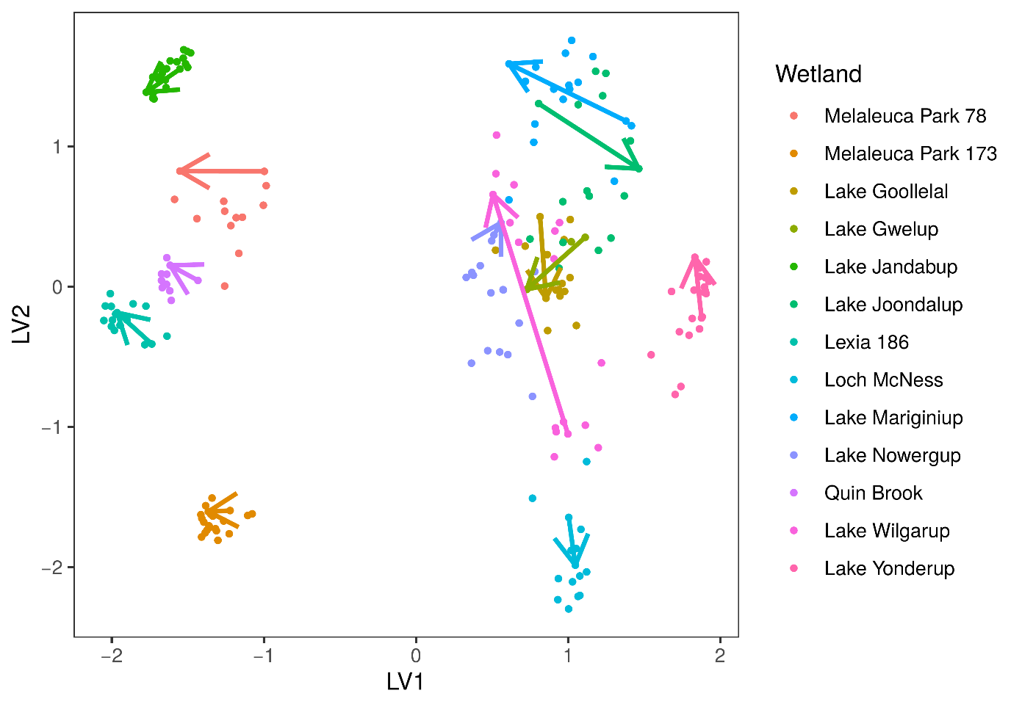

Figure 22 Unconstrained ordination plot of vegetation at each wetland site during the survey period (1996-2018). Arrows represent change from first survey to last survey. Vegetation ordination includes native vegetation only.

The aquatic invertebrate assemblages form three distinct groups based on the dunal system of the wetland (Figure 23). The Spearwood Dunes (Lake Goollelal, Lake Joondalup, Loch McNess, Lake Nowergup and Lake Yonderup) form the most diverse group, while the Bassendean Dunes Wetlands (Melaleuca Park 173) and East Wanneroo Interdunal Wetlands (Lake Jandabup and Lake Mariginiup) have different assemblages to each other. Generally, the Bassendean Dunes and East Wanneroo Interdunal wetlands are becoming more similar to each other, although such conclusions are based on a very limited set of wetlands. The Spearwood Dunes contain wetlands with two distinct trajectories, those migrating towards initial Lake Joondalup compositions (Loch McNess, Lake Goollelal and Lake Nowergup), and those migrating towards initial Loch McNess compositions (Lake Joondalup and Lake Yonderup). Nonetheless, each wetland has a distinct assemblage of macroinvertebrates but, aquatic macroinvertebrate communities have shifted during the monitoring period. Recent monitoring suggests that Loch McNess and Melaleuca Park 173 are becoming more similar to other wetlands. For instance, Loch McNess has shifted dramatically towards early Lake Joondalup composition. Lake Goollelal has displayed a similar, although not as dramatic, shift in composition. During the monitoring period, it is becoming apparent that Melaleuca Park 173, Lake Jandabup and Lake Mariginiup are converging in terms of macroinvertebrate assemblages. The communities at Lake Joondalup and Lake Yonderup have been shifting towards the early communities of Loch McNess. Lake Nowergup has shown some variation in community composition, but the current trajectory shows little change to the 1996 assemblage.

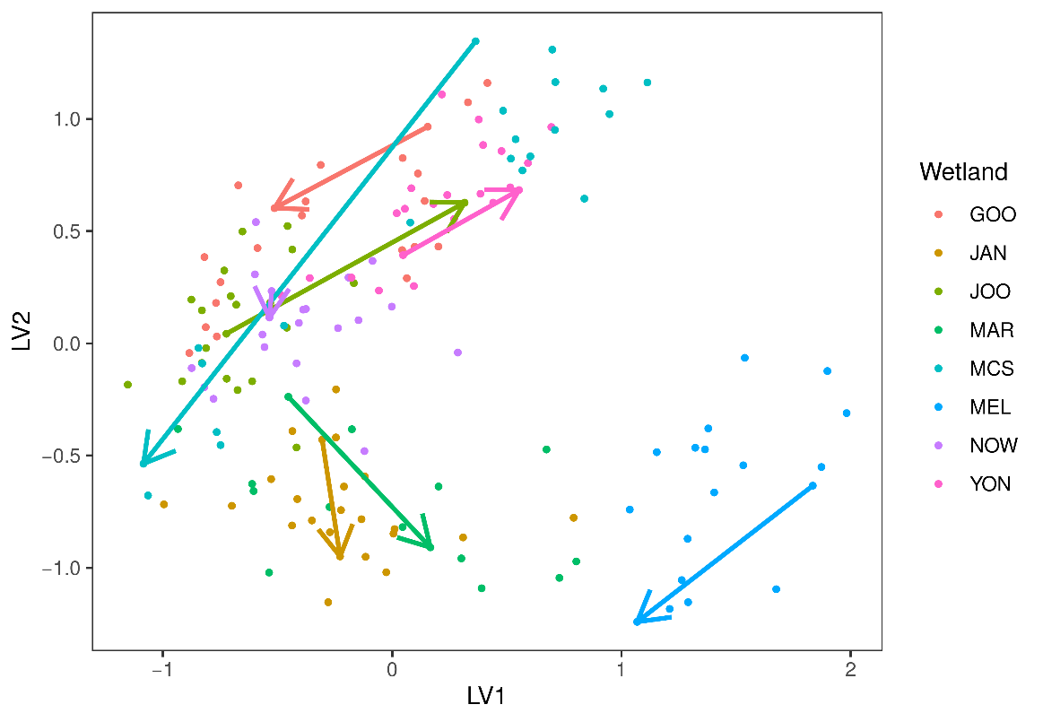

Figure 23 Unconstrained ordination plot of aquatic invertebrates at each wetland site during the survey period (1996-2018). Arrows represent change from first survey to last survey. Vegetation ordination includes native vegetation only. Wetlands included in invertebrate analysis include Lake Goollelal (GOO), Lake Jandabup (JAN), Lake Joondalup (JOO), Lake Mariginiup (MAR), Loch McNess (MCS), Melaleuca Park 173 (MEL), Lake Nowergup (NOW) and Lake Yonderup (YON).

Patterns of changing assemblages and declining richness are complemented by an analysis of monitoring data for macroinvertebrates (Table 38). The limitations of these data are that they are only once-off sampling for the season of spring each year, and only at usually three sites representing three different habitats, so the presence of taxa is a more reliable indicator than the absence of taxa. Nevertheless, patterns are discernible and if repeated over a sequence of years, and if they can be shown at more than one wetland, then they warrant closer attention. For the dataset examined, two patterns were determined. Some taxa were regularly present in the samples, in most years in the early period of monitoring (between 1996 and 2006) but have since become less frequently observed and are now actually absent in the samples in the last 5-15 years). Other taxa were extremely common in the early period of monitoring (between 1996 and 2006) but have since become much rarer or absent in the samples in the last 5-15 years).

Lakes Nowergup, Yonderup and Loch McNess have many taxa in one of these two groups (8, 9 and 10 taxa overall, respectively). Two insect groups have shown the same pattern of decline – Scirtidae beetles (from 4 of the six wetlands) and the Cordulidae damsel flies (also from 4 of the six wetlands). The insects, Corduliidae (Odonata), Ecnomidae (Trichoptera), Haliplidae (Coleoptera) and Mesoveliidae (Hemiptera) are all species with widespread distributions in the Swan Coastal Plain (Sommer et al., 2008), but are now not found in the monitored wetlands reported here.

Table 38 Taxa that have gone from regularly rare to absent and taxa that have gone from common to rare, or absent during spring monitoring.

|  |  |  |
| --- | --- | --- |
| Lake | Taxa that have gone from regularly rare to absent | Taxa that have gone from common to rare or absent |
| Lake Goollelal | Scirtidae (beetle) last seen in 2004 | Hydrophilidae (beetle) last seen 2014 |
| Lake Joondalup | Cordulidae (damsel fly) last seen 2011 |  |
|  | Haliplidae (beetle) last seen 2010 |  |
|  | Scirtidae (beetle) last seen 2010 |  |
| Lake Nowergup | Sphaeridae (bivalve) last seen 2002 | Ceinidae (amphipod) last seen 2007 |
|  | Arrenuridae (mite) last seen 2007 | Notodromadidae (ostracod) last seen 2005 |
|  | Limnesiidae (mite) last seen 2007 |  |
|  | Cordulidae (damsel fly) last seen spring 2011 |  |
|  | Scirtidae (beetle) last seen in spring – 2004 |  |
|  | Chydoridae (Cladoceran) last seen 2011 |  |
| Lake Yonderup | Hirudinea (Leech) last seen 2003 |  |
|  | Ancylidae (limpet) last seen 2011 |  |
|  | Physidae (snail) last seen 2012 |  |
|  | Cordulidae (damsel fly) last seen spring 2008 |  |
|  | Lestidae (damsel fly) last seen spring 2006 |  |
|  | Libellulidae (damsel fly) last seen spring 2005 |  |
|  | Mesovelidae (bug) last seen 2006 |  |
|  | Dytiscidae (beetle) last seen 2014 |  |
|  | Macrothricidae (cladoceran) last seen 2013 |  |
| Loch McNess | Limnesiidae (mite) last seen 2007 | Palaemonidae (shrimp) last seen 2010 |
|  | Oxiidae (mite) last seen 2008 | Hydroptilidae (purse caddis) last seen 2014 |
|  | Unioncolidae (mite) last seen 2006 |  |
|  | Parastacidae (crayfish) last seen 2003 |  |
|  | Caenidae (mayfly) last seen 2010 |  |
|  | Simuliidae (blackfly) last seen 2003 |  |
|  | Calanoida (zoopl.) last seen 2009 |  |
|  | Macrothricidae (cladoceran) last seen 2007 |  |

## Appendix 2: Data analysis for each wetland

### Lake Goollelal

#### Water quality

Lake Goollelal has stable water quality (Judd and Horwitz, 2019). Water pH, normally around 7.5, has only been recorded below 7 in 2007 while the current risk of acidification remains low due to declining chloride:sulphate ratios. Currently, the lake has low phosphorous, but is experiencing increasing levels of nitrogen, although levels are still below long-term averages.

#### Vegetation dynamics

The composition of vegetation at Lake Goollelal has been assessed 15 times between 1997 and 2019 at four plots along an established transect. Plot A represents fringing *Melaleuca rhaphiophylla*/*Eucalyptus rudis* vegetation and a stable community of the native sedges, *Baumea articulata* and *Lepidosperma gladiatum*. The *M. rhaphiophylla*/*E. rudis* complex continues throughout the transect, which has also remained relatively stable in terms of cover abundance since 2002. There is a high richness of exotic vegetation species present at the lake. Generally, these exotic species have increased in abundance during the survey period. The projected changes in surface water levels are likely to maintain the ecological water requirements of key wetland species, including *B. articulata*, *E. rudis* and *M. rhaphiophylla* (Figure 24).

Ordination reveals that Plot A has a distinct assemblage to the other plots but has displayed similar shifts in vegetation composition during the monitoring period (Figure 25). All plots show minor shifts in composition during the study period, with each plot distinct from the others. Plot D displays a different pattern, probably due to the recorded presence of *B. articulata* in 1997 and the high cover abundance of exotic species. Bayesian regression analysis predicts many exotic species to increase in cover abundance with declining surface water levels (Figure 26).

Figure Range in elevation (mAHD) of key wetland species along the vegetation monitoring transects for 2001, 2014 and 2019 at Lake Goollelal. *Lepidosperma longitudinale* only occurred in the transect in 2014 and *T. orientalis* in 2001. Red bars represent the absolute range in elevation and yellow bar represent mean range. Blue bars represent the ecological water requirements for key species at this site as determined by Froend et al. (2004b). The current minimum threshold is provided as a dotted line while the proposed 2030 threshold is provided by the dashed line.

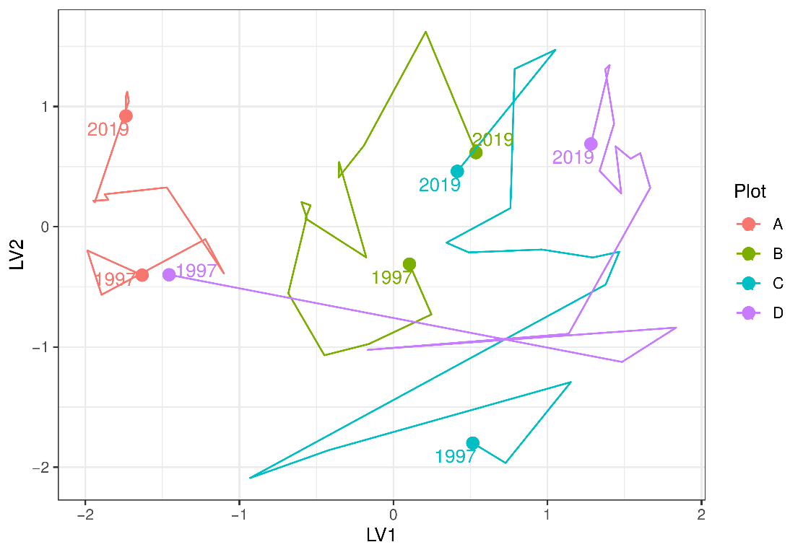

Figure 25 Unconstrained ordination based on vegetation data for each surveyed year for Lake Goollelal. Plots are represented as different colours and consecutive years are joined by a line with first and last survey years labeled.

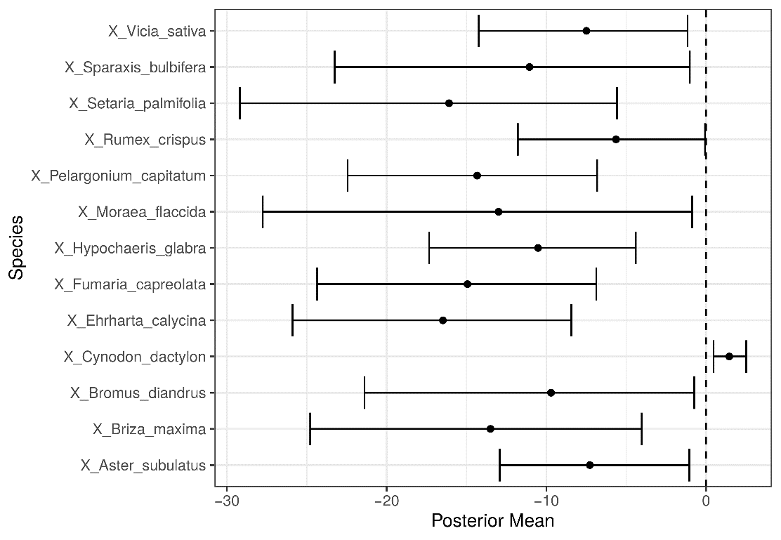

Figure 26 Estimated mean regression coefficients (dots) and 95% credible intervals (bars) for effect of groundwater levels at Lake Goollelal on vegetation species cover abundances based on Bayesian Regression Analysis (Hui, 2016). Species with a negative mean posterior value are likely to increase in cover abundance as water levels decline while species with positive posterior values are likely to increase in cover abundance with increasing water levels. Only those species with coefficients significantly different to zero are shown. Invasive species are identified by the pre-text ‘X’.

#### Aquatic invertebrates

The mean spring family richness of aquatic invertebrates is 22 for Lake Goollelal (Figure 27). Since 2008, family richness has mostly been stable and above the long-term average. There are stable populations of Amphisopidae, Calanoida, Ceinidae, Chironominae, Corixidae, and Cyprididae at the lake. The current absence of the Chydoridae (Cladocera) is notable given the abundance in early monitoring years. Also, the beetle family Scirtidae has not been found at the wetland since 2004. Other taxa showing recent absences in the lake include Ceratopogonidae, Chydoridae, Oligochaeta and Pionidae. There was a major shift in the assemblage composition in 2006-2007, with ordination revealing two main groups of annual data; those collected pre 2007, and those collected post 2007 (Figure 28). However, recent high-water levels and low nutrients appear to be shifting the assemblages back towards pre-2007 compositions (see Judd and Horwitz 2019).

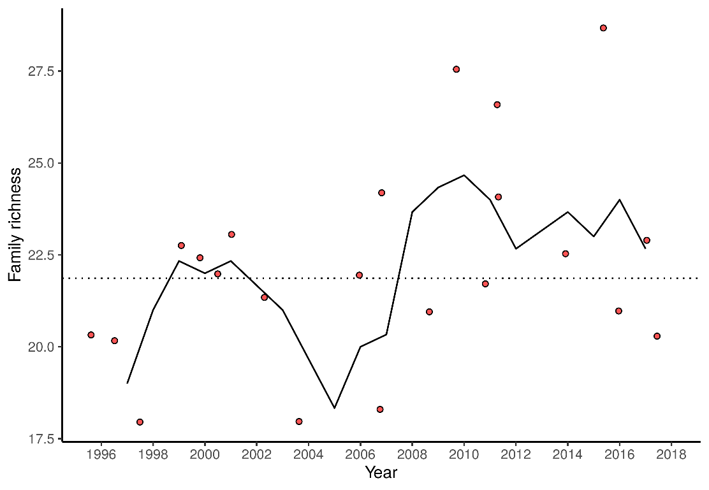

Figure 27 Richness of aquatic invertebrate families for each year at Lake Goollelal. Line is a moving 3-year average.

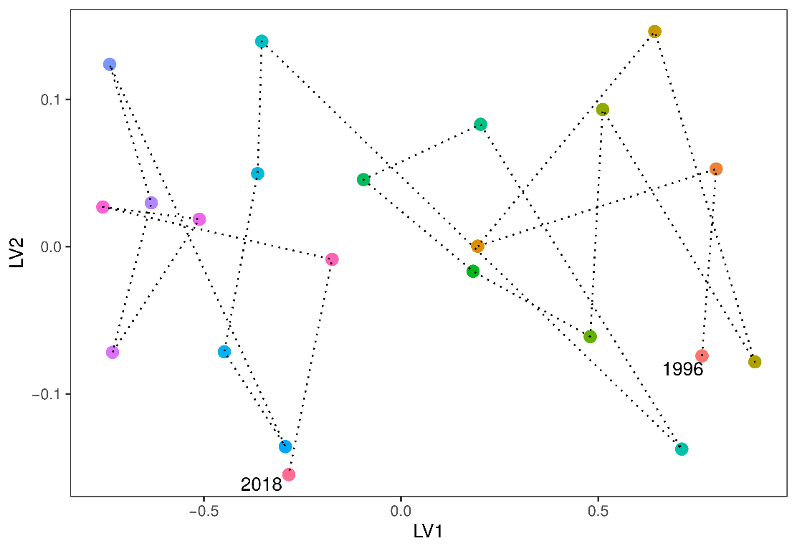

Figure 28 Unconstrained ordination based on invertebrate data for each surveyed year for Lake Goollelal. Consecutive years are joined by a line with first and last survey years labeled.

### Loch McNess

#### Water quality

Water quality at Loch McNess appears to have stabilised in the past couple of years. Normal pH is thought to be over 8.0 but has been below 8.0 since 2010. Current monitoring suggests a pH of 7.8, the highest since 2010 (Judd and Horwitz, 2019). Chloride:sulphate and alkalinity observations suggest that acidification is not a current concern at Loch McNess South; but the same cannot be said for Loch McNess North. In Loch McNess South there has been a trend of increasing nitrogen levels in the wetland since 2010, current levels are double those recorded in 1997-2007 levels. Current phosphate levels are an order of magnitude greater than 1999-2004 levels and require close monitoring. These changes are probably due to exposure of unconsolidated sediments to a drying-rewetting regime.

#### Vegetation dynamics

A vegetation monitoring transect was established in 2004 with three plots (A, B, and C) plus an additional up-slope plot in 2009 (Plot D) and a plot down-slope of Plot A in 2010 (Plot E). The fringing vegetation is largely comprised of a *Melaleuca rhaphiophylla*/*Eucalyptus rudis* complex. Most trees are in average to good health (Buller et al., 2019). *Baumea juncea* is found in Plots A - D at relatively constant cover abundances. *Baumea articulata*, however, disappeared from Plot A in 2005 and was present in the new down-slope plot (Plot E) until 2014. Currently, *B. articulata* is probably not present at the site (Buller 2019 - personal observation) and the disappearance is likely due to a combination of a fire in 2009 and declining water.

The proposed minimum threshold is likely to cause added hydrological stress to some key wetland species found at Loch McNess (Figure 29). Nonetheless, the projected lower water levels are unlikely to reduce water levels below the ecological water requirements for *B. juncea*, *E. rudis* and *M. rhaphiophylla*. There may be migration of some of these species downslope overtime as preferred hydrological regimes for each species maintained.

Plots A and B have shifted in community composition dramatically during the monitoring period as the vegetation responds to lower surface water levels in the lake and the impact of fire in 2004 and 2009 (Buller et al. (2019); Figure 30). Regression analysis reveals that the exotic *Avena barbata* and the native *Tricoryne elatior* will increase the most in cover abundance as water levels in the lake remain low or decline further (Figure 31). The natives, *Carex fascicularis*, *Triglochin centrocarpa* and *M. rhaphiophylla* are most likely to decline dramatically at the wetland under a scenario of continued low water levels.

#### Aquatic macroinvertebrates

Loch McNess is the most taxonomically rich of the Spearwood Dune wetlands, with about 27 macroinvertebrate families regularly found there in spring seasonal monitoring (Figure 32). However, the composition of the community is shifting (Figure 33). The communities were relatively stable in terms of composition until 2008 after water levels had begun to decline significantly. The current trajectory suggests the dissimilarity between pre-2008 and contemporary communities will continue. The site is now dominated by common taxa of the Swan Coastal Plain such as Amphisopidae, Chironomidae larvae, Corixidae, Culicidae larvae, Cyclopoida (*Daphnia*), Dytiscidae, Notonectidae and Pionidae. Some of these, namely Chironomidae and Culicidae larvae, are considered nuisance species. The Amphipod, Ceinidae, has not been collected in the lake since 2014 and the shrimp *Palamonetes australis* not recorded since 2010 – both of these taxa were once abundant. Nine families of invertebrates that were once regularly detected in the spring monitoring events, are no longer so. This shift in macroinvertebrate assemblage indicates serious changes in ecological processes as the wetland transitions towards a nutrient enriched shallow lake.

Figure Range in elevation (mAHD) of key wetland species along the vegetation monitoring transects for 2001, 2014 and 2019 at Loch McNess. Red bars represent the absolute range in elevation and yellow bar represent mean range. The current minimum threshold is provided as a dotted line while the proposed 2030 threshold is provided by the dashed line.

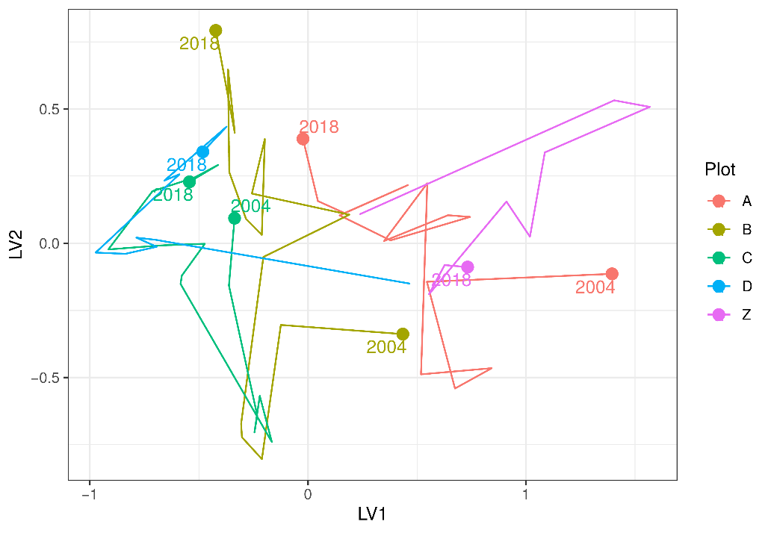

Figure 30 Unconstrained ordination based on the latent variable model for each surveyed year for Loch McNess. Plots are represented as different colours and consecutive years are joined by a line with first and last survey years labeled.

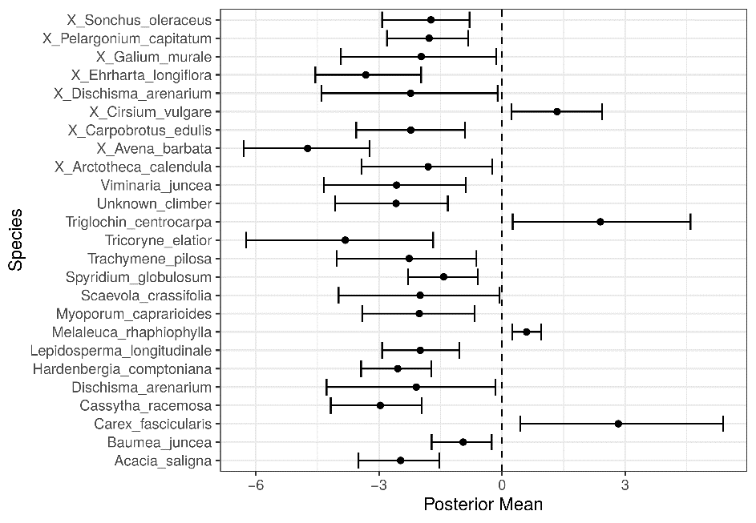

Figure 31 Estimated mean regression coefficients (dots) and 95% credible intervals (bars) for effect of groundwater levels at Loch McNess on vegetation species cover abundances based on Bayesian Regression Analysis (Hui, 2016). Species with a negative mean posterior value are likely to increase in cover abundance as water levels decline while species with positive values are predicted to increase in cover abundance with water increasing water levels. Only those species with coefficients significantly different to zero are shown. Invasive species are identified by the pre-text ‘X’.

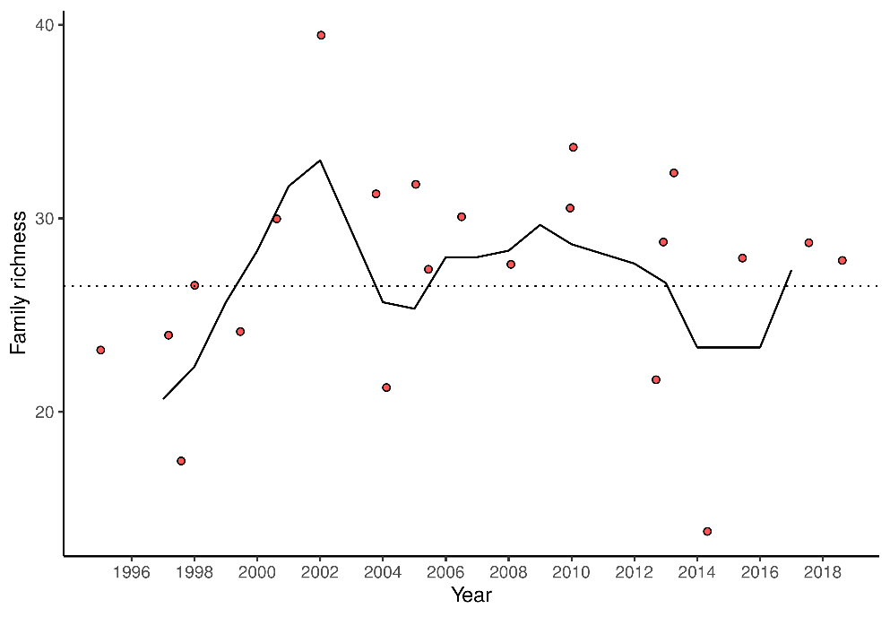

Figure 32 Richness of aquatic invertebrate families for each year. Line is a moving 3-year average at Loch McNess.

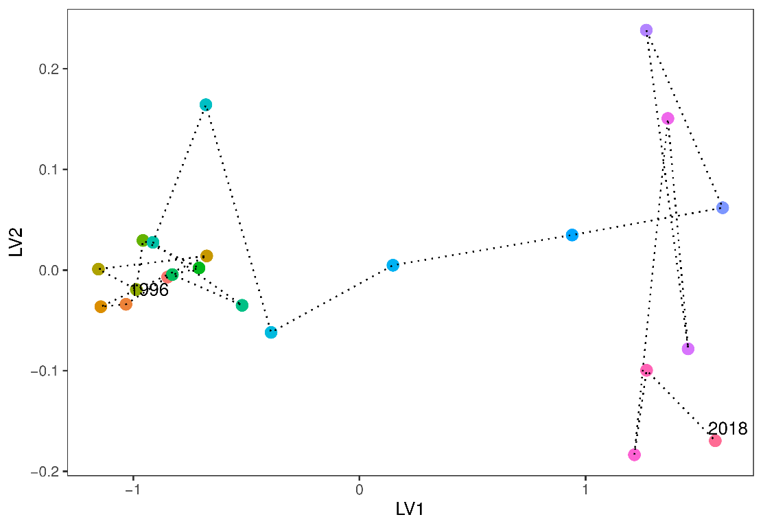

Figure 33 Unconstrained ordination based on invertebrate data for each surveyed year for Loch McNess. Consecutive years are joined by a line with first and last survey years labeled.

### Lake Yonderup

#### Water quality

Lake Yonderup has the lowest nutrient levels of all the monitored wetlands on the Gnangara Groundwater System (Judd and Horwitz, 2019). However, the most recent observations for spring 2018 indicate that total nitrogen levels may be increasing. Otherwise, the water chemistry of the lake has remained relatively stable. Stable alkalinity and a pH that consistently remains above 7.0 suggests there is little risk of acidification.

#### Vegetation dynamics

The vegetation transect, established in 1997, is located 750 m south of the basin and is therefore not representative of vegetation at the wetland itself. The lake provides habitat for *Baumea articulata* although there is recent evidence of *Typha orientalis* invading the wetland (Judd and Horwitz, 2019). At the vegetation monitoring transects, the site was reported to have a rich exotic community before monitoring began in 1997 and this characteristic of the site has persisted. Currently, exotics account for 60% of the cover abundance and native richness has been declining (Buller et al., 2019).

Vegetation at the monitoring transect is located more than 1.5 m higher than current minimum surface water levels of the lake (Figure 34). It is therefore likely that some individuals are experiencing water stress at times during the year. The proposed threshold, although a slight improvement over current conditions, will not ensure the health of key wetland species. This is particularly true for *M. rhaphiophylla* which has a mean maximum depth to ground water of 2.14 m in the Gnangara Groundwater System (Froend et al. 2004b). The managing water levels at the proposed minimum threshold of 5.7 mAHD is likely to maintain the stressed state of *M. rhaphiophylla* that occurs in the vegetation monitoring transects as the plants will be experience water levels only 0.3 m above their mean maximum depth.

The shifts in vegetation composition at each plot suggest vegetation has changed dramatically since 1997 but largely stabilised in the late 2000s (Figure 35). There was a dramatic shift in vegetation composition after the 2004/2005 fire which also coincided with an increase in the rate of decline of surface waters. All the native species, including *Banksia attenuatta* and *Melaleuca preissiana*, are likely to decline in cover abundance under a scenario of sustained low water levels or further declining groundwater levels (Figure 36). In fact, *B. attenuatta* and *M. preissiana* have already disappeared from the monitoring transect, while stands of *Melaleuca rhaphiophylla* are unhealthy.

#### Aquatic invertebrates

Taxonomic richness of the macroinvertebrate assemblage in Lake Yonderup has been declining since 2012 (Figure 37). Richness is now lower than previous records and the trend may suggests some shifts in ecological processes due to declining water levels. The composition of the Lake Yonderup macroinvertebrate community is variable (Figure 38). Many taxa are not recorded every year, or are absent for periods, such as Ceinidae, Oligochaeta and Orthocladiinae. Other taxa have declined, or perhaps become locally extinct, including the beetle families of Dytiscidae and Hydrophilidae. Three families of damselflies have not been recorded in spring families in about the last decade. Chironominae, Cyclopoida, Cyprididae and Leptoceridae have been recorded in nearly every sampling event at Lake Yonderup.

Figure Range in elevation (mAHD) of key wetland species along the vegetation monitoring transects for 2001, 2014 and 2019 at Lake Yonderup. Red bars represent the absolute range in elevation and yellow bar represent mean range. The current minimum threshold is provided as a dotted line while the proposed 2030 threshold is provided by the dashed line.

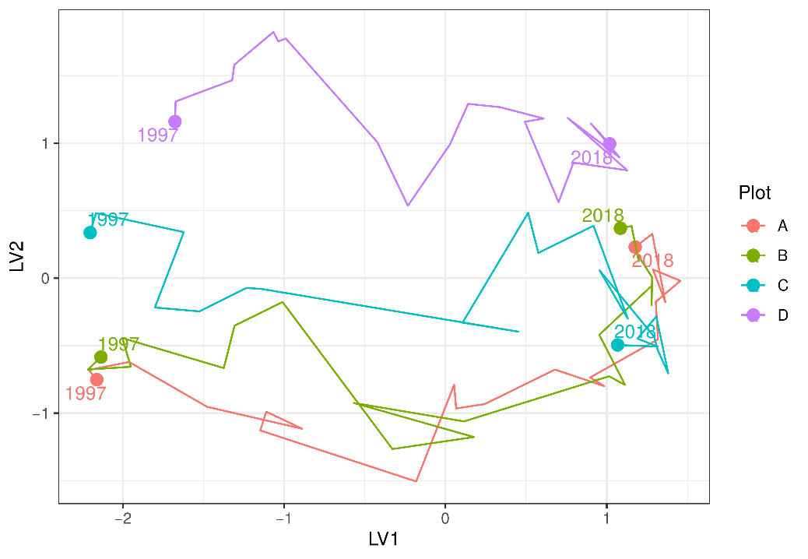

Figure 35 Unconstrained ordination based on the latent variable model for each surveyed year for Lake Yonderup. Plots are represented as different colours and consecutive years are joined by a line with first and last survey years labeled.

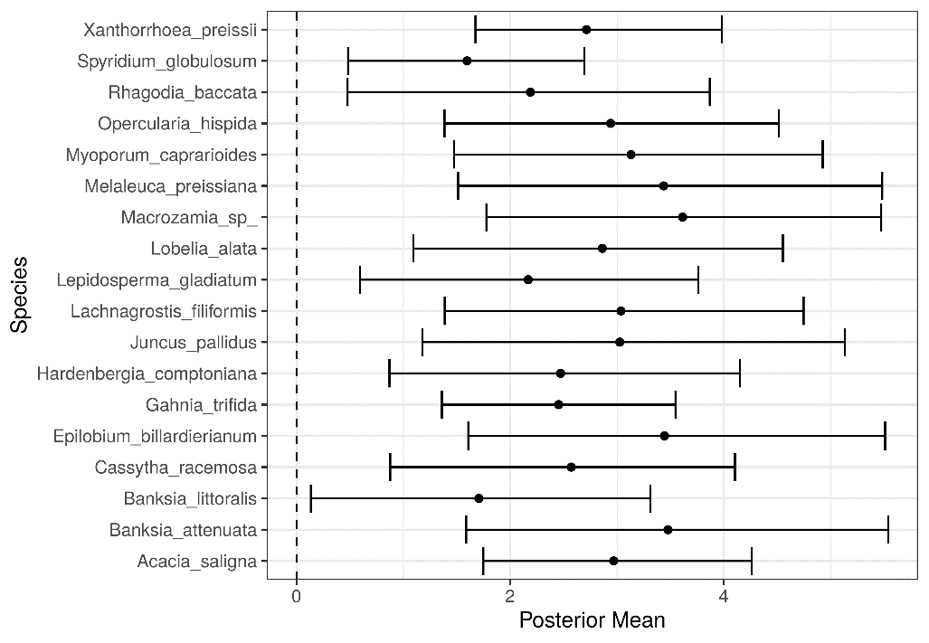

Figure 36 Estimated mean regression coefficients (dots) and 95% credible intervals (bars) for effect of groundwater levels at Lake Yonderup on vegetation species cover abundances based on Bayesian Regression Analysis (Hui, 2016). Species with a negative mean posterior value are likely to increase in cover abundance as water levels decline. Only those species with coefficients significantly different to zero are shown.

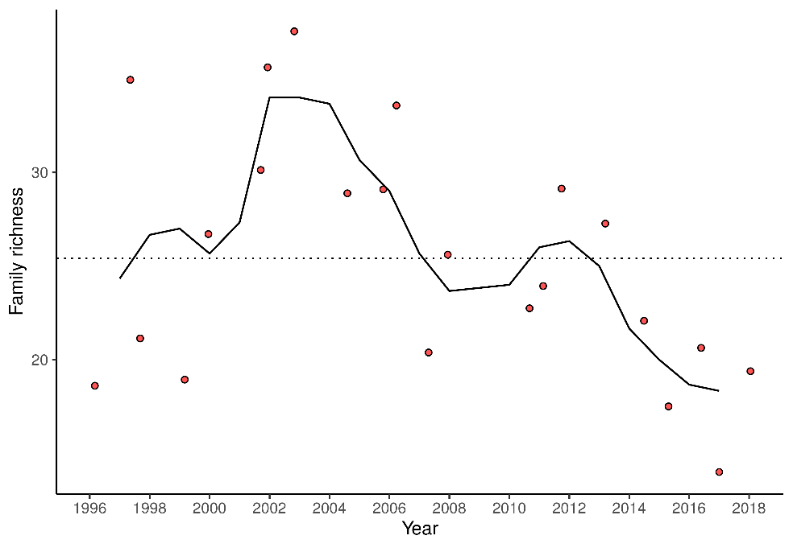

Figure 37 Richness of aquatic invertebrate families for each year at Lake Yonderup. Line is a moving 3-year average.

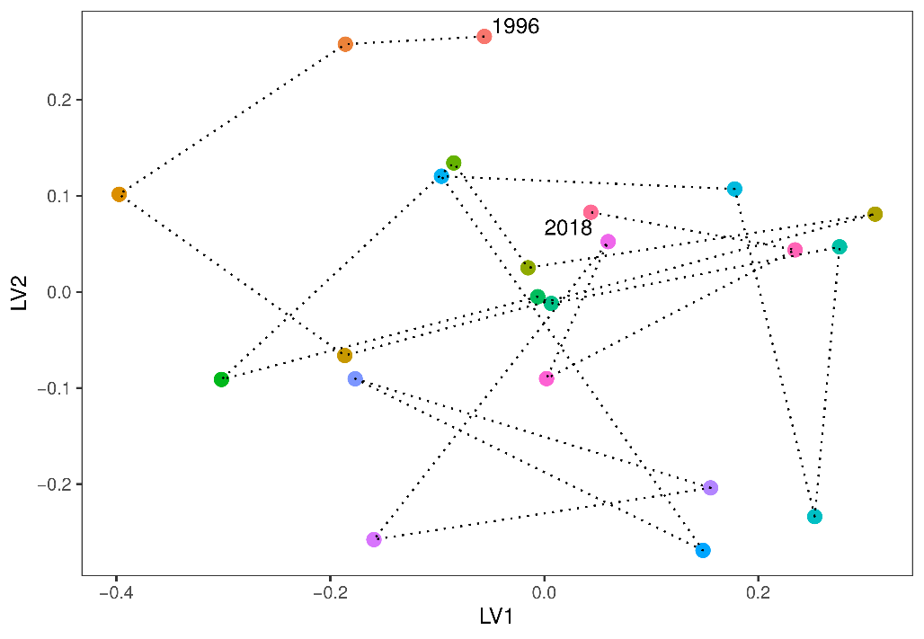

Figure 38 Unconstrained ordination based on invertebrate data for each surveyed year for Lake Yonderup. Consecutive years are joined by a line with first and last survey years labeled.

### Lake Joondalup

#### Water quality

Recent monitoring suggests pH has been increasing from 6.8 in 2016 up to 8.4 in 2018, probably attributable the higher water levels (Judd and Horwitz, 2019). The lake often has the lowest levels of acidity and highest alkalinity of all the monitored wetlands. Total nitrogen and phosphorus levels have been high in Lake Joondalup, which is now typical of Spearwood dune lakes in modified urban landscapes. These high nutrient levels need to be considered carefully, particularly if combined with increases in water temperatures because they may lead to algal blooms.

#### Vegetation Dynamics

Vegetation surveys have been conducted along a northern and southern transect at Lake Joondalup since 1996 and were last surveyed in 2015. *Melaleuca raphiophylla* dominates the overstory of plots in the northern transect while exotic species are abundant in the understory vegetation. There has been an increasing trend in cover abundance of the exotics *Bromus diandrus*, *Ehrharta longiflora*, *Euphorbia terracina*, *Fumaria muralis* and *Pelargonium capitatum* in recent years. Fires in 2003 reduced the canopy condition and abundance of *M. raphiophylla* in the southern transect, and despite the slightly higher cover abundance of native species, native and exotic species richness is equal along the transect. The site also contains healthy stands of *Baumea articulata* in the submerged regions of the transect. The proposed minimum threshold is likely to be beneficial to a number of key wetland species, including *B. articulata* and *M. rhaphiophylla*, as they are more likely to have their ecological water requirements met (Figure 39).

All plots in both transects have displayed similar trends in community compositional change during the survey periods (Figure 40). In the southern transect, ordination reveals separation of the plots along the first axis, with a general temporal trend along the second axis, except for a period around 2003 - 2006 where there was a hiatus. This hiatus may be associated with the 2003 bushfire and represents a recovery period where species composition changed little. The trajectory for plot A is different, however, as the trend away from the original 1996 survey has reversed and the contemporary community is now becoming more like the 1996 communities. Similar patterns have been observed in the northern transect despite the transect not being impacted by the 2003 fire event. A number of native species are likely to increase in cover abundance at the transects if water levels remain at present levels or increase further, including *Baumea articulata* (Figure 41). Other natives are likely to decline in cover abundance under a similar scenario of high-water levels, including a number of *Acacia saligna*, *Banksia menziesii* and *Banksia prionotes*.

#### Aquatic Invertebrates

Aquatic invertebrates have been sampled from Lake Joondalup every year since 1996. During this period, 16-30 families of aquatic invertebrates have been recorded per sampling event, except for the latest round in 2018 where family richness was only nine (Figure 42). This exceptionally low family richness was likely due to the lack of insects and associated parasitic mites among the sampled communities. Three families of beetles and one damsel fly family have been missing from spring monitoring samples in recent years. The phreatoicid isopod *Amphisopus palustris* was also absent in 2018 despite being collected every spring in Lake Joondalup (except 2004). Furthermore, this reduced richness occurred during a period of relatively high surface water levels, suggesting other anthropogenic factors may be responsible for the decline of insect fauna within the lake, like an as yet undiagnosed water quality issue. Otherwise, the lake hosts abundant populations of Ceinidae (amphipods), *Palaemonetes australis* (crustacean), *Calanoid copepods* and Cyprididae (ostracods). There is high variation in the composition of annual macroinvertebrate community composition making it difficult to interpret a trajectory of compositional change (Figure 43). There has been a general trend of community composition shifting away from the initial 1996 community.

Figure Range in elevation (mAHD) of key wetland species along the vegetation monitoring transects for 2001, 2014 and 2019 at Lake Joondalup. Red bars represent the absolute range in elevation and yellow bar represent mean range. Blue bars represent the ecological water requirements for key species at this site as determined by Froend et al. (2004b). The current minimum threshold is provided as a dotted line while the proposed 2030 threshold is provided by the dashed line. *Eucalyptus rudis* currently does not occur in the monitoring transects, hence there is no elevation data for this species.

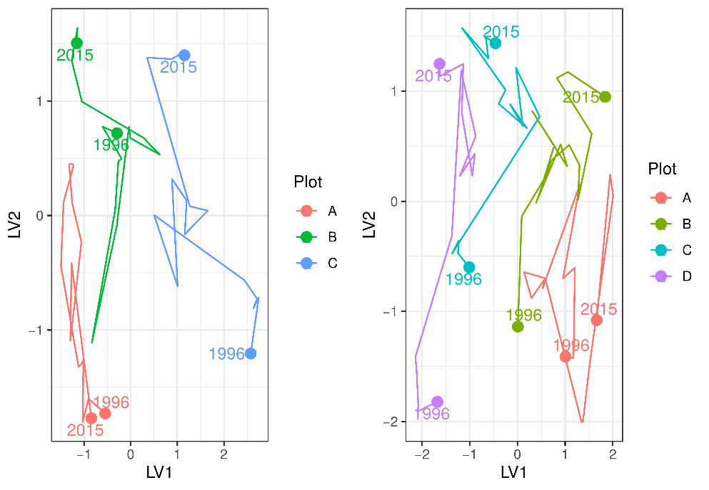

Figure 40 Unconstrained ordination based on the latent variable model for each surveyed year for the northern (left) and southern (right) Lake Joondalup transects. Plots are represented as different colours and consecutive years are joined by a line with first and last survey years labeled.

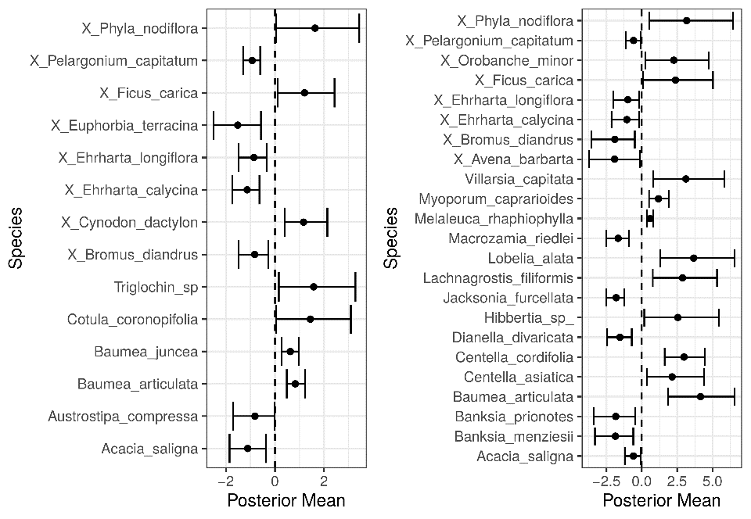

Figure 41 Estimated mean regression coefficients (dots) and 95% credible intervals (bars) for effect of groundwater levels at the northern (left) and southern (right) Lake Joondalup transects on vegetation species cover abundances based on Bayesian Regression Analysis (Hui, 2016). Species with a negative mean posterior value are likely to increase in cover abundance as water levels decline and species with positive values are likely to increase in cover abundance when water levels increase. Only those species with coefficients significantly different to zero are shown. Invasive species are identified by the pre-text ‘X’.

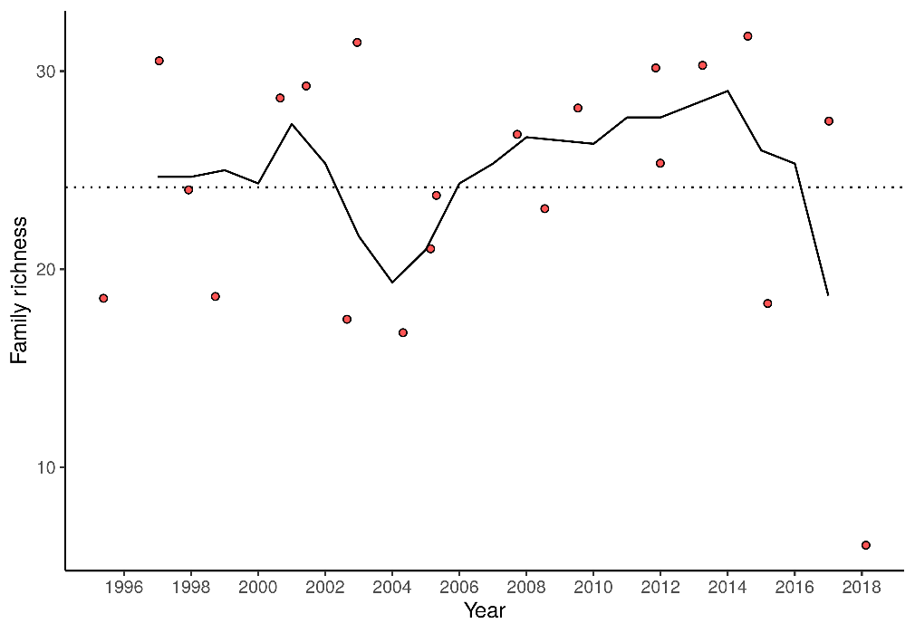

Figure 42 Richness of aquatic invertebrate families for each year at Lake Joondalup. Line is a moving 3-year average.

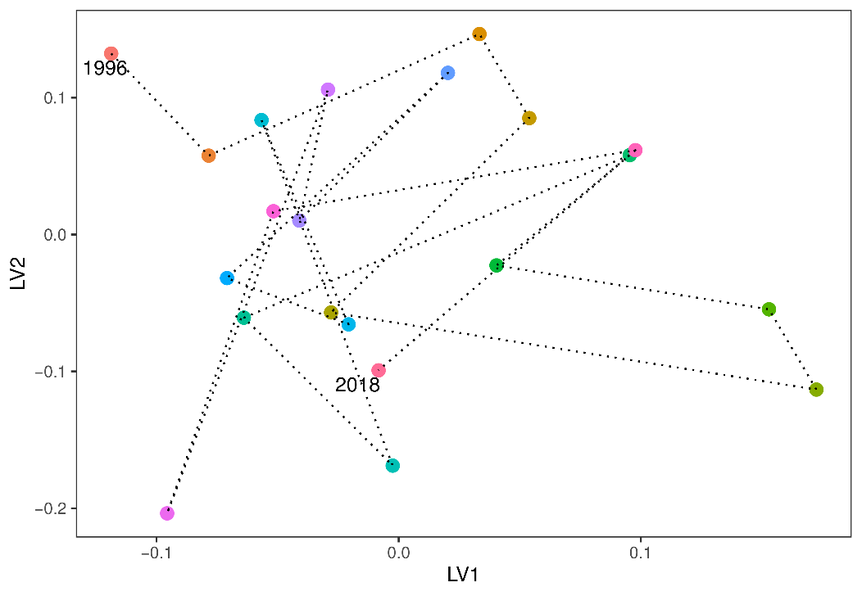

Figure 43 Unconstrained ordination based on invertebrate data for each surveyed year for Lake Joondalup. Consecutive years are joined by a line with first and last survey years labeled.

### Lake Mariginiup

#### Water quality

Acidification has affected the water quality at Lake Mariginiup. Since 2005, the pH of the surface water has consistently been below 4.0 with only 2018 levels slightly higher (4.3; Judd and Horwitz (2019)). Alkalinity is below 1 mg/L suggesting that the lake has lost its capacity to buffer changes in pH. Recent changes in acidification are likely due to the rises in surface waters since 2015 that has helped reduce the sulphate concentrations. Ammonia and total nitrogen levels of Lake Mariginiup are the highest of any lake monitored on the Swan Coastal Plain. Recent total phosphorus levels have doubled due to unknown causes.

#### Vegetation dynamics

Vegetation composition and shifts in composition are similar along the length of the transect at Lake Mariginiup which was established in 1996. *Baumea articulata* was present at high cover abundance throughout the transect until the early 2000’s but has since disappeared from the transect as surface water levels declined (*B. articulata* still occurs in other regions of the wetland). *Eucalyptus rudis* has declined in the lower parts of the plots and *Melaleuca rhaphiophylla* is no longer present in the transect. There has been a general increase in the cover abundances of exotics throughout the monitoring period. There was a shift in community composition at all three plots around 2005 which was driven by increases in *Exocarpus sparteus* and *Jacksonia furcellata* and some exotics, such as *Ehrharta calycina*, *Ehrhatah longiflora*, *Lotus suaveolens* and *Ursinnia anthemoides* (Figure 45).

The projected increases in surface water levels are going to have a dramatic effect on the vegetation at Lake Mariginiup. For instance, the current range of *B. articulata* and *E. rudis* alng the monitoring transects are likely to become permanently inundated (Figure 44). Both of these species are able to tolerate 12 months of inundation (Froend et al. 2004b), however maximum water depth ranges are likely to be exceeded. For instance, the absolute maximum water depth that *B. articulata* occurs in is 0.81 m and 1.03 m for *E. rudis.* Surface waters exceeding these depths are very likely to cause the death of these species. A low rate of inundation will need to be considered to ensure that these species can migrate upslope. Alternatively, a lower minimum threshold could be considered to preserve the current distribution of fringing vegetation. Regression analysis reveals a number of native species that will increase in cover abundance with increasing surface water levels (Figure 46). Species likely to increase in cover abundance include *Angianthus* sp., *Epilobium billardierianum*, *Isolepis cernua*, *Juncus* sp., *Lepyrodia muirii*, *Lobelia alata* and *Villarsia capitata*. Other natives, including *Acacia cyclops*, *Acacia saligna* and *E. sparteus*, are likely to decrease in cover abundance as water levels increase.

#### Aquatic invertebrates

Lake Mariginiup has been sampled yearly 1996 - 2002, 2004 - 2009, 2012, and – 2018. Missing years make it difficult to interpret trends in community change. Despite the acidification that has occurred in the lake, there is a remarkably high richness of invertebrates (Figure 47) and there seems to be a recovery since the 2012 sampling event where family richness was 13. Nonetheless, richness has been below average for the site since 2005 when acidification processes began affecting the assemblage. Recent increases in water levels may be promoting higher richness by increasing habitat availability and diversity. There has been a dramatic shift in macroinvertebrate community compositions between 2002 and 2004 (Figure 48). Recent data suggests the community may be returning to pre-2004 composition, which again may be attributable to increased surface waters and habitat availability. Some families have disappeared from the lake, including Amphisopidae, Ceinidae, Chydoridae and Cyprididae.

Figure Range in elevation (mAHD) of key wetland species along the vegetation monitoring transects for 2001, 2014 and 2019 at Lake Mariginiup. Red bars represent the absolute range in elevation and yellow bar represent mean range. Blue bars represent the ecological water requirements for key species at this site as determined by Froend et al. (2004b). The current minimum threshold is provided as a dotted line while the proposed 2030 threshold is provided by the dashed line. There is no data for ­*T. orientalis* as it is not currently observed in the vegetation monitoring transects.

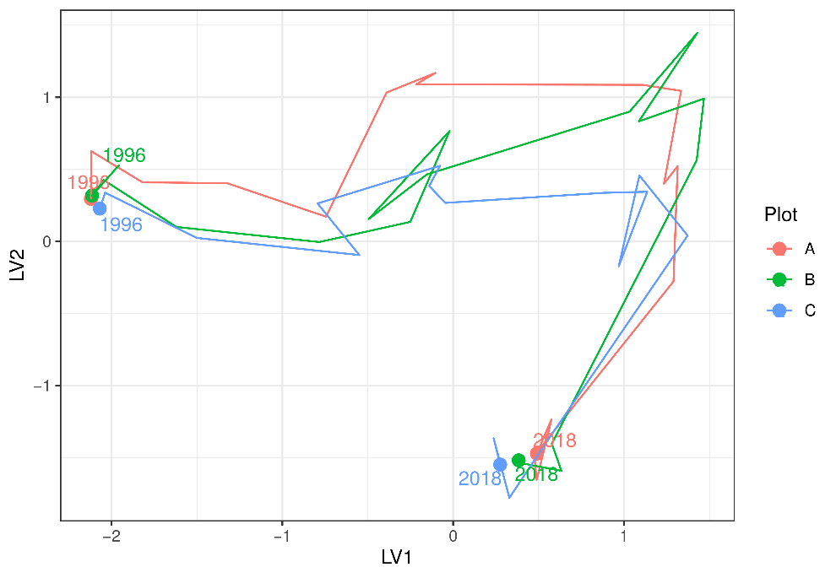

Figure 45 Unconstrained ordination based on the latent variable model for each surveyed year for Lake Mariginiup. Plots are represented as different colours and consecutive years are joined by a line with first and last survey years labeled.

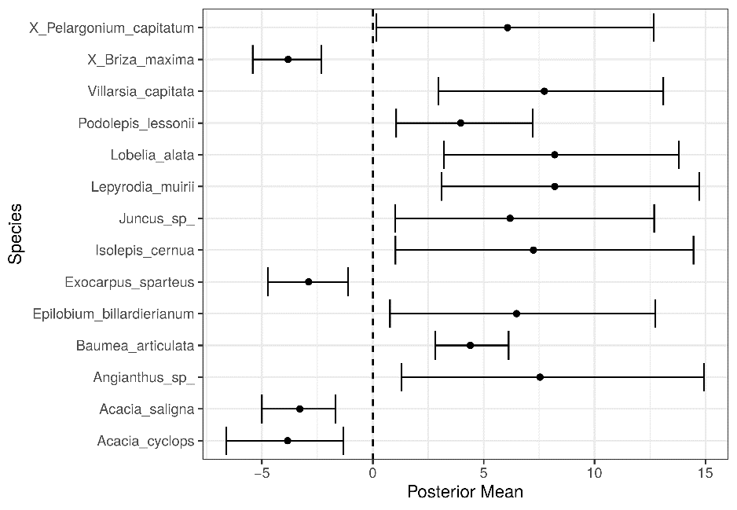

Figure 46 Estimated mean regression coefficients (dots) and 95% credible intervals (bars) for effect of groundwater levels at Lake Mariginiup on vegetation species cover abundances based on Bayesian Regression Analysis (Hui, 2016). Species with a negative mean posterior value are likely to increase in cover abundance as water levels decline and species with positive values are predicted to increase in cover abundance with increasing water levels. Only those species with coefficients significantly different to zero are shown. Invasive species are identified by the pre-text ‘X’.

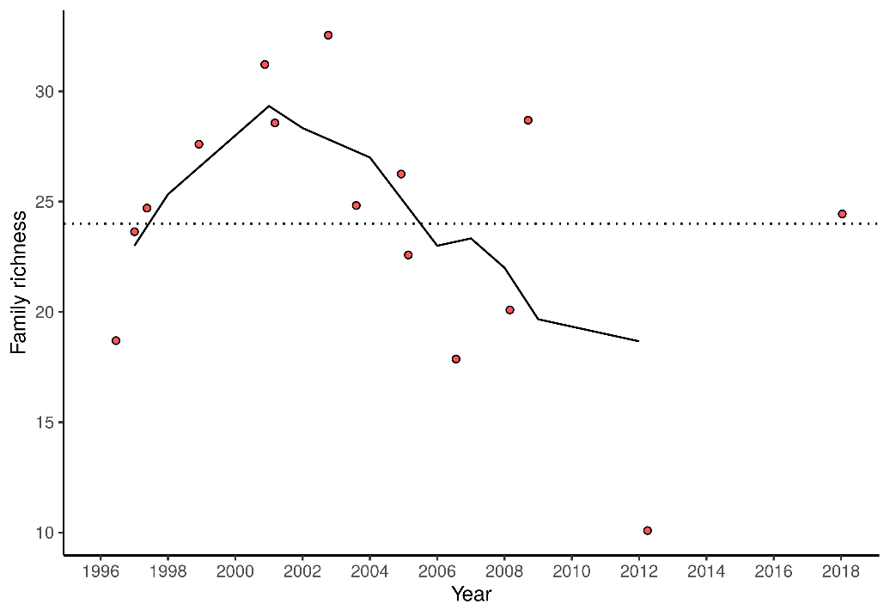

Figure 47 Richness of aquatic invertebrate families for each year at Lake Mariginiup. Line is a moving 3-year average.

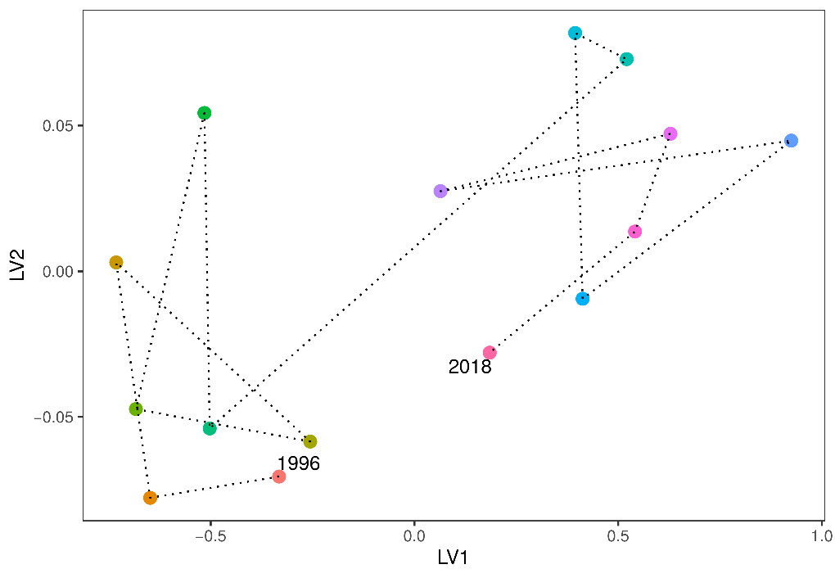

Figure 48 Unconstrained ordination based on invertebrate data for each surveyed year for Lake Mariginiup. Consecutive years are joined by a line with first and last survey years labeled.

### Lake Jandabup

#### Water quality

The pH of Lake Jandabup has not exceeded 7.0 since 2011 and is currently between 6.1 and 6.6. Low water levels expose sediments at Lake Jandabup, making it susceptible to acidification and past episodes drove the pH to <4. Alkalinity is currently very low, suggesting that the lake may be losing its capacity to buffer further pH changes. Deterioration of the chloride:sulphate ratio is also concerning. Maintaining high water levels will be essential to preventing the drying of sediments around the lake margin and subsequent acidification of this wetland. Typically, Lake Jandabup is a low nutrient wetland, however total nitrogen and phosphorus levels are currently the highest recorded for the annual spring monitoring programme.

#### Vegetation dynamics

The Lake Jandabup wetland consists of a diverse community of native vegetation. In the 2017-2018 season, 43 native species were recorded with only 14% of the total cover abundance belonging to exotic species (Buller et al., 2019). There are four overstorey species present at the wetland, including *Banksia attenuata*, *Banksia ilicifolia*, *Banksia menziesii*, *Eucalyptus rudis* and *Melaleuca preissiana*, all of which have been increasing in health. This is likely a result of the ecological water requirements for these species being met (Figure 49). A dense understory of *A. scoparia*, *B. elegans* and *H. angustifolium* exists at the lower elevated plots A and B. There has been a continual shift in community composition of Lake Jandabup throughout the monitoring period that reflects changes in invasive species’ cover abundances (Figure 50). A number of species are predicted to increase in cover abundance with increasing water levels, particularly *Euchilopsis linearis* which is currently present in the lower parts of the basin (Figure 51).

#### Aquatic invertebrates

Family richness of aquatic macroinvertebrates in Lake Jandabup is distinct and higher than other monitored sites because of the relatively high degree of habitat diversity. However, the family richness of the lake has been below average for the lake since 2016 (Figure 52). There has been a recent shift in community composition away from the 1996 community, suggesting that the community may continue to shift away from what has typically been recorded in the lake in future years as water quality and hydrological changes alter ecosystem processes (Figure 53). The decline of water beetles in the lake is concerning and warrants further investigation. The highly variable communities between 1996-2006 may be in response to acidification events. Ceinidae, Calanoida, Daphniidae and Notonectidae are usually present in the lake at high abundance.

Figure Range in elevation (mAHD) of key wetland species along the vegetation monitoring transects for 2001, 2014 and 2019 at Lake Jandabup. Red bars represent the absolute range in elevation and yellow bar represent mean range. Blue bars represent the ecological water requirements for key species at this site as determined by Froend et al. (2004b). The current minimum threshold is provided as a dotted line. There is no data for *E. rudis* as it is not currently observed in the vegetation monitoring transects.

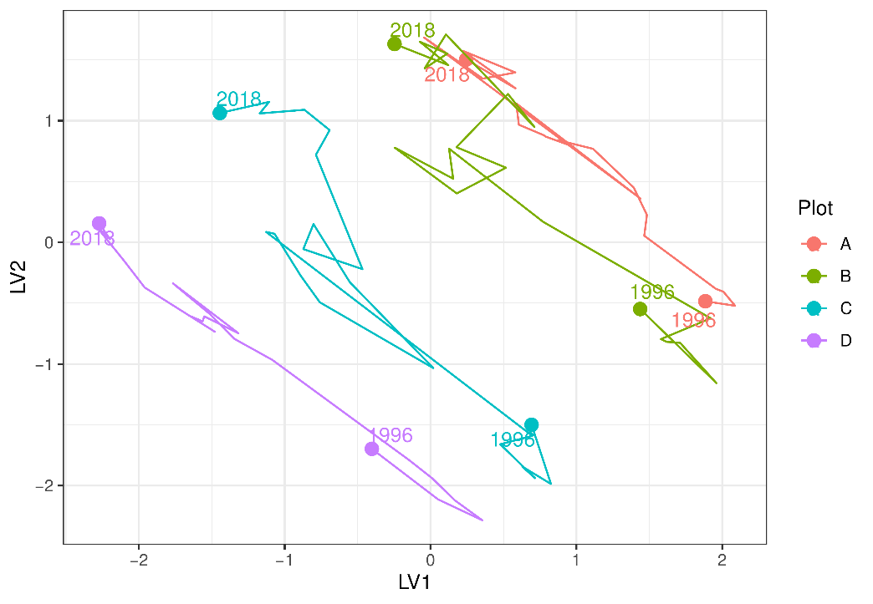

Figure 50 Unconstrained ordination based on the latent variable model for each surveyed year for Lake Jandabup. Plots are represented as different colours and consecutive years are joined by a line with first and last survey years labeled.

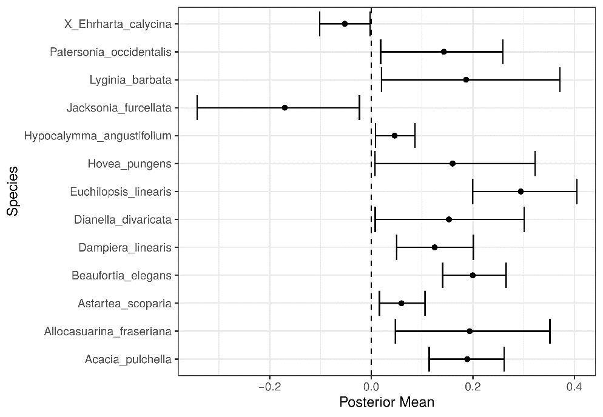

Figure 51 Estimated mean regression coefficients (dots) and 95% credible intervals (bars) for effect of groundwater levels at Lake Jandabup on vegetation species cover abundances based on Bayesian Regression Analysis (Hui, 2016). Species with a negative mean posterior value are likely to increase in cover abundance as water levels decline while species with positive values are likely to increase in cover abundance as water levels increase. Only those species with coefficients significantly different to zero are shown. Invasive species are identified by the pre-text ‘X’.

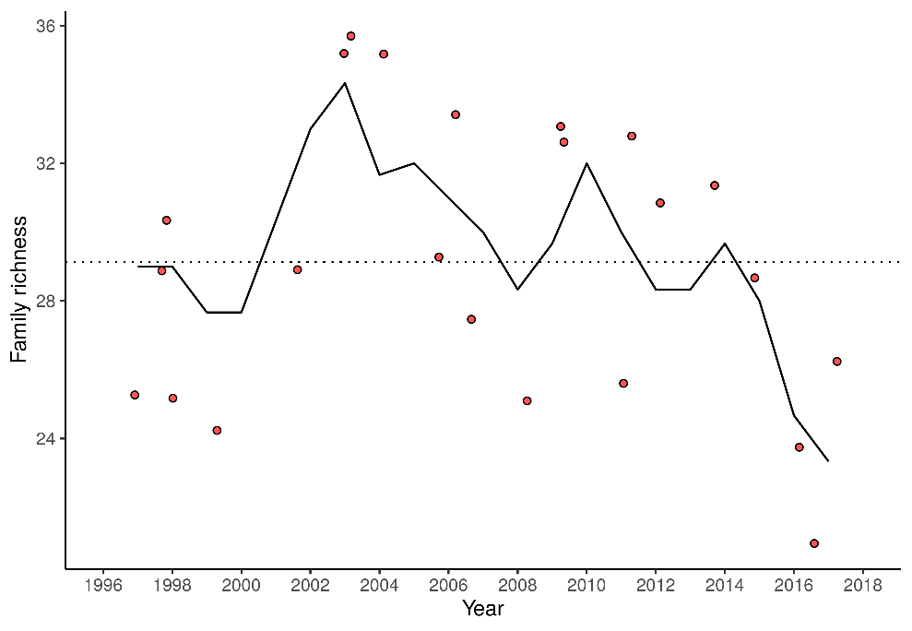

Figure 52 Richness of aquatic invertebrate families for each year at Lake Jandabup. Line is a moving 3-year average.

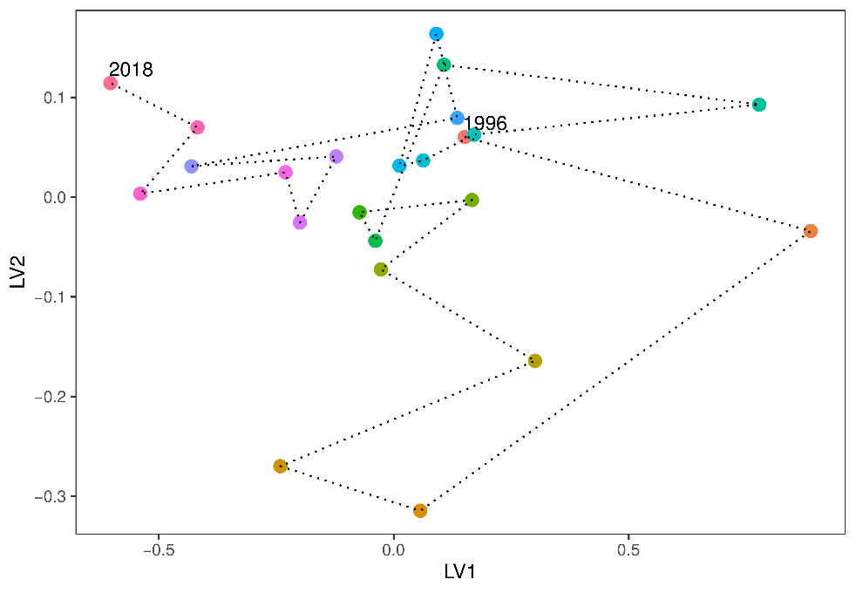

Figure 53 Unconstrained ordination based on invertebrate data for each surveyed year for Lake Jandabup. Consecutive years are joined by a line with first and last survey years labeled.

### Lake Nowergup

#### Water quality

Water quality in Lake Nowergup is remarkably stable given the declines in surface waters and associated groundwaters (Judd and Horwitz, 2019). Acidity is usually low and alkalinity high, indicating that the lake has sufficient capacity to buffer against acidification. A pH above 9 is not unusual for this system. Recent monitoring suggests the lake currently has high nutrient levels, with current total nitrogen and total phosphorus at record high concentrations for the lake, and among the highest for all Spearwood Dune wetlands. Current nitrogen levels are twice the long-term mean levels. Livestock have recently been able to access the lakebed and may in part be the cause of elevated nutrients.

#### Vegetation Dynamics

There are two vegetation monitoring transects at Lake Nowergup, one in the northern part of the lake and one in the southern part. Both transects were established in 1996 and the northern one was last surveyed in 2016 while the southern one was last surveyed in 2018. In 2001, the original plots were realigned to better encompass wetland vegetation near the lake. Therefore, only post 2001 data is analysed here.

The ecological water requirements have been satisfied for a number of key wetland species found at Lake Nowergup, and the proposed minimum threshold will ensure that these requirement continue to be met (Figure 54). In both transects, there has been a recent shift in vegetation composition of the down-slope plots (A and B) transitioning towards the higher, more terrestrial plots (C and D; Figure 55). This shift has been driven by declines of *B. articulata* and *M. rhaphiophyla* and the increase of *E. rudis*. Further declines in water level are likely to decrease the abundance of fringing vegetation *B. articulata* and *Typha orientalis*. Other native species, including *E. rudis*, *Lepidosperma longitudinale* and *Rhagodia baccata* are likely to increase in abundance (Figure 56), particularly at lower elevations of the basin.

#### Aquatic invertebrates

Aquatic invertebrate richness has been below average for Lake Nowergup since 2010, with 19 families detected for the last three sampling occasions (Figure 57). There is currently a trend of declining richness since 2008. This decline in richness is likely due to the loss of fringing macrophytes due to declining water levels and submerged macrophytes in the center of the lake which have also disappeared (GMEMP 2018). Loss of macrophytic habitat has coincided with elevated nutrient levels which would have also altered ecological processes and invertebrate assemblages. Ordination reveals a marked change in assemblage composition from 1996 to 2018 (Figure 58). Communities appeared to be shifted most dramatically from 2002 to 2006 which coincides with both drying and supplementation of surface waters by artificial watering. The current shift away from the 1996 community may be driven by the high nutrients being experienced at the lake. The lake was best known in terms of invertebrates for its population of the bivalve family Sphaeridae. It can no longer be found at the wetland. Two families of aquatic mites, the beetle family Scirtidae and damsel fly family Cordulidae, have disappeared from spring monitoring samples. Further changes can be associated with a loss of the crustacean families Ceinidae, Amphisopidae, Notodromadidae and Chydoridae. As stated by Judd (2019) “*The macroinvertebrate monitoring undertaken in 2018 confirms the trends of reduced richness and changing assemblages. The artificial maintenance regime at this wetland was clearly inadequate to maintain ecological integrity and has failed to prevent a loss of habitats, the consequence of lowered water levels. The resulting change in invertebrate assemblages may well be irreversible and steps to restore more representative assemblages must involve more than maintenance of minimum water levels.*”

Figure Range in elevation (mAHD) of key wetland species along the vegetation monitoring transects for 2001, 2014 and 2019 at Lake Nowergup. Red bars represent the absolute range in elevation and yellow bar represent mean range. Blue bars represent the ecological water requirements for key species at this site as determined by Froend et al. (2004b). The current minimum threshold is provided as a dotted line while the proposed 2030 threshold is provided by the dashed line.

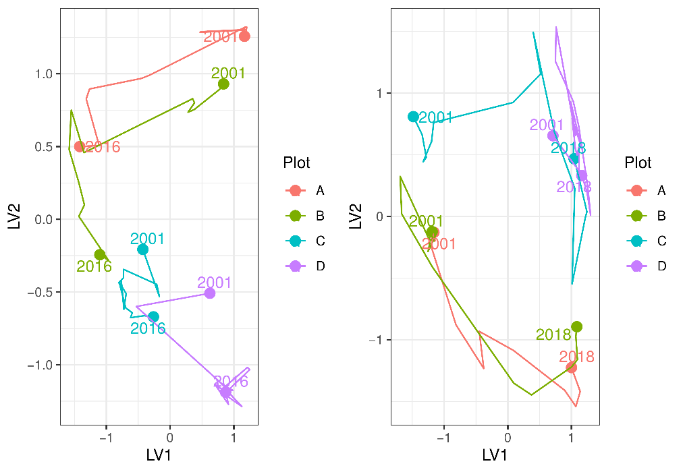

Figure 55 Unconstrained ordination based on the latent variable model for each surveyed year for the northern (left) and southern (right) Lake Nowergup transects. Plots are represented as different colours and consecutive years are joined by a line with first and last survey years labeled.

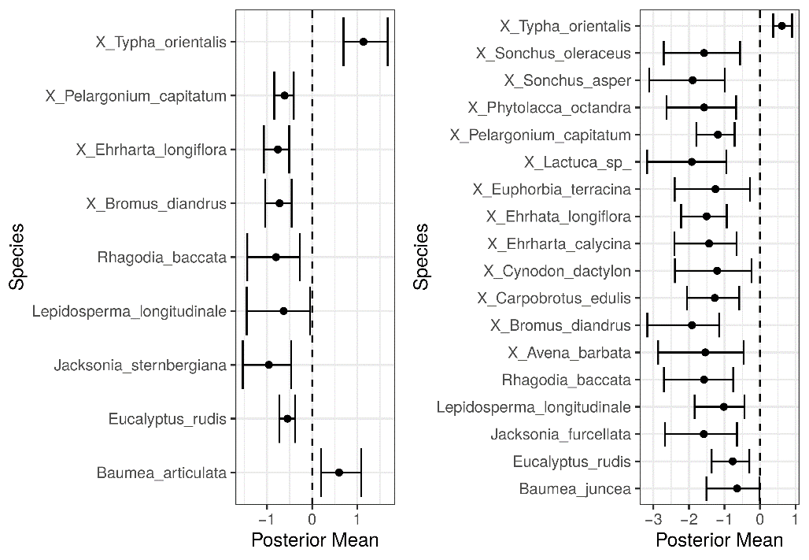

Figure 56 Estimated mean regression coefficients (dots) and 95% credible intervals (bars) for effect of groundwater levels at the northern (left) and southern (right) Lake Nowergup transects on vegetation species cover abundances based on Bayesian Regression Analysis (Hui, 2016). Species with a negative mean posterior value are likely to increase in cover abundance as water levels decline and species with positive values are likely to increase in cover abundance when water levels increase. Only those species with coefficients significantly different to zero are shown.

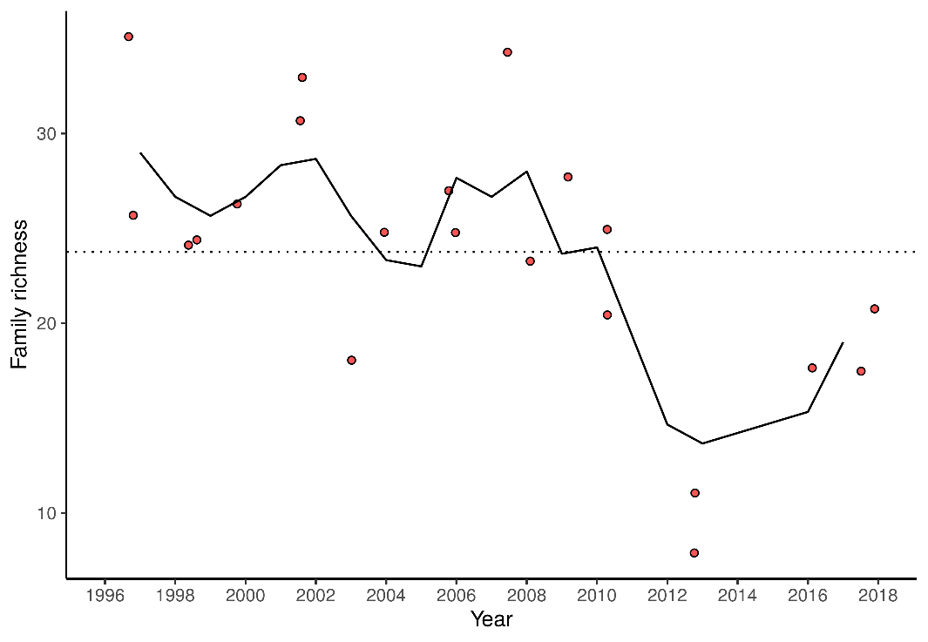

Figure 57 Richness of aquatic invertebrate families for each year at Lake Nowergup. Line is a moving 3-year average.

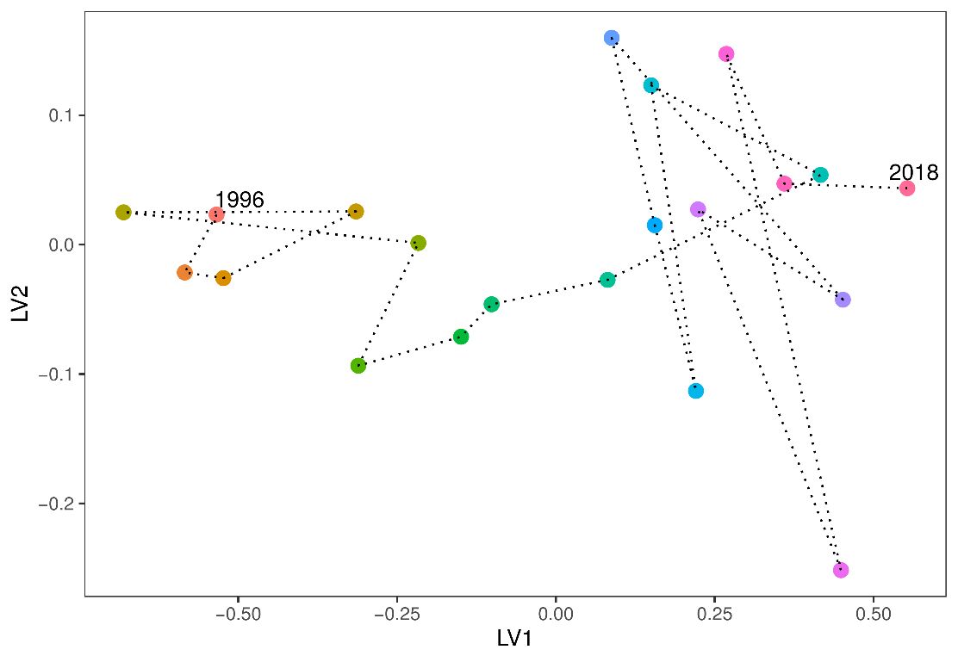

Figure 58 Unconstrained ordination based on invertebrate data for each surveyed year for Lake Nowergup. Consecutive years are joined by a line with first and last survey years labeled.

### Lake Wilgarup

#### Vegetation dynamics

A vegetation monitoring transect was established at Lake Wilgarup in 1997 and was last surveyed in 2012. Two additional sites were added to the transect in 2009 down-slope of Plot A. The sedges, *Baumea articulata*, *Baumea juncea* and *Baumea vaginalis* have all disappeared from the wetland during the monitoring period. Tuart trees (*Eucalyptus gomphocephala*) have migrated down slope during the monitoring period and were recorded in Plot A in 2005. The proposed minimum threshold is going to place extra stress on *M. rhaphiophylla* individuals as their ecological water requirements may not be met (Figure 59). *Plots* A, B and C display similar shifts in community composition during the monitoring period, while Plot D displayed a significant change in composition in 2004-2005 in response to fire (Figure 60). Under a scenario of continuing groundwater decline, regression analysis reveals that a number of exotic species, including *Ehrharta longiflora* and *Bromus diandrus*, are likely to increase in cover abundances (Figure 61).

Figure Range in elevation (mAHD) of key wetland species along the vegetation monitoring transects for 2001, 2011 and 2019 at Lake Wilgarup. Red bars represent the absolute range in elevation and yellow bar represent mean range. Blue bars represent the ecological water requirements for key species at this site as determined by Froend et al. (2004b). The current minimum threshold is provided as a dotted line while the proposed 2030 threshold is provided by the dashed line. *Baumea articulata*, *B. juncea* and *B. littoralis* data is based only on 2001 data.

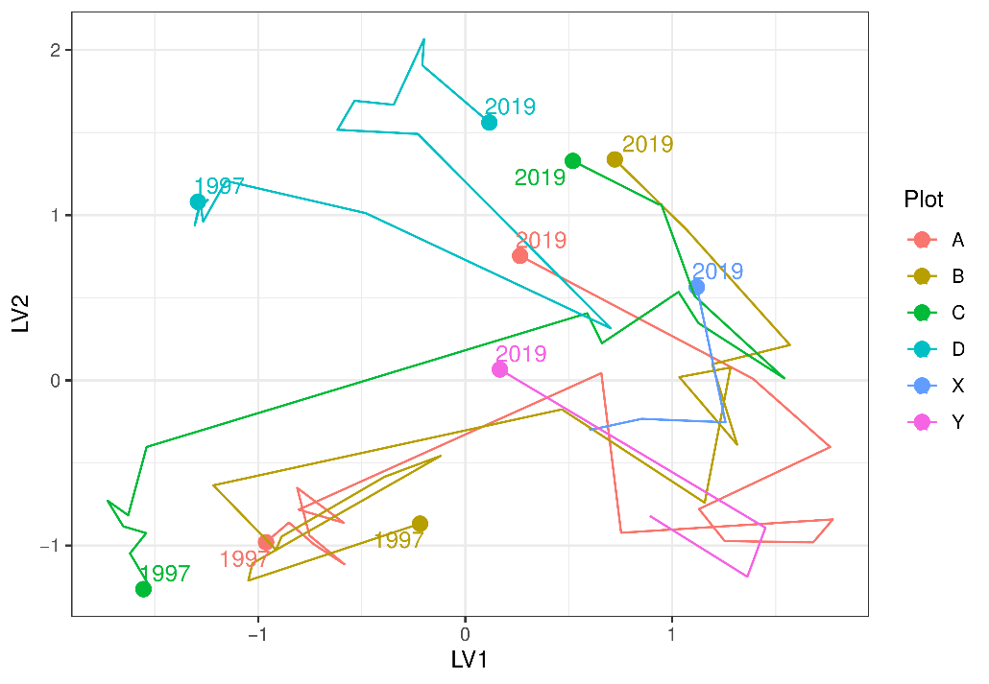

Figure 60 Unconstrained ordination based on the latent variable model for each surveyed year for Lake Wilgarup. Plots are represented as different colours and consecutive years are joined by a line with first and last survey years labeled.

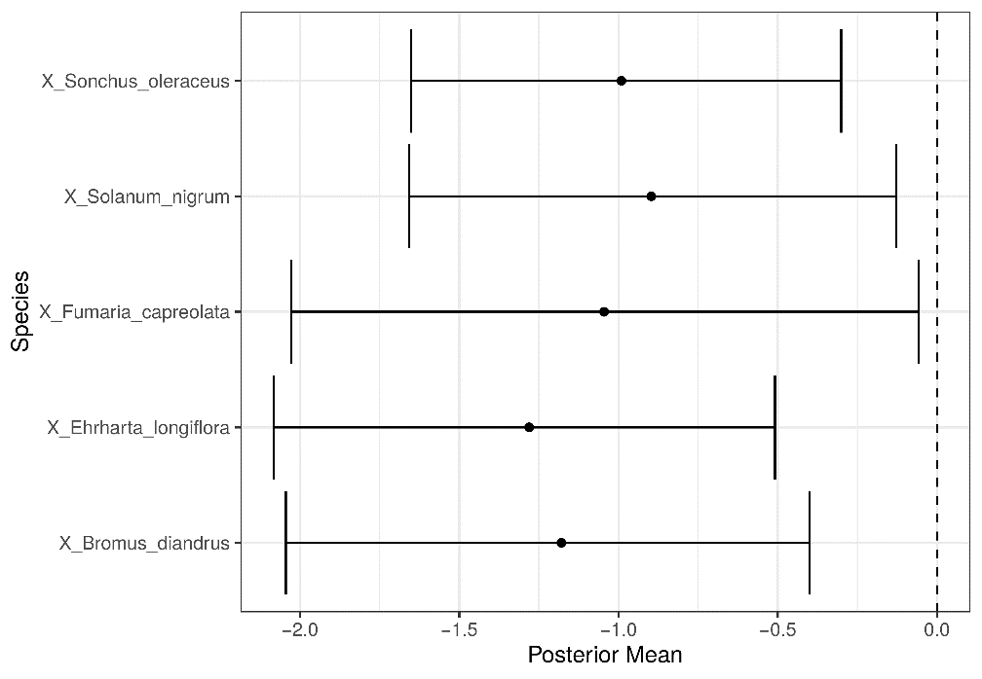

Figure 61 Estimated mean regression coefficients (dots) and 95% credible intervals (bars) for effect of groundwater levels at Lake Wilgarup on vegetation species cover abundances based on Bayesian Regression Analysis (Hui, 2016). Species with a negative mean posterior value are likely to increase in cover abundance as water levels decline. Only those species with coefficients significantly different to zero are shown. Invasive species are identified by the pre-text ‘X’.

### Pipidinny Swamp

#### Vegetation dynamics

The transect at Pipidinny Swamp consists of a series of depressions/swamps interspersed with tracks and grassy banks. The transect was established close to the bore but was only 20 m in length due to the terrain. Subsequently, only four *Melaleuca* trees could be included. Species richness and diversity on and around the transect was low, with *Acacia saligna* the dominant overstorey species, although *Melaleuca rhaphiophylla* appeared in good health (both on and around the transect). *Baumea articulata* was present, albeit in low abundance, several meters up slope from the surface water, and was in moderate health with a couple of dead stems present. No recruitment was recorded. The location’s potential value as important habitat was indicated by the presence of a south west carpet python (*Morelia apilota*) in amongst the *Typha orientalis* during the 2019 survey. Several exotic species are abundant at the site, including *Bromus diandrus*, *Ehrharta longiflora* and the potentially invasive native bullrush *T. orientalis*.

Table 39 Vegetation cover abundance at the two plots established at Pipidinny Swamp in September 2019.

|  |  |  |  |
| --- | --- | --- | --- |
| Species | Plot A | Plot B | Status |
| *Bromus diandrus* | 4 | 9 | Exotic |
| *Cirsium vulgare* | 2 | 0 | Exotic |
| *Ehrharta longiflora* | 7 | 9 | Exotic |
| *Euphorbia sp.* | 0 | 1 | Exotic |
| *Fumaria muralis* | 2 | 3 | Exotic |
| *Pelargonium capitatum* | 2 | 2 | Exotic |
| *Sonchus oleraceus* | 2 | 1 | Exotic |
| *Symphiotrichum squamatum* | 1 | 0 | Exotic |
| *Acacia saligna* | 6 | 10 | Native |
| *Baumea articulata* | 2 | 0 | Native |
| *Melaleuca rhaphiophylla* | 4 | 0 | Native |
| *Myoporum caprarioides* | 3 | 2 | Native |
| *Rhagodia baccata* | 3 | 4 | Native |
| *Spyridium globulosum* | 3 | 3 | Native |
| *Typha orientalis* | 6 | 0 | Native |

### Lexia 186

#### Vegetation dynamics

Vegetation monitoring has been occurring at Lexia 186 since 1997 with the last survey conducted in 2018. Overall canopy health has remained stable with most *Melaleuca preissiana* in good or excellent condition and most *Banksia ilicifolia* with average condition (Buller et al., 2018). Exotic richness is very low at Lexia 186 and natives account for approximately 90 % of total cover abundance at the transect. A number of key wetland species are currently experiencing water levels below their ecological water requirements, a situation the proposed minimum threshold will not alleviate (). Ordination reveals similar trajectories in compositional change for each plot that reflect the continual changes in cover abundances of species (Figure 63). Regression analyses did not reveal significant effects of groundwater levels on any of the species present at Lexia 186. This result suggests that community composition is changing due to other factors that are independent of groundwater level. This is surprising given the significant declines in groundwater at the site. Vegetation may be altered by other processes such as altered sediment processes and acidification.

Figure Range in elevation (mAHD) of key wetland species along the vegetation monitoring transects for 2001, 2011 and 2019 at Lexia 186. Red bars represent the absolute range in elevation and yellow bar represent mean range. Blue bars represent the ecological water requirements for key species at this site as determined by Froend et al. (2004b). The current minimum threshold is provided as a dotted line while the proposed 2030 threshold is provided by the dashed line.

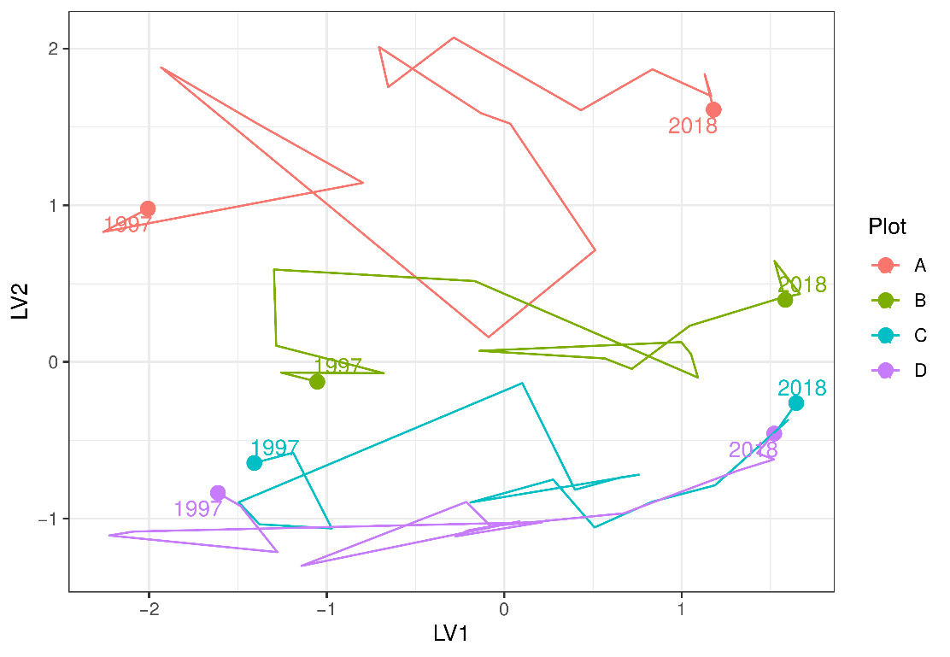

Figure 63 Unconstrained ordination based on the latent variable model for each surveyed year for Lexia 186. Plots are represented as different colours and consecutive years are joined by a line with first and last survey years labeled.

### Melaleuca Park 173

#### Water quality

Melaleuca Park 173 is the only monitored wetland to show organic acidity (Judd and Horwitz, 2019). The waters are dark and have high gilvin levels (94.7 FTU). The acidic waters have a pH between 3.4 and 5.1 and recent monitoring suggests the current pH is 3.7. The lake usually has total nitrogen levels between 2000 and 2800 $μ$ g/L.

#### Vegetation dynamics

Vegetation monitoring has been occurring at Melaleuca Park from 1997 to 2018 (Buller et al., 2019). There has been marked changes in vegetation composition along the transect during this monitoring period. In 2014, *Baumea articulata* was absent from the transect, however, due to a wet season which saw Plot A and B submerged in 2018, *B. articulata* was recorded in low abundance. Similar changes have been observed for *Astartea scoparia*, which prior to 2018 was recorded wither dead or in poor condition. Since 2018, many of the *A. scoparia* plants were observed with new shoots. Other important vegetation components in Plot A include *Lepidosperma longitudinale* and *Leptocarpus scariosus*, both of which are also present in Plot B, whilst the former is present throughout the transect.

The long-term decline in water levels has had an adverse effect on the health of key wetland species as their ecological water requirements have not been met. The proposed minimum thresholds are going to continue this trend as water levels are projected to reach minimum levels below their ecological water requirements (Figure 64). The important canopy forming function of *M. preissiana* has been compromised due to declining health.

Ordination reveals distinct shifts in community composition since 1997 (Figure 65). Although Plot A is distinct, in terms of vegetation cover abundances, to Plots B, C and D, all plots display an upwards trajectory along the second axis (LV2). For Plot A, this shift in composition is likely due to the loss of *B. articulata* from the plot. Modelling compositional changes in vegetation with changes in groundwater levels suggests a number of species which are likely to increase in cover abundance with declining groundwater levels (Figure 66). These species, such as *Xanthorrhoea preissii* and *Dielsia stenostachya*, are likely to increase in cover abundance in lower areas of the basin under a scenario of continuing declining groundwater levels.

#### Aquatic invertebrates

Aquatic macroinvertebrate family richness has been declining since the late 2000s when water levels began declining (Figure 67). As water chemistry has changed little during this period, the decline in richness is likely due to the degradation of habitats caused by the lower surface waters and extended dry periods during summer (Judd and Horwitz, 2019). Macroinvertebrate assemblage composition has shifted since the initial 2000 survey (Figure 68). Since 2011, assemblage composition has been shifting away from the 2000 community, suggesting further shifts in composition are likely due to sustained low water levels. Taxa that are no longer found in monitoring samples from the wetland include the crustacean families of Perthiidae and Chydoridae, insect family Leptoceridae, Orthocladiinae midges and Unioncolidae mites.

Figure Range in elevation (mAHD) of key wetland species along the vegetation monitoring transects for 2001, 2011 and 2019 at Melaleuca Park 173. Red bars represent the absolute range in elevation and yellow bar represent mean range. Blue bars represent the ecological water requirements for key species at this site as determined by Froend et al. (2004b). The current minimum threshold is provided as a dotted line while the proposed 2030 threshold is provided by the dashed line.

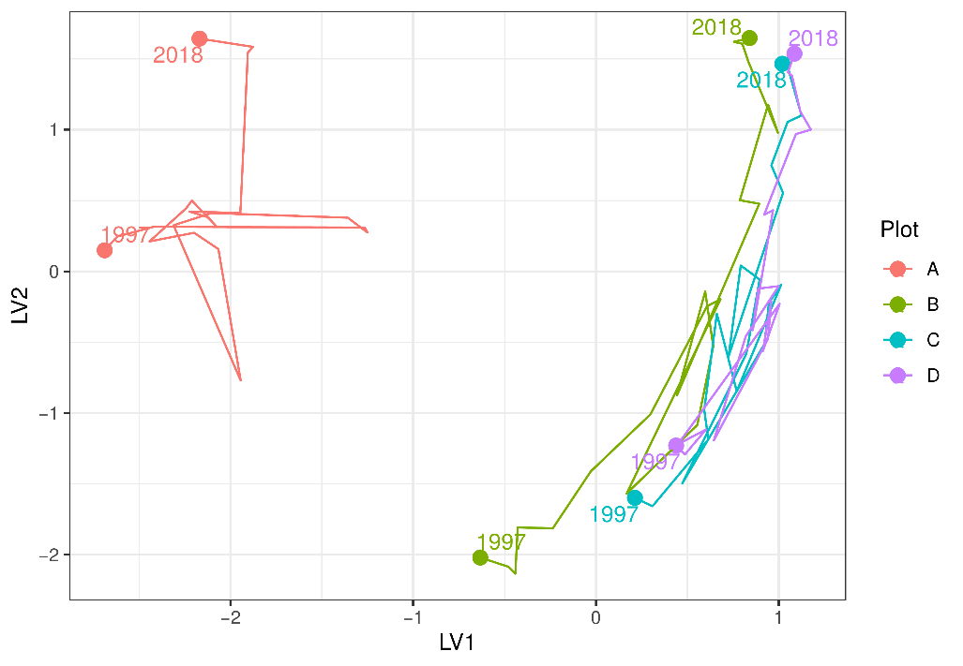

Figure 65 Unconstrained ordination based on the latent variable model for each surveyed year for Melaleuca Park 173. Plots are represented as different colours and consecutive years are joined by a line with first and last survey years labeled.

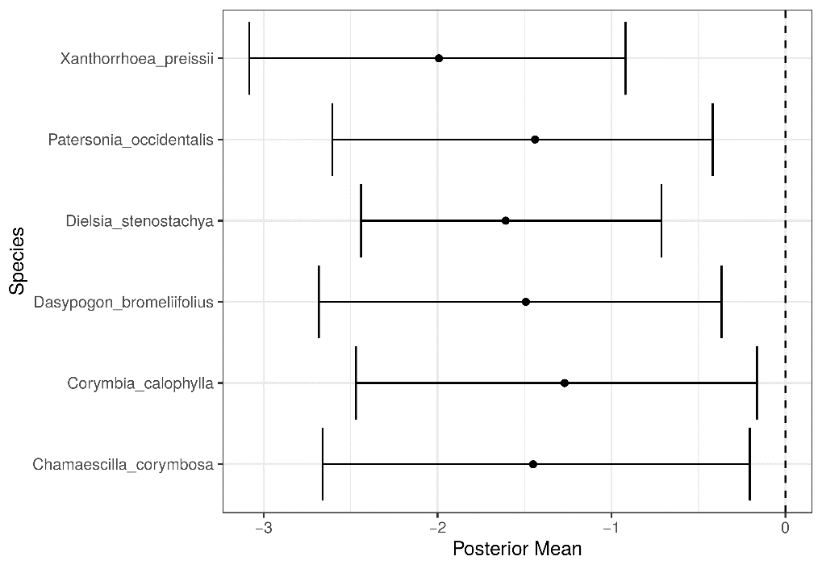

Figure 66 Estimated mean regression coefficients (dots) and 95% credible intervals (bars) for effect of groundwater levels at Melaleuca Park 173 on vegetation species cover abundances based on Bayesian Regression Analysis (Hui, 2016). Species with a negative mean posterior value are likely to increase in cover abundance as water levels decline. Only those species with coefficients significantly different to zero are shown.

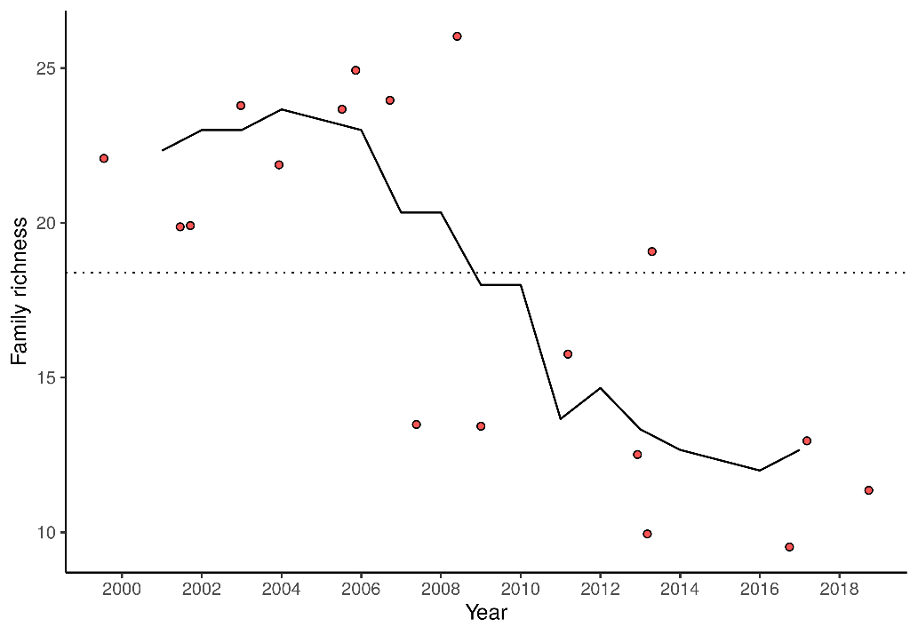

Figure 67 Richness of aquatic invertebrate families for each year at Melaleuca Park 173. Line is a moving 3-year average.

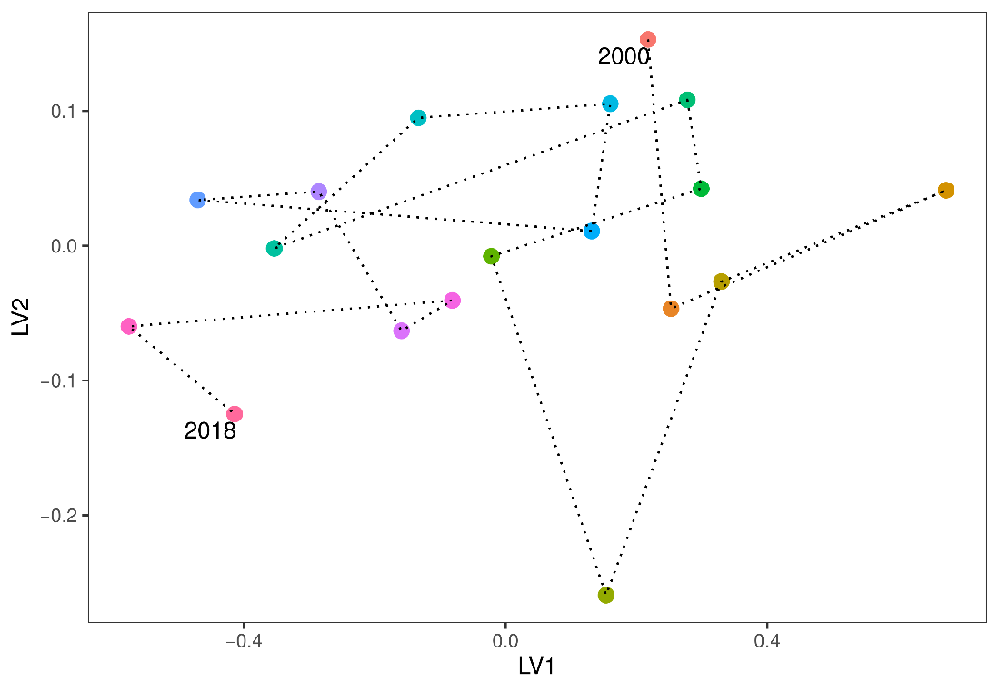

Figure 68 Unconstrained ordination based on invertebrate data for each surveyed year for Melaleuca Park 173. Consecutive years are joined by a line with first and last survey years labeled.

### Melaleuca Park 78

#### Vegetation dynamics

The vegetation transect has been monitored at Melaleuca Park 78 since 1997 and was last surveyed in 2018 (Buller et al., 2019). The site is largely dominated by native species that include a dense understory of *Beaufortia elegans*, *Pultenea reticulata* and *Kunzea glabrescens*. The overstorey is largely composed of *Melaleuca preissiana* throughout the transect and *Banksia attenuata*, *Banksia ilicifolia* and *Banksia menziesii* in the higher parts of the basin. The ecological water requirments of *M. preissiana* have been met, and will continue to be met by the projected increases in groundwater (Figure 69). In 2006, the transect was heavily affected by a fire but the vegetation has since made some recovery. *Baumea articulata* disappeared from the transect during this period. Several tree deaths were reported following the fire but there is evidence of recovery, particularly for low-lying stands of *M. preissiana*. Trajectories of compositional change provide further evidence for post-fire recovery as recent plot assemblages are becoming more similar to those recorded before the fire (Figure 70).

Bayesian regression modelling suggests a number of species associated with low groundwater levels (Figure 71), including *B. attenuata*, *Hibbertia subvaginata* and *M. preissiana*, are likely to increase in cover abundance under a scenario of further decreasing groundwater levels. The cover abundance of exotics, including *Aira caryophyllea*, *Briza maxima*, *Ehrharta calycina*, *Hypochaeris glabra*, *Poa annua*, *Sonchus oleraceus* and *Ursinia anthemoides*, is also likely to increase with declining groundwater levels. It is also likely that the richness of exotic species will increase with groundwater decline as the site becomes invaded by exotics not currently recorded at the site.

Figure Range in elevation (mAHD) of key wetland species along the vegetation monitoring transects for 2001, 2011 and 2019 at Melaleuca Park 78. Red bars represent the absolute range in elevation and yellow bar represent mean range. Blue bars represent the ecological water requirements for key species at this site as determined by Froend et al. (2004b). The current minimum threshold is provided as a dotted line while the proposed 2030 threshold is provided by the dashed line.

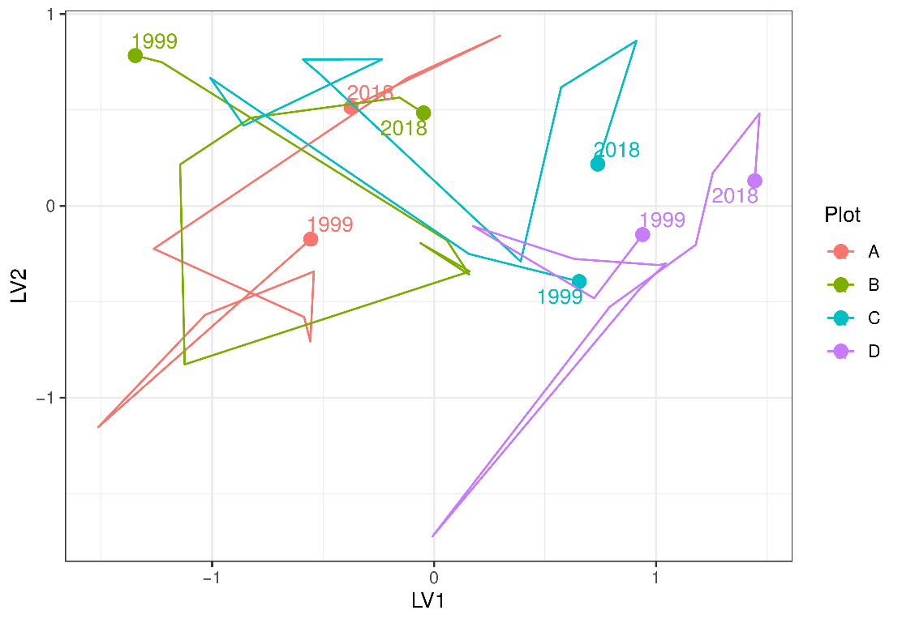

Figure 70 Unconstrained ordination based on the latent variable model for each surveyed year for Melaleuca Park 78. Plots are represented as different colours and consecutive years are joined by a line with first and last survey years labeled.

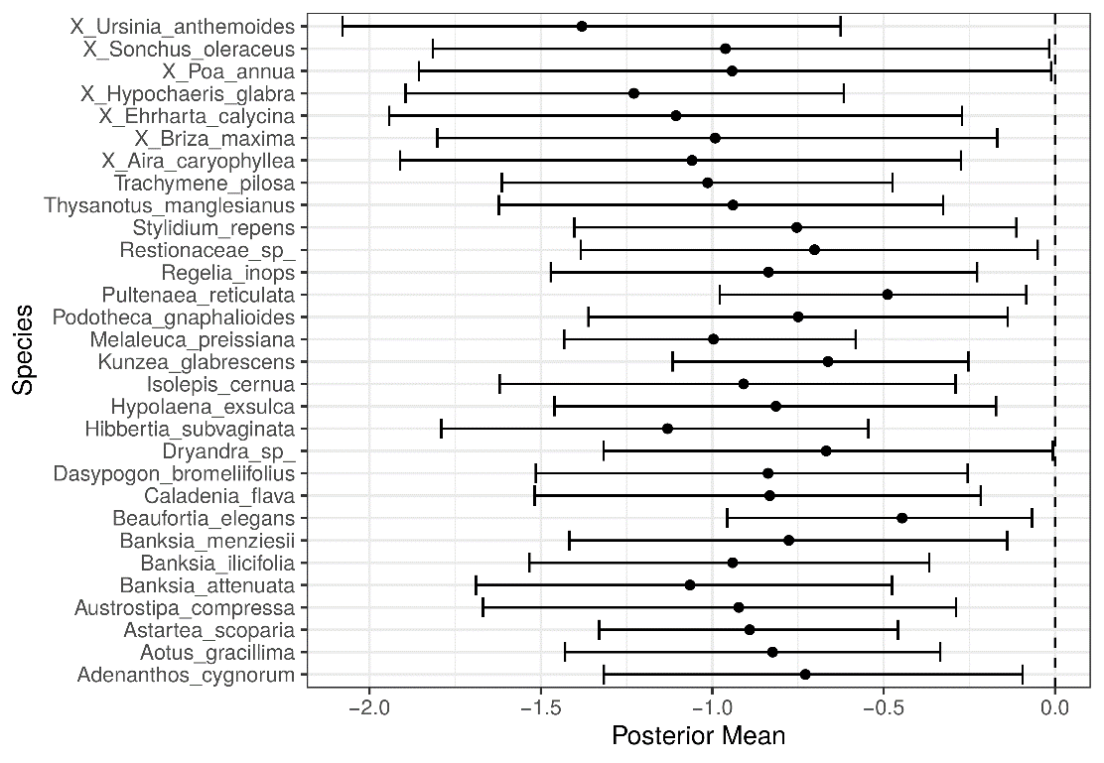

Figure 71 Estimated mean regression coefficients (dots) and 95% credible intervals (bars) for effect of groundwater levels at Melaleuca Park 78 on vegetation species cover abundances based on Bayesian Regression Analysis (Hui, 2016). Species with a negative mean posterior value are likely to increase in cover abundance as water levels decline. Only those species with coefficients significantly different to zero are shown. Invasive species are identified by the pre-text ‘X’.